Housing Authority of Paducah Section 8

Administrative Plan for Housing Choice Voucher Program


KY006

Effective Date: January 1, 2027
Adopted by the Housing Authority Board of Commissioners
Resolution Number: XXX
TABLE OF CONTENTS – Administrative Plan - HCV Program

INTRODUCTION 5
Housing Choice Voucher (HCV) Program overview 5
Disclaimer Policy 6
Part I. ELIGIBILITY AND OBLIGATIONS 6
1. Eligibility Determination 6
2. Determination of Income (24 CFR 5.609) 7
A. Annual Income 7
B. Income Inclusions 8
C. Income Exclusions 11
D. Assets 16
E. HUD Required Deductions 18
2. Selection of Program Participants – Local Preferences 26
3. Income Targeting Selection Criteria 27
4. Eligibility Exceptions (not eligible) 27
5. Considerations in Denials and Termination- 28
6. Criminal Background Checks and Consent HUD 9886-A/HUD-9887 & 9777-A 28
7. Citizenship and Eligible Immigration Status 30
8. Verifying Income and Determining & Gross Family Contribution 30
9. Social Security and Supplemental Security Income Verification 30
10. Fraud and Income Calculation Errors 30
11. Family Obligations 31
12. Interim Adjustments 32
13. Family Information Provided to Owners 34
14. Violence Against Women (VAWA) and Department of Justice Reauthorization Act of 2022 34
Part II. HOUSING STANDARDS AND INSPECTIONS 37
1. NSPIRE & Housing Quality Standards and Inspection Procedures 37
2. NSPIRE/Housing Quality Standards (Approval of Unit Size Family Selects) 38
3. Unit Size Selection by Family 39
4. Occupancy Standards 40
5. Disapproval of Owner 40
6. Annual Re-examinations 40
7. Continued Assistance after Family Break-Up 41
Part III. SPECIAL HOUSING TYPES & STANDARDS 42
1. Single Room Occupancy (SRO) [Sec. 982.602] 42
2. Congregate Housing [Sec. 982.606 of 24 CFR 982] 44
3. Group Home [Sec. 982.610] 44
4. Shared Housing [Sec. 982.615] 48
5. Cooperative Housing [Sec. 982.619] 49
6. Manufactured Home [Sec. 982.620] 51
Part IV. RENT, UTILITY ALLOWANCE STANDARDS 54
1. Minimum Rent 54
2. Rent Reasonableness - Housing Choice Voucher Program 54
3. Security Deposit 54
4. Payments 54
5. Payment Standard and FMR 55
6. Contract Rent Adjustments 55
7. Utility Allowances 55
8. Portability - Voucher Program 55
Part V. TERMINATION & GRIEVANCES 56
1. Grounds for Denial or Termination of Assistance to Applicants and Participants 56
2. Termination of Tenancy 56
3. Grievance Procedures 57
4. Complaints and Appeals 59
5. Absence from Unit 59
6. Restriction on the Number of Moves by a Participant Family 59
Part VI. PROGRAMS 60
1. Conversion HCV's 60
2. HUD-VASH 60
3. Supported Programs (SP) 66
4. Family Self-Sufficiency Program 66
5. HCV Homeownership Program 70
6. Homeownership Option 10 Year Asset Exclusion 76
7. Project-Based Voucher Program 77
Part VII. ADMINISTRATION & EVALUATION 79
1. Responsibilities of the Paducah Section 8 Housing office 79
2. Program Management 79
3. Outreach 81
4. Briefing Families, Issuing Housing Choice Vouchers 81
5. Administrative Fee Reserve Expenditures 82
6. Monitoring Program Performance & De Minimis Errors 83
7. Purged Files 83
8. Fair Housing Policy and Equal Opportunity Housing Plan 83
9. Limited English Proficient (LEP) Policy 84
10. Reduction of Families Due to Reduced Funding 88
Part VIII. MANAGEMENT ASSESSMENT OBJECTIVES 89
APPENDIX: 2027 Fair Market Rents and 2026 Income Limits 90
APPENDIX: 2026 Utility Allowances 91
Single-family / Manufactured Home 91
Walk-up / multi-family 92
Duplex / Townhouse 93
APPENDIX: VAWA Emergency Transfer Plan 94
Appendix: HOTMA 102
Appendix: NSPIRE-V 133

INTRODUCTION
Our goal is to provide in Paducah-McCracken County decent, safe and sanitary rental housing for eligible families and to provide opportunities, promote self-sufficiency and economic independence for Housing Choice Voucher (HCV), also known as Section 8, program participants.
To achieve this mission, we will:
- Recognize residents as our ultimate customer
- Through effective and efficient management
- Seek problem-solving partnerships with residents, landlords, community, and government leadership
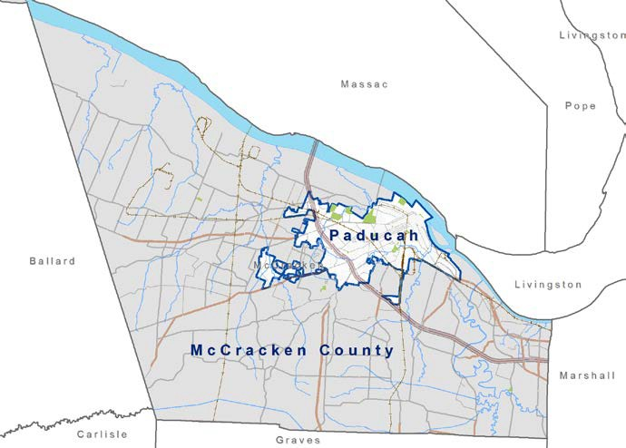
The purpose of this administrative plan is to establish guidelines for staff to follow in determining eligibility for Housing Choice Voucher (Section 8) programs. The basic guideline for this plan is governed by the requirements of the U.S. Department of Housing and Urban Development (HUD) with latitude for local policies and
procedures. The policies and procedures governing admissions and continued occupancy are outlined in the plan and these requirements are binding upon applicants, residents, landlords and this Public Housing Agency (PHA), known as the Housing Authority of Paducah Section 8 Housing office. Notwithstanding the above, changes in applicable federal law or regulations shall supersede provisions in conflict with this policy.
Federal Regulations shall mean those found in Section 24 CFR (Code of Federal Regulations).

Housing Choice Voucher (HCV) Program overview
In the Housing Choice Voucher (Section 8) program, the PHA pays monthly rental subsidies so that eligible families can afford decent, safe, and sanitary housing. HUD provides housing assistance funds to the PHA and funds the PHA to administer the program.
Under the HCV tenant-based program, families select and rent units that meet program housing quality standards (NSPIRE/HQS). If the PHA approves a family’s unit and tenancy, the PHA contracts with the owner to make rent subsidy payments (housing assistance payments) (HAP) directly to the owner on behalf of the family, monthly. The family enters a lease with the owner and pays its share of the rent to the owner in accordance with the lease.
The HAP contract between the PHA and the owner covers only a single unit and a specific assisted family. If the family moves out of the leased unit, the HAP contract with the owner terminates. The family may generally move to another unit with continued assistance, so long as the family is complying with program requirements.

Disclaimer Policy
This policy will be interpreted and applied in accordance with applicable federal statutes and HUD regulations and policy guidance. Any conflict between the language of this policy and such federal statutes and/or regulations will be resolved in accord with federal law and policy. Additionally, since the provisions of this plan are based on local, state and federal law and regulation, the policy will be deemed automatically revised should any of those laws or regulations change. To the extent that the change is mandatory (allowing no PHA discretion), the text of this policy will be revised without requirement for administrative processing. By approving this provision, the Board of Commissioners understands that they are approving future automatic revisions responding to mandatory changes. Anywhere the policy is found to be contradictory to HUD regulations, HUD regulations will prevail, and changes will be made to correct the policy in the next revision.

Part I. ELIGIBILITY AND OBLIGATIONS

Eligibility Determination
The Paducah Section 8 office serves the residents of Paducah-McCracken County, Kentucky and will use a simple pre-application form as suggested by HUD that will enable us to make a preliminary determination of eligibility. Complete applications of eligible families (Family is described as: A person or group of persons, as determined by the Paducah Section 8 Housing office consistent with 24 CFR 5.403, approved to reside in a unit with assistance under the program) will be arranged by date and time of application.
Eligibility Criteria:
  - A qualifying family is described as:
The term “family'' includes, but is not limited to the following, regardless of actual or perceived sexual orientation, gender identity, or marital status:
    - A single person, who may be an elderly person, displaced person, disabled person, near-elderly person, or any other single person;
      - Otherwise, eligible youth who have attained at least 18 years of age and not more than 24 years of age;
      - Has left foster care, or will leave foster care within 90 days, in accordance with a transition plan that complies with the requirements of the Social Security Act: and
      - Is homeless or at risk of becoming homeless at age 16 or older; or

    - A group of people residing together, and such group includes, but is not limited to:
      - A family with or without children (a child who is temporarily away from the home because of placement in foster care is considered a member of the family);
      - An elderly family;
      - A disabled family;
      - A displaced family; and/or
      - The remaining member of a tenant family.
  - The applicant must be of a very low-income status as established by HUD reflecting 50% of the median income. Annual income (as defined by 24 CFR is compared to income limits published by the Federal Register.
  - The family must not exceed the asset limitation.
All applicants who are out of compliance with the asset limitation found at 24 CFR 5.618 will be denied admission. This includes families with net family assets (as defined by 24 CFR 5.603) that exceed $100,000 (which amount will be adjusted for inflation annually by HUD) and/or a family that has a present ownership interest in, a legal right to reside in, and the effective legal authority to sell (based on lase of the state or locality in which the property is located), real property that is suitable for occupancy by the family as a residence.
The real-property restriction does not apply to the following circumstances identified in 24 CFR 5.618;
- Property for which the family is receiving assistance under 24 CFR § 982.620 or under the HCV Homeownership Option;
- Property jointly owned by a family member and at least one non-household member who does not live with the family, when the non-household member resides at the jointly owned property;
- A person who is a victim of domestic violence, dating violence, sexual assault, or stalking, as defined by HUD regulations; or
- A family that is offering the property for sale.
Before denying admission on this alone, the PHA will offer an opportunity for the applicant to explain why any property or asset should be excluded or why real property owned by the family is exempt or not suitable for occupancy.
Real property will be considered not suitable for occupancy for the following reasons:
- Property does not meet the disability related needs of the family.
- Property is insufficient for family size (not enough bedrooms based on the PHA’s occupancy standards).
- The property is geographically located so that it creates a hardship for the family. HAP will generally consider a geographic hardship to exist when the property is more than 50 miles or approximately 60 minutes of normal one-way travel from the family’s place of employment, school, necessary medical providers, or other essential services or obligations. HAP will consider the specific circumstances of each family and may determine that a geographic hardship exists at a shorter distance or travel time or does not exist at a greater distance or travel time, based on documented circumstances. Factors considered may include employment schedules, frequency of travel, school attendance, necessary medical treatment, disability-related needs, availability of transportation, caregiving responsibilities, and other circumstances determined by HAP.
- Property is unsuitable because its physical condition presents a health or safety risk that cannot be easily remedied, including circumstances involving environmental factors outside the family's control or cost-prohibitive alterations. The PHA may consult local code enforcement or the local health department when necessary to help determine if the property is unsuitable for occupancy.
- Property is not a property the family may reside in under State of local laws of the jurisdiction where the property is located (e.g. the property is zoned for commercial use).

2. Determination of Income (24 CFR 5.609)

A. Annual Income
Annual income is used to determine whether the family is within the Income Limits applicable to the PHA’s jurisdiction. Annual income is the anticipated amounts, monetary or not, that go to, or on behalf of, the family (including temporarily absent head, spouse or co-head), and are received from a source outside the family” within the twelve (12) months following certification.
- Annual Income Includes, with respect to the family;
  - All income that is not specifically excluded by HUD regulation, received from all sources by each member of the family who is 18 years of age or older or is the head of household or spouse of the head of household, plus unearned income by or on behalf of each dependent who is under 18 years of age, and
  - When the value of net family assets exceeds $50,000 (which amount will be adjusted for inflation annually by HUD) and the actual returns from a given asset cannot be calculated, imputed returns on the asset based on the current passbook savings rate.
- Adjusted income is the annual income minus HUD mandated deductions.
- Both annual and adjusted incomes are used to calculate the amount of rent. In calculating annual and adjusted income, the PHA must include the income of every member of the household, including those who are temporarily absent. Income of persons who are permanently absent from the household will not be counted.

B. Income Inclusions
- Temporarily and Permanently Absent
HUD regulations specify that the income of family members who are “temporarily absent” from the household is to be included in total family income. The PHA has determined that “temporarily absent” is defined as an absence for up to one-hundred eighty (180) days. An exception to the inclusion of that income is extended to members of the military and temporarily absent may exceed one year. Military absence can be confirmed with call-up orders. Other absences will be confirmed based on the circumstances of the absence.
Families must report in writing to the PHA any absence of the entire household from the unit of more than ninety (90) consecutive days, consistent with the lease provisions. Families must report any family members who have been or are expected to be absent from the household for more than fifteen (15) days. Any changes in family composition must be reported to the PHA within ten (10) days. Families will be counseled at briefing sessions and re-certification on the effect family composition may have in determining unit size and Total Tenant Payment as well as the PHA's policies for dealing with such changes. At times, situations may arise that result in the temporary or permanent absence of a family member or members from the household. Such situations will be handled in the following manner:
- Absence of children for foster care
In instances in which the children have been removed from the home by a social service agency, the agency will be contacted to determine the approximate length of time the children are expected to be away from the home.
- If the agency indicates that the children are expected to return to the home at some point during the next twelve (12) months, the children will remain a part of the family composition and will be counted in determining the family’s unit size.
- If the children are not ever expected to be returned to the home, the children will be removed from the family composition and the family’s unit size may be reduced accordingly.
- If the agency indicates that it is unknown whether the children will be returned to the home, the children will remain a part of the family composition.
Oral conversations with the social service agency must be thoroughly documented in the family file, including the date of contact, name and title of contact person, name of agency, and telephone number and the details of the conversation.
- Absence of single parent; use of caretaker adult
When a single parent leaves the household for an extended period as a result of imprisonment, hospitalization, military service, etc., and another adult approved by the PHA moves into the home to care for the children, the rental assistance will not be terminated. The family composition will be modified to include the name of the caretaker as head of household. The caretaker's income will not be included in the family income. The single parent's name shall be temporarily removed, and the file documented to explain the circumstances. When the parent returns to the unit, the caretaker may leave or remain in the household. If the caretaker remains, his/her income will be included in the calculation of family income.
- Absence of head of household, spouse or co-head due to military service or school
If the head of household, spouse or co-head is absent from the home to serve in the military or attend school, the individual will be considered temporarily absent and the income will be included in the calculation of family income. However, income received as a result of special hazardous duty pay when exposed to hostile fire will not be included.
- Absence of other family member due to military service or school
If a family member other than the head of household, spouse or co-head is absent from the home to serve in the military or attend school, the family has the option of considering the person permanently absent (income not counted; not on lease) or temporarily absent (income counted; on lease). Income received as a result of imminent danger pay when exposed to hostile fire will not be included.
- Absence due to hospitalization of sole member
When the family consists of only one member and that person leaves the home to go into a hospital or nursing home for a period of more than six (6) months, the assistance will be terminated. If a responsible medical professional verifies prior to the expiration that the confinement will be permanent, the PHA will terminate the assistance.
If a medical source documents that a family member who is residing in a nursing facility or hospital is expected to return to the unit in 180 days or less, the person shall be considered temporarily absent. If the person does not return to live in the unit within 180 days, the individual will be considered permanently absent.
- Absence of All Household Members
If all members of the household are absent for ninety (90) consecutive days, but have not moved from the unit, assistance will be terminated. In order to determine if the family is absent from the unit, the PHA may write letters to the family at the unit, telephone the family at the unit, interview neighbors, and/or verify if utilities are in service. In cases in which the family has moved from the unit, assistance will be terminated in accordance with the PHA’s termination and eviction policies.
- Adult visitors
An adult may visit a unit for no more than fourteen (14) cumulative days per year. Exceptions may be granted by the PHA if the visitor is providing care for a household member with a long-term illness. Adults exceeding this limit must be approved by the PHA before being considered a family member and added to the lease. Addition of such person may not be approved if they cannot be accommodated within the existing occupancy limits for the unit.
- Child visitors
Children under the age of eighteen (18) may visit a unit for a maximum of ninety (90) accumulative days per year without being considered part of the family, provided the family has the written permission of the PHA.
- Joint Custody of Children
Children who are subject to a joint custody agreement but live in the unit at least fifty-one percent (51%) of the time will be considered members of the household. The PHA defines 51% of the year as 186 days. If the family includes a child who is temporarily absent from the home due to foster care, the standards in paragraph “a” above will be used.
- Earned Income
Earnings anticipated to be received in the twelve (12) months following the effective date of the certification will be annualized. To annualize income, the PHA will multiply:
- Hourly income by the number of hours worked in a year;
- Weekly income by 52 weeks, unless it is verified that less weeks will be worked;
- Bi-weekly income by 26 pay-periods;
- Semi-monthly by 24 pay-periods; and
- Monthly by 12 pay-periods.
Where income is fluctuates as to hours or rates, such as for teachers, construction workers, farmers or migrant workers, the PHA will use an average for twelve (12) months based on past income history of the family and such anticipated income that can be verified.
- Income from Assets
- Assets Valued Under $50,000 (which amount will be adjusted for inflation annually by HUD);
When assets owned by any family member (including minors) have a combined cash value of less than $50,000 (which amount will be adjusted for inflation annually by HUD), actual income received from the asset(s) is counted as income. (For example, checking and savings accounts.) In determining the value of checking accounts, the PHA will use the lesser of the current balance or the average daily balance of the account for the most recent past three (3) months. Anticipated interest will be determined by multiplying the value of the checking account by the annual interest rate.
- Assets Valued Over $50,000 (which amount will be adjusted for inflation annually by HUD);
When assets owned by any family member (including minors) have a combined cash value of more than $50,000 (which amount will be adjusted for inflation annually by HUD), the PHA will use actual income received from the asset(s). When actual returns from a given asset cannot be calculated, imputed returns on the asset, based on the current passbook savings rate will be used. Actual returns and imputed returns can be added together when some assets can be determined and some cannot.
- Assets Disposed of for Less than Fair Market Value
The PHA will count as an asset the difference between the market value and the actual amount received for assets disposed of for less than market value for two (2) years from date of disposition.
- Asset Calculations may change as a result of further HOTMA implementation. The PHA will follow HUD regulations, even if it differs from this policy as additional HOTMA provisions are enforced.

C. Income Exclusions
Some amounts are prohibited from being included in a family’s income for rent determination purposes. These amounts, called exclusions, are not part of Annual Income. See Section VIII: Verifications for verification and reporting requirements related to Fully Excluded and Partially Excluded Income. The federally mandated exclusions are as follows and will be applied to all transactions with an effective date on or after July 1, 2025 (until such date, the prior income exclusions will be used):
- Any imputed return on an asset when net family assets total $50,000 or less (which amount HUD will adjust annually in accordance with the Consumer Price Index for Urban Wage Earners and Clerical Workers) and no actual income from the net family assets can be determined.

- The following types of trust distributions:
  - For an irrevocable trust or a revocable trust outside the control of the family or household excluded from the definition of net family assets under 24 CFR 5.603(b):
    - Distributions of the principal or corpus of the trust; and
    - Distributions of income from the trust when the distributions are used to pay the costs of health and medical care expenses for a minor.
  - For a revocable trust under the control of the family or household, any distributions from the trust; except that any actual income earned by the trust, regardless of whether it is distributed, shall be considered income to the family at the time it is received by the trust.
- Earned income of children under 18 years of age per 24 CFR 5.609(b)(3).
- Payments received for the care of foster children or foster adults, or State or Tribal kinship or guardianship care payments.
- Insurance payments and settlements for personal or property losses, including but not limited to payments through health insurance, motor vehicle insurance, and workers' compensation.
- Amounts received by the family that are specifically for, or in reimbursement of, the cost of health and medical care expenses for any family member.
- Any amounts recovered in any civil action or settlement based on a claim of malpractice, negligence, or other breach of duty owed to a family member arising out of law, that resulted in a member of the family becoming disabled.
- Income of a live-in aide, foster child, or foster adult as defined in 24 CFR 5.403 and 5.603, respectively.
- Student Financial Assistance (as described below)
  - Any assistance that section 479B of the Higher Education Act of 1965, as amended (20 U.S.C. 1087uu), requires be excluded from a family's income; and
  - Student financial assistance for tuition, books, and supplies (including supplies and equipment to support students with learning disabilities or other disabilities), room and board, and other fees required and charged to a student by an institution of higher education (as defined under Section 102 of the Higher Education Act of 1965 (20 U.S.C. 1002)) and, for a student who is not the head of household or spouse, the reasonable and actual costs of housing while attending the institution of higher education and not residing in an assisted unit.
- Student financial assistance, for purposes of this paragraph (9)(ii), means a grant or scholarship received from—
  - The Federal government;
  - A State, Tribe, or local government;
  - A private foundation registered as a nonprofit under 26 U.S.C. 501(c)(3);
  - A business entity (such as corporation, general partnership, limited liability company, limited partnership, joint venture, business trust, public benefit corporation, or nonprofit entity); or
  - An institution of higher education.
- Student financial assistance , for the purposes of this paragraph (9)(ii), does not include—
  - Any assistance that is excluded pursuant to paragraph (C)(9)(i) of this section;
  - Financial support provided to the student in the form of a fee for services performed (e.g., a work study or teaching fellowship that is not excluded pursuant to paragraph (C)(9)(i) of this section);
  - Gifts, including gifts from family or friends; or
  - Any amount of the scholarship or grant that, either by itself or in combination with assistance excluded under this paragraph or paragraph (C)(9)(i), exceeds the actual covered costs of the student. The actual covered costs of the student are the actual costs of tuition, books and supplies (including supplies and equipment to support students with learning disabilities or other disabilities), room and board, or other fees required and charged to a student by the education institution, and, for a student who is not the head of household or spouse, the reasonable and actual costs of housing while attending the institution of higher education and not residing in an assisted unit. This calculation is described further in paragraph (C)(9)(ii)(E) of this section.
- Student financial assistance, for purposes of this paragraph (C)(9)(ii) must be:
  - Expressly for tuition, books, room and board, or other fees required and charged to a student by the education institution;
  - Expressly to assist a student with the costs of higher education; or
  - Expressly to assist a student who is not the head of household or spouse with the reasonable and actual costs of housing while attending the education institution and not residing in an assisted unit.
- Student financial assistance, for purposes of this paragraph (C)(9)(ii), may be paid directly to the student or to the educational institution on the student's behalf. Student financial assistance paid to the student must be verified by the responsible entity as student financial assistance consistent with this paragraph (C)(9)(ii).
- When the student is also receiving assistance excluded under paragraph (C)(9)(i) of this section, the amount of student financial assistance under this paragraph (C)(9)(ii) is determined as follows:
  - If the amount of assistance excluded under paragraph (C)(9)(i) of this section is equal to or exceeds the actual covered costs under paragraph (C)(9)(ii)(B)(4) of this section, none of the assistance described in this paragraph (C)(9)(ii) of this section is considered student financial assistance excluded from income under this paragraph (C)(9)(ii)(E).
  - If the amount of assistance excluded under paragraph (C)(9)(i) of this section is less than the actual covered costs under paragraph (C)(9)(ii)(B)(4) of this section, the amount of assistance described in paragraph (C)(9)(ii) of this section that is considered student financial assistance excluded under this paragraph is the lower of:
    - the total amount of student financial assistance received under this paragraph (C)(9)(ii) of this section, or
    - the amount by which the actual covered costs under paragraph (C)(9)(ii)(B)(4) of this section exceeds the assistance excluded under paragraph (C)(9)(i) of this section.
For Section 8 programs, including the Housing Choice Voucher and Project-Based Voucher programs, student financial assistance shall be treated in accordance with the applicable HUD appropriations requirements and HUD guidance. For a Section 8 student who is the head of household, spouse, or co-head and who is age 23 or younger or does not have dependent children, any student financial assistance received from the Higher Education Act of 1965, private sources, or an institution of higher education that exceeds the student's tuition and other required fees and charges shall be included in annual income. The PHA shall calculate the amount included in income by subtracting the student's total tuition and required fees and charges from the total student financial assistance received from all sources. Any positive amount shall be included in annual income.
This Section 8 limitation does not apply to a student who is over age 23 and has dependent children. For such students, student financial assistance shall be treated in accordance with the applicable provisions of 24 CFR § 5.609 and HUD HOTMA guidance.
- Income and distributions from any Coverdell education savings account under section 530 of the Internal Revenue Code of 1986 or any qualified tuition program under section 529 of such Code; and income earned by government contributions to, and distributions from, “baby bond” accounts created, authorized, or funded by Federal, State, or local government.
- The special pay to a family member serving in the Armed Forces who is exposed to hostile fire.

- Amounts received by a person with a disability that are disregarded for a limited time for purposes of Supplemental Security Income eligibility and benefits because they are set aside for use under a Plan to Attain Self-Sufficiency (PASS);
- Amounts received by a participant in other publicly assisted programs which are specifically for or in reimbursement of out-of-pocket expenses incurred (e.g., special equipment, clothing, transportation, child care, etc.) and which are made solely to allow participation in a specific program;
- Amounts received under a resident service stipend not to exceed $200 per month. A resident service stipend is a modest amount received by a resident for performing a service for the PHA or owner, on a part-time basis, that enhances the quality of life in the development.
- Incremental earnings and benefits resulting to any family member from participation in training programs funded by HUD or in qualifying Federal, State, Tribal, or local employment training programs (including training programs not affiliated with a local government) and training of a family member as resident management staff. Amounts excluded by this provision must be received under employment training programs with clearly defined goals and objectives and are excluded only for the period during which the family member participates in the employment training program unless those amounts are excluded under paragraph (b)(9)(i) of this section.

- Reparation payments paid by a foreign government pursuant to claims filed under the laws of that government by persons who were persecuted during the Nazi era.
- Earned income of dependent full-time students in excess of the amount of the deduction for a dependent in 24 CFR 5.611.
- Adoption assistance payments for a child in excess of the amount of the deduction for a dependent in 24 CFR 5.611.
- Deferred periodic amounts from Supplemental Security Income and Social Security benefits that are received in a lump sum amount or in prospective monthly amounts, or any deferred Department of Veterans Affairs disability benefits that are received in a lump sum amount or in prospective monthly amounts.
- Payments related to aid and attendance under 38 U.S.C. 1521 to veterans in need of regular aid and attendance.
- Amounts received by the family in the form of refunds or rebates under State or local law for property taxes paid on the dwelling unit.
- Payments made by or authorized by a State Medicaid agency (including through a managed care entity) or other State or Federal agency to a family to enable a family member who has a disability to reside in the family's assisted unit. Authorized payments may include payments to a member of the assisted family through the State Medicaid agency (including through a managed care entity) or other State or Federal agency for caregiving services the family member provides to enable a family member who has a disability to reside in the family's assisted unit.
- Loan proceeds (the net amount disbursed by a lender to or on behalf of a borrower, under the terms of a loan agreement) received by the family or a third party (e.g., proceeds received by the family from a private loan to enable attendance at an educational institution or to finance the purchase of a car).
- Payments received by Tribal members as a result of claims relating to the mismanagement of assets held in trust by the United States, to the extent such payments are also excluded from gross income under the Internal Revenue Code or other Federal law.
- Amounts that HUD is required by Federal statute to exclude from consideration as income for purposes of determining eligibility or benefits under a category of assistance programs that includes assistance under any program to which the exclusions set forth in paragraph (b) of this section apply. HUD will publish a notice in the Federal Register to identify the benefits that qualify for this exclusion. Updates will be published when necessary.
- Replacement housing “gap” payments made in accordance with 49 CFR part 24 that offset increased out of pocket costs of displaced persons that move from one federally subsidized housing unit to another Federally subsidized housing unit. Such replacement housing “gap” payments are not excluded from annual income if the increased cost of rent and utilities is subsequently reduced or eliminated, and the displaced person retains or continues to receive the replacement housing “gap” payments.
- Nonrecurring income, which is income that will not be repeated in the coming year based on information provided by the family. Income received as an independent contractor, day laborer, or seasonal worker is not excluded from income under this paragraph, even if the source, date, or amount of the income varies. Nonrecurring income includes:
  - Payments from the U.S. Census Bureau for employment (relating to decennial census or the American Community Survey) lasting no longer than 180 days and not culminating in permanent employment.
  - Direct Federal or State payments intended for economic stimulus or recovery.
  - Amounts directly received by the family as a result of State refundable tax credits or State tax refunds at the time they are received.
  - Amounts directly received by the family as a result of Federal refundable tax credits and Federal tax refunds at the time they are received.
  - Gifts for holidays, birthdays, or other significant life events or milestones (e.g., wedding gifts, baby showers, anniversaries).
  - Non-monetary, in-kind donations, such as food, clothing, or toiletries, received from a food bank or similar organization.
  - Lump-sum additions to net family assets, including but not limited to lottery or other contest winnings.
- Civil rights settlements or judgments, including settlements or judgments for back pay.
- Income received from any account under a retirement plan recognized as such by the Internal Revenue Service, including individual retirement arrangements (IRAs), employer retirement plans, and retirement plans for self-employed individuals; except that any distribution of periodic payments from such accounts shall be income at the time they are received by the family.
- Income earned on amounts placed in a family's Family Self Sufficiency Account.
- Gross income a family member receives through self-employment or operation of a business; except that the following shall be considered income to a family member:
  - Net income from the operation of a business or profession. Expenditures for business expansion or amortization of capital indebtedness shall not be used as deductions in determining net income. An allowance for depreciation of assets used in a business or profession may be deducted, based on straight line depreciation, as provided in Internal Revenue Service regulations; and
  - Any withdrawal of cash or assets from the operation of a business or profession will be included in income, except to the extent the withdrawal is reimbursement of cash or assets invested in the operation by the family.

D. Assets
Family members with assets are required to report all assets annually. The PHA will determine the net cash value of each asset by deducting reasonable costs that would be incurred to convert the asset to cash from the market or face value of the asset.
Reasonable costs include but are not limited to: penalties for early withdrawal of funds from CD’s, Money Market accounts, IRAs, annuities, etc.; the cost basis plus commissions and fees for stocks, bonds and other capital investments; appraisal fees, realtor commissions, closing costs, repair costs, if applicable, for real property: penalty fees for early withdrawal of IRA’s, pensions and annuities.
If assets are held jointly in an “and” or an “or” account, the full value of the asset less any reasonable costs will be counted unless the family member can demonstrate that their access to the account is legally restricted. The PHA must be able to verify the restriction.
Necessary items of personal property are not counted as assets. These include but are not limited to; clothing; furniture, personal automobiles, computers and related equipment for personal but not business use.
Assets include but are not limited to trusts (only if a family member has access or control of the trust), joint accounts, investments, CDs, IRAs, Keogh, real or personal property or other annuities to which the family member has access even if penalties would be imposed for early withdrawal.

In determining the net cash value of assets, the PHA will treat assets as follows:
- Trusts
Principal from a trust is not counted as an asset if the trust is not revocable by, or under the control of, any member of the family, so long as the fund continues to be held in trust. The distributions are considered to be part of annual income. A lump sum distribution in total or in part will be added to all other income and divided by twelve (12) to obtain the gross monthly income. Verification of trust provisions should be contained in the original trust documents. If the documents cannot be obtained, verification should be obtained from the trustee (individual or financial institution).
If a family sets up an irrevocable trust for the benefit of another person outside of the household, the PHA must determine whether or not the value of the trust is less than the fair market value of the assets contained therein had the family retained the asset. If that is the case, the fair market value less reasonable costs must be determined, and the net value of the asset included in total assets. Any income the family receives from this trust will be included in annual income. Nominal amounts set aside in trust for or donated to charitable organizations up to $1000.00 will not be considered assets disposed of for less than fair market value.
- Joint Ownership
For joint ownership of assets, the PHA must determine the percentage of ownership attributable to the family member. Documents that may provide this information include deeds, tax returns, ownership papers, and financial institution records. These types of documents should, if applicable to the asset, describe whether the family member has full or restricted access to the asset. If restricted, the PHA will use only that portion of the asset available to the family member.
- Investments
The PHA will use the balance from the most recent statement or report and subtract all costs for converting the investment to cash in order to determine the cash value of investments. Income from investment accounts will be based on the rate of return. Whenever the PHA cannot determine an anticipated rate of return, use the earnings shown on the most recent statement or report as the basis for calculation.
- Retirement Benefits (CDs, IRAs, Keogh)
Retirement/pension accounts, while the household member is employed, are counted as assets only if there is access to cash from the account while employed. Similarly, if funds are held in the account with the principal restricted from access, only distributions from the fund are counted as income.
- Checking and Savings Accounts
Checking and savings accounts are also considered as assets. The total amount in savings will be considered an asset unless the account is specifically designated under a plan for self-sufficiency for a person with a disability under Social Security Administration guidelines. Checking accounts are also assets under HUD guidelines; however, since most checking accounts are used primarily as a pass-through for receipt of income and payment of monthly household expenses, only the amount in the checking account in excess of $5,000.00 will be considered to be an asset. In determining the value of the checking and/or savings account, the PHA will use the average balances of the last two (2) consecutive month bank statements verified/generated by a third-party source dated within 60 days preceding the reexamination or PHA request date.
- Annuities
Annuities may provide for either fixed or variable payment. For variable payments, the PHA will evaluate historical information to determine the approximate anticipated payment amount for the next twelve (12) month period. This annualized income may be adjusted based on significant changes from the anticipated income. The holder of an annuity may withdraw the funds at any time before maturity but will pay a penalty for early withdrawal. Verification of the penalty amount may be obtained from the company holding the annuity and should be deducted from the total distribution before determining asset or income amounts. Monthly or periodic regular annuity payments are counted, as income while the principal of the annuity remains an asset until fully liquidated. Verification of any annuity expenses will be obtained from the annuity provider.
- Net Cash Value of Assets Disposed of for Less than Fair Market Value for 2 Years from Date of Disposition
Reasonable costs include but are not limited to: penalties for early withdrawal of funds from CD’s, Money Market accounts, IRAs, annuities, etc.; the cost basis plus commissions and fees for stocks, bonds and other capital investments; appraisal fees, realtor commissions, closing costs, repair costs, if applicable, for real property: penalty fees for early withdrawal of IRA’s, pensions and annuities.
If assets are held jointly in an “and” or an “or” account, the full value of the asset less any reasonable costs will be counted unless the family member can demonstrate that their access to the account is legally restricted. The PHA must be able to verify the restriction.
Not counted, as assets are necessary items of personal property. These include but are not limited to; clothing; furniture, personal automobiles, computers and related equipment for personal but not business use.
- Lump Sum Additions
Lump sum additions such as inheritances, insurance payments (including payments under health and accident insurance and Workers’ Compensation, except those portions which are reimbursement for expenses paid out by the family or otherwise excluded by HUD regulation), capital gains and settlement for personal or property losses are counted as assets whether or not they are placed in savings or other investment vehicles. The PHA will verify payments of inheritances through the executor; health, accident and Workers’ Compensation payments through the provider; capital gains through the broker, original 1099s or tax returns; and settlements for personal or property losses through the insurer.
Lump sum payments of $500 or less will not be included in the calculation of assets.

E. HUD Required Deductions
HUD has mandatory deductions from annual income:
- Dependent Allowance
$525 (which amount will be adjusted for inflation annually by HUD, rounded to the next lowest multiple of $25) each for family members (other than the head, spouse or co-head) who are minors (including children who are adopted), and for family members who are eighteen (18) and older who are full-time students or who are disabled (foster children, foster adults, and children of live-in aides are not entitled to this deduction).
- Elderly/Disabled Allowance
$575 (which amount will be adjusted for inflation annually by HUD, rounded to the next lowest multiple of $25) per family for families whose head, spouse or co-head is 62 or over or disabled.
- Allowable Medical Expenses
Deducted for all family members of an eligible elderly/disabled family.
- Appendix K will be used to determine allowable medical and dental expenses that can be included as medical deductions. Where an expense item can be treated as either a medical or a disability assistance expense the PHA will calculate the expenses both ways and give the family the greater deduction.

- The PHA will advise all families at each certification and each reexamination that they may report any one-time nonrecurring medical or disability expense cost and request an interim recertification.

- The PHA will include the following as a standard medical expense deduction when determining the family’s medical expenses deduction:

(1) The amount of un-reimbursed out-of-pocket expenses for prescription drugs

(2) Any premiums incurred for a Medicare prescription drug plan

- Standard medical deduction is the sum of allowable medical deductions that exceed ten percent (10%) percent of annual income.

- Allowable Disability Assistance Expenses
Deducted for attendant care or auxiliary apparatus for persons with disabilities if needed to enable the disabled person or another adult family member to work.
Disability assistance expenses are those reasonable expenses that are anticipated during the period for which annual income is computed for attendant care and auxiliary apparatus for a disabled family member and that are necessary to enable a family member (including the disabled family member) to be employed.
These expenses may not be paid to a member of the family nor reimbursed by an outside source.
The PHA must determine what is “reasonable” based on local conditions and costs as well as whether the expenses are directly linked to enabling the family member to work. Reasonable attendant care costs for the locality should be verified through a local social services agency which handles attendant care needs, or an independent Living Center that assists families in matching attendants with disabled clients.
Attendant care includes the actual cost of providing an attendant to care for a disabled person either in the home or in the workplace based on local standards for hourly pay or salary.
Equipment may include but not be limited to providing a wheelchair (manual or electric) to allow the disabled individual the mobility to go from home to place of employment or to facilitate care in the home, ramps to provide access to and from the unit, modifications to a vehicle or special equipment to enable a blind individual to read or type, but only if this enables the disabled person or other family member to work, any other type of special equipment needed for mobility if the use thereof is demonstrated to be employment related for the disabled person or another family member.
The amount allowed is limited to the amount that exceeds three percent (10%) of gross family income and does not exceed the amount earned as a result of the expense.
The PHA must be able to verify that there is a direct link between the disability assistance expenses claimed by the family and a family member’s (including the disabled family member) employment.
If more than one family member is enabled to work as a result of the incurring of disability assistance expenses, the PHA will verify the employment and combine the incomes of all working family members to establish the cap by which the expenditures are limited.
If both childcare and disability expenses are needed to enable a person to work, the PHA will use the same employment income to justify the childcare allowance and the disability assistance allowance.
- Financial hardship exemption for unreimbursed health and medical care expenses and reasonable attendant care and auxiliary apparatus expenses.
- All families who received a deduction for unreimbursed health and medical care and/or reasonable attendant care or auxiliary apparatus expenses based on their most recent income examination prior to January 1, 2027, will begin receiving the 24-month phased-in relief at their next annual or interim reexamination, whichever occurs first.
- Families who receive this phased-in relief will have eligible expenses deducted as follows
- 1st twelve months – in excess of 5% of annual income.
- 2nd twelve months – in excess of 7.5% of annual income.
- After 24 months – in excess of 10% threshold will phase in and remain in effect unless the family qualifies for general hardship relief.
- Once a family chooses to obtain General Relief, a family may no longer receive the phased-in relief.

- General Relief Hardship Exemption
A family may request a hardship exemption for health or medical care expenses, reasonable attendant care, or auxiliary apparatus expenses.
- Eligibility: A family must demonstrate that their applicable expenses increased or they experienced a change in circumstances that resulted in a financial hardship, as defined below, that would not otherwise trigger an interim reexamination. This relief is available regardless of whether the family previously received health and medical deductions or is currently receiving, or previously received, a phased-in hardship exemption under 24 CFR 5.611(c) (1).
- A change in circumstances includes the need for new, qualifying, health/ medical, reasonable attendant care and auxiliary apparatus expenses or an increase in the cost of qualifying expenses so that qualifying expenses exceed 5% of the family’s annual income.
- The exemption ends when the circumstances that made the family eligible for the exemption no longer apply or after 90 days, whichever comes earlier.
- If the family wishes to request a successive 90-day period for the exemption, they must demonstrate to the PHA why an additional period of exemption is warranted. It is the tenant’s responsibility to notify the PHA within 10 days if the circumstances change. Failure to report a change in circumstances can result in retroactive rent.
If the PHA determines that the expense giving rise to the hardship exemption will not end within 90 days, the PHA may grant one or more 90-day extensions in advance.
The PHA will consider requests for this hardship exemption so long as the hardship exist. It is the tenants responsibility to notify the PHA within 10 days if the circumstances change.
Verification:
The PHA must obtain third-party verification of the family’s inability to pay rent or must document in the file the reason third-party verification was not available. The PHA must attempt to obtain third-party verification prior to the end of the 90-day period.
The PHA must comply with the Health Insurance Portability and Accountability Act (HIPAA) (Pub. L. 104-191, 110 Stat. 1936) and the Privacy Act of 1974 (Pub. L. 93-579, 88 Stat. 1896) when requesting documentation to determine eligibility for a financial hardship exemption for unreimbursed health and medical care expenses.

The PHA may not request documentation beyond what is sufficient to determine anticipated health and medical care and/or reasonable attendant care and auxiliary apparatus costs or when a change in circumstances took place. Before placing bills and documentation in the tenant file, The PHA will redact all personally identifiable information. The PHA will comply with all federal nondiscrimination and civil rights statutes and requirements, including, but not limited to, the Fair Housing Act, Title VI of the Civil Rights Act, Section 504, and the Americans with Disabilities Act, as applicable. Among other obligations, this includes providing for reasonable accommodations that may be necessary for persons with disabilities.

Attendant Care
The PHA will accept written third-party documents provided by the family. If family provided documents are not available, the PHA will provide a third-party verification form directly to the care provider requesting the needed information.

Expenses for attendant care will be verified through:
- Written third-party documents provided by the family, such as receipts or canceled checks.
- Third-party verification form signed by the provider, if family-provided documents are not available.
- If third-party verification is not possible, written family certification as to costs anticipated to be incurred and the anticipated period.
Auxiliary apparatus expenses will be verified through:
- Written third-party documents provided by the family, such as billing statements for purchase of auxiliary apparatus, or other evidence of monthly payments or total payments that will be due for the apparatus during the period for which the hardship is requested.
- Third-party verification form signed by the provider, if family-provided documents are not available.
- If third-party or document review is not possible, written family certification of estimated apparatus costs for the period for which the hardship is requested.
In addition, the PHA will verify that:
- The family member for whom the expense is incurred is a person with disabilities.
- The expense permits a family member, or members, to work.
- The expense is not reimbursed from another source.
Family member(s) permitted to work:
- The PHA will verify that the expenses claimed enable a family member, or members, including the person with disabilities, to work.
- The PHA will request third-party verification from a rehabilitation agency or knowledgeable medical professional indicating that the person with disabilities requires attendant care or an auxiliary apparatus to be employed, or that the attendant care or auxiliary apparatus enables another family member, or members, to work.
- This documentation may be provided by the family. If third-party verification has been attempted and is either unavailable or proves unsuccessful, the family must certify that the disability assistance expense enables a family member, or members (possibly including the family member receiving the assistance), to work.
Unreimbursed Expenses
- To be eligible, the costs must not be reimbursed by another source.
- The family is required to certify that attendant care or auxiliary apparatus expenses are not paid by or reimbursed to the family from any source.
Determination of Families Inability to Pay Rent
It is the policy of the PHA to offer general hardship relief for the regular health and medical expenses deduction. Hardship includes the following situations:
Family health and medical expenses
1) A change in circumstances includes the need for new, qualifying, health / medical, reasonable attendant care and auxiliary apparatus expenses or an increase in the cost of qualifying expenses so that qualifying expenses exceed 5% of the family’s annual income.
2) For hardship conditions based on loss of income, the hardship condition will continue to be recognized until new sources of income are received that are at least equal to the amount lost.
3) For hardship conditions based upon hardship-related expenses, the minimum rent exemption will continue to be recognized until the cumulative amount exempted is equal to the expense incurred.
4) The family may receive a deduction of all eligible expenses exceeding 5% of their annual income.
5) The exemption ends when the circumstances that made the family eligible for the exemption no longer apply or after 90 days, whichever comes earlier.
- Child Care Expenses
Deducted for the care of children, including foster children, under thirteen (13) years of age when childcare is necessary to allow an adult member to work, attend school, or actively seek employment.
The following standards are the criteria for allowing childcare expenses as a deduction:
- Childcare expenses must be “reasonable” and may not exceed the amount of employment income that is included in annual income. If childcare is required to allow one or more family members to be employed, the amount of the childcare expense may not exceed the total of earned income received by all family members.

One or more family members can engage in qualifying activities for childcare purposes as long as the limitations of reasonable expenses for job search and education and expenses not exceeding earned income for employment are applied.

- The amount of childcare expenditure must be reasonable if the purpose of the childcare is to allow a family member to actively seek employment or to further his or her education

- The PHA will make a determination as to what is a reasonable rate for childcare based on local conditions and rates. The PHA will obtain information from the social services agency that certifies childcare providers, day care centers, federally funded after school programs, etc., and determine a scale of reasonable costs. If it is determined that there is a significant difference between in-home care and day care center charges, the PHA will develop a separate scale for each.

- To claim the deduction, verification from the child care provider must include the name, address, and phone number of the company or individual child care provider, the names of the children being cared for, the number of hours for which child care is provided, the rate of pay, and the typical yearly amount paid (taking into account school and vacation periods).

- Childcare to work: The maximum childcare allowed would be based on the amount earned by the person enabled to work. The "person enabled to work" is the adult member of the household who earns the least amount of income from employment. The childcare deduction may not exceed the amount of income earned by the person enabled to work.
- Childcare for school: To qualify for childcare deductions under the provision of furthering education, the family member must demonstrate that they are enrolled in some accredited or approved educational or training program. While the type of educational effort may vary widely and be either full-time or part-time, evidence of regular participation will be required and verified by the PHA.
Furthering education can include but is not limited to; completing high school or equivalency (GED), trade school, Community or Junior College, four-year College, technical schools, ESL or basic education classes, apprenticeship programs, certificate programs, clerical school and even independent study, if the family member must access on-line educational programs out of the home.
The family member must provide and the PHA verifies information on the type of educational program, the number of units or hours of participation, the name of the educational institution or training facility.
- Childcare to seek employment: The deduction for childcare to seek employment must not exceed the Annual Adjusted Income of the family member seeking employment. The deduction does not include transportation costs, or other expenses incurred, and are limited to one year per individual.
To qualify for childcare deductions under the provision of actively seeking employment, the family member may be a participant in an official job search program or may simply demonstrate independent job search activities. In either case, in order to verify the time spent in seeking employment, the PHA will require the family to maintain a log that reflects the following:
- The date and time of departure from home (including time needed to drop off children for childcare, if provided outside the home);
- The name and location of the prospective employer, unemployment office or employment agency;
- The name of the person(s) contacted and telephone number;
- The length of time for completion of the application, the interview, testing or other job search activity;
- The time the children are picked up and the time arrived at home;
- The name, address, telephone number and social security number of the childcare provider; and
- The total amount paid for the childcare.
If multiple applications are placed or interviews are held consecutively or on the same day, the above information should be provided for each prospective employer or agency. The PHA will use this information to verify the contacts and the eligibility of childcare expenses.

Since job search activities may be irregular and not easily anticipated, the PHA may attempt a limited inclusion at the annual certification and conduct an interim examination after some actual expenditures have been incurred. In many instances, job search periods will be of limited duration, but in some cases the job search period may be extended, especially if the type of employment sought is limited in availability, employment opportunities of any kind are scarce or the job skills needed are unusual.

If the family has school age children who require care only before and/or after school hours, the PHA will consider payment for before and/or after school activities to be a reasonable expense in lieu of individual childcare.

The PHA will allow childcare expense coverage to include pick-up and drop-off of children at the provider’s location. The PHA will also evaluate expenses which may exceed the norm if childcare must be provided evenings, nights or weekends for either educational or employment purposes.

The PHA will review the work hours or educational hours to assure that the combined employment or education hours plus pick-up/drop-off times are within a reasonable timeframe (generally determined to be no more than one hour before or after scheduled work hours or class times). Exceptions may be made for overtime, special seminars or testing, providing the PHA can verify the extended times.

Childcare expenses may be divided between two households in cases of split custody. If only one custodian is an assisted family, the cost of childcare will be pro-rated based on the percentage paid by each custodial parent. The cap on eligibility for childcare expenses allowed the assisted family would still be based on the earned income limitation.

At annual certification, the PHA will determine the total anticipated childcare expense for the employed family members (including increases for care need during school breaks and summer vacations for school age children) and average the amount over twelve (12) months. Should there be a significant variation from the estimated amount the family may request an interim certification adjustment.

The deduction for childcare is not given if an agency or person outside the household reimburses the expenses.

- Exemption to Continue Childcare Deduction
A family whose eligibility for the child care expense deduction is ending may request a financial hardship exemption to continue the child care expense deduction. It is the policy of the PHA to extend the child care expense deduction for additional 90-day periods if the family demonstrates that they are unable to pay their rent because of loss of the child care expense deduction, and the child care expense is still necessary even though the family member is no longer employed, looking for work, or furthering his or her education.
  - The PHA may extend the hardship exemption for additional 90-day periods based on family circumstances.
  - The PHA may terminate the hardship exemption if it is determined that the family no longer needs the exemption.
  - The child care deduction may continue to be necessary when the family has a hardship so that they continue to need child care.
Families must report if the circumstances that made the family eligible for the hardship exemption are no longer applicable.
If the family reports the change in circumstances in a timely manner (within 10 days) the PHA will provide the family with 30 days advance notice of any rent increase, and such rent increase will be effective the first day of the month beginning after the end of that 30 day notice period.
If the family does not report the change in a timely manner, the adjustment will be made retroactive to the date it would have been effective had the information been provided on a timely basis. The family will be responsible for any underpaid rent and may be offered a repayment agreement.
Determination of Families Inability to Pay Rent
It is the policy of the PHA to offer general hardship relief the child care deduction. Hardship includes the following situations:
Child care
1) A death has occurred in the family. In order to qualify under this provision, a family must describe how the death has created a need for child care.
2) A health/ medical issue in the family which has created the need for child care. In order to qualify under this provision, a family must describe how the health or medical issues have created a need for child care.
A family is considered to have a hardship when:
1) The household’s family share of total housing costs exceeds 40 percent of adjusted household income.
2) Or when the family would be evicted because it is unable to pay the tenant portion of the rent.

Selection of Program Participants – Local Preferences
This PHA – Paducah Section 8 Housing office – will utilize the following weighted local preferences in

the classification of families and placement on the waiting list. Priority will be given utilizing a point system and organized on the waiting list by time and date of application in the following order in coordination with the income targeting criteria as follows:
  - (20 points) Eligible applicants referred by a partnering service organization (PIH Notice 2017- 08) who are or have been victims within the past year of domestic violence as defined and outlined by "Violence Against Women and Department of Justice Reauthorization Act of 2005" or current legislation regarding violence against women.
  - (15 points) Eligible applicants who are currently enrolled or enrolled to be full-time students (minimum 12 credit hours per semester) at an institution of higher learning in pursuit of a degree or specialty program and are seeking self-sufficiency.
  - (10 points) Federally Declared Disaster Families or locally displaced by governmental action.
- A family displaced by a federally declared disaster. Housing Choice Voucher participants or Public Housing residents from the disaster area will receive preference over non-assisted disaster families.
  - (5 points) Previously assisted eligible families that have been terminated by the PHA due to reduced federal funding.
  - (3 points) Working families (at least one person employed a minimum of 25 hours per week or receiving an equivalent pay of minimum federal wage times 25 weekly), disabled or elderly families and families certified for homeowner assistance.
  - All other eligible families followed by (G).
  - Single, non-elderly, non-disabled.

Income Targeting Selection Criteria
A minimum of 75% of all new admissions during any fiscal year will have incomes at or below 30% of area median income as established by HUD and published in Federal Register.

Eligibility Exceptions (not eligible)
  - No person owing money to this Agency, or any other federally funded housing program shall be deemed eligible for Section 8 Housing Assistance.
  - Applicants who were past participants in the Section 8 Program may be determined ineligible if it is determined that the applicant either:
    - Failed to satisfy liability for unpaid rent or damages.
    - Vacated the unit in violation of their lease.
    - Failed to promptly and/or honestly supply information relating to income, allowable deductions, and family compensations.
    - Intentionally and willfully abused the program.
    - Was abusive or threatening to Section 8 workers.
  - In determining whether an applicant shall be determined ineligible and in determining the length of the ineligibility, the Program Administrator shall consider factors such as:
    - The seriousness of the offense.
    - The applicant's current attitude.
    - The length and time that has lapsed since the offense.
  - Applicants and current Section 8 participants will be deemed ineligible for Rental Assistance because of family members that engage in drug-related criminal activities on or off the premises.
  - This Agency will deny or terminate assistance based on the following:
    - The felonious manufacture, sale or distribution or the possession with intent to manufacture, sell or distribute of a controlled substance [as defined in Section 102 of the Controlled Substance Act (21U.S.C. 802)]
    - The felonious use or possession of a controlled substance.
    - Illegal drug use or pattern of illegal drug use that may interfere with the safety or welfare of other tenants.
    - Abuse of alcohol or pattern of such abuse may interfere with the safety or welfare of other tenants.
    - Violent criminal activity includes any felonious criminal activity that has as one of its elements the use, attempted use, or threatened use of physical force against the person or property of another. Felonious is described as criminal activity classified as a felony under Federal, State or Local Laws.
    - Any criminal activity that threatens the safety or welfare of other residents.
    - Manufacture or producing of methamphetamine (will receive a lifetime ban)
    - Family members fleeing to avoid prosecution or custody or confinement after conviction for a felony or high misdemeanor.
    - Sex offenders subject to a lifetime sex offender registration.

Considerations in Denials and Termination-
  - This Agency, Paducah Section 8 office, will deny or terminate assistance if the preponderance of the evidence indicates that a Family member has engaged in such activity regardless of whether the Family member has been arrested or convicted.
  - This Agency will consider all circumstances in each case i.e., seriousness of offense, extent of Family member participation, effects of denial or termination on other Family members, etc.
  - This Agency shall give the applicant or participant an opportunity for an informal hearing procedure.
  - This Agency will deny assistance to applicants who have been evicted from public housing or terminated from assisted housing within the past 3 years for drug related activities, except for the manufacture or producing of methamphetamine on the premise of the assisted unit which will permanently deny eligibility for assisted housing.
  - The PHA shall require all applicants and participants to sign the HUD 9886-A consent form. Failure to sign or revocation of consent will result in denial of or termination of assistance.
  - The PHA will notify applicant and provide the applicant and the subject of the record with the copy of the criminal record (at no cost) to dispute the accuracy and relevance of the record before sending a written denial letter.

Criminal Background Checks and Consent HUD 9886-A/HUD-9887 & 9777-A
All applicants must sign the consent form at admission, and participants must sign the consent form no later than their next interim or regularly scheduled income reexamination. PHA will require family members to sign consent forms at annual reexamination.
- When any person 18 years or older becomes a member of the family
- When a member of the family turns 18 years of age: and
- As required by HUD or the PHA in administrative instructions
- The Paducah Section 8 program applicants must consent to the release of records for background checks, including drug related criminal activity and sex offender registry
- status purposes.
- The Paducah Section 8 program will conduct a criminal background check for program applicants and participants and will be maintained separately and confidentially from
- other applicant and program participant files.
- The Paducah Section 8 program does not explicitly prohibit basing determinations for program admission, termination of assistance and/or eviction proceeding solely on arrest records.
- The Paducah Section 8 program will conduct background checks for all applicant
- household members ages 18 and older to obtain criminal history information, including
- sex offender status from the Commonwealth of Kentucky and for all states in which the members are known to have resided.
- The Paducah Section 8 program requires that all applicants consent to the release of records for criminal drug or criminal drug production. The PHA will conduct a similar background check for drug related criminal offenses including the manufacturing of methamphetamine. The criminal background information will not be misused or improperly disseminated, and the documentation will be properly destroyed at the appropriate time.
- The owner may conduct a criminal background check for a family who requests tenancy at one
- of their units. The PHA has no liability or responsibility to the owner for the family’s behavior or suitability for tenancy. The PHA may opt to conduct additional screening to determine whether an applicant is likely to be a suitable tenant. The PHA may deny an applicant based on failure to meet the suitability screening criteria.
- The owner is responsible for screening and selection of the family to occupy the owner’s unit.
- The PHA must inform the owner that screening and selection for tenancy is the responsibility of the owner.

HUD 9886-A

Each member of the applicant family who is eighteen (18) years of age or older, must sign an Authorization for the Release of Information/Privacy Act form (HUD-9886-A) annually authorizing HUD and the PHA to request information from specified sources necessary to verify the household’s income. A household member who turns 18 during the year will be required to sign a HUD-9886-A at the family’s next annual or interim recertification.

Any adult that is requested to be added to the household composition must sign the authorization form at the time that the request is made.

The executed consent form (Form HUD-9886-A) will remain effective until the family is denied assistance, the assistance is terminated, or if the family provides written notification to the PHA to revoke consent.

Failure to Sign Consent Form: Your failure to sign the consent form will result in the denial of eligibility or termination of assisted housing benefits, or both. Denial of eligibility or termination of benefits is subject to the Section 8 informal hearing procedures.

Revocation of consent: If you revoke consent, the PHA will be unable to verify your information, although the data matches between HUD and other agencies will continue to automatically occur in the Enterprise Income Verification (EIV) System if the family is not terminated from the program. Revocation of consent will result in the denial of eligibility or termination of assisted housing benefits.

Upon revocation of consent, the PHA will send a notice to the family acknowledging the revocation of consent and notifying the family that assistance is terminated.

The sources of information to be obtained by HUD and/or the PHA will be in accordance with the limitations addressed for each source in form HUD-9886-A.

Critical implementation factors require the PHA to utilize other consent forms to verify information other than the limited sources permitted by form HUD-9886-A. The information requested is pertinent to determine the family’s eligibility and/or level of assistance the PHA can provide.

The PHA must notify the local HUD office when an applicant or participant family member revokes their consent.

Citizenship and Eligible Immigration Status
Paducah Section 8 Housing office will obtain and verify evidence of citizenship and eligible immigration status as required by HUD regulations implementing statutory restrictions on assisted occupancy by certain noncitizens.

Verifying Income and Determining & Gross Family Contribution
  - Paducah Section 8 Housing office will verify income and gross family contribution as follows:
    - PIH Enterprise Income Verification System (EIV) to be utilized per HUD regulations in 24CFR 5.233¹
      - The PHA shall use the EIV system for regular income and employment verifications. The PHA will not use EIV for interim reexaminations.
      - The PHA shall apply updated rules for assets under/over $50,000 (adjusted annually by HUD for inflation) and assets disposed of below market value. The PHA will include anticipated earnings using specified HUD formulas.
    - Third party verification
    - Review documents
    - Notarized statements and/or self-declaration of attributed income
  - Assets up to $50,000.00 (as adjusted annually by HUD for inflation) may be self-verified with a self-declaration statement. The PHA will obtain third-party verification at least every three years or when a change triggers reexamination.
  - VASH participant’s income may be verified by the Housing Inquiry statement (HINQ) as provided by our partner VA office.
  - Every calculation will be checked by another staff member and spot checked by the Administrator at random intervals.
  - The PHA shall apply HOTMA updated definitions for earned and unearned income, family, dependent, day laborer, independent contractor, foster children/adults, minor, and other key terms.

Social Security and Supplemental Security Income Verification
Paducah Section 8 Housing office will require verification of SS and SSI income from each applicable participant and applicant by the provision of documents that indicate benefit amounts.
Upon receipt of SS/SSI Benefit History Report from HUD, we will review the applicable tenant income history and notify the tenant of any discrepancy found that would adversely affect the amount of housing assistance provided. The tenant will be given an opportunity to contest the findings through the normal informal hearing process.

Fraud and Income Calculation Errors

If after verifying that a tenant received excessive housing assistance by not reporting all their income, the Paducah Section 8 Housing office will use various enforcement actions depending on the cost and benefits of the technique selected. Options selected include, but are not limited to:
• Immediate Restitution
• Repayment Agreement
• Retroactive Rent
• Garnishment of Wages
• Prosecution
• Termination of Assistance

The Paducah Section 8 Housing office will use a confessed judgment note when immediate restitution or repayment agreement action is instituted.

All Tenant Income Discrepancy Reports used as a control for recording resolutions to income differences will be maintained for two years and destroyed.

De minimis errors occur when the Agency’s determination of a family’s income deviates from the correct income determination by no more than $30 per month in monthly adjusted income (or $360 in annual adjusted income). HUD may revise the amount of de minimis error through rulemaking.

Once the Agency becomes aware of the existence of an income calculation error, the error(s) will be corrected retroactive to the effective date of the action resulting in an error regardless of the dollar amount associated with the error. Families will not be required to repay the Agency in instances where the Agency miscalculated income resulting in a family being undercharged for rent. Once the Agency becomes aware of the error the family will be provided with a 30-day notice of the increase to their rent portion. The Agency will take corrective action to credit or repay a family if the family was overcharged tenant rent, including di minimis errors, in the income determination. In the case of public housing residents, the Agency will provide an immediate rent credit. If the amount of the credit would be more than the charges due in the next 30 days, the Agency will provide payment to the family within 30 days of becoming aware of the error.

Family Obligations
The family shall:
- Notify the Paducah Section 8 Housing office BEFORE vacating the dwelling unit.
- Supply such certification, release information or documentation as PHA or HUD determines to be necessary in the administration of the program including use by the PHA for a regularly scheduled re-examination of family income and composition in accordance with HUD requirements.
- Allow the Paducah Section 8 Housing office to inspect the dwelling unit at reasonable times and after reasonable notice.
- Use the dwelling unit solely for a residence by the family, and as the family's principal place of residence.
- REPORT ANY CHANGES of family composition, increases or decreases in health care and medical (elderly) or childcare expenses, increases or decreases in family income.
- The PHA shall limit adult visitors to 14 days/year and child visitors to 90 days/year. The PHA will require prior approval for extended visitors.
The family shall not:
✗ Own or have any interest in the dwelling unit (other than in a manufactured home assisted under regulations or a member of a cooperative). PHA will restrict the eligibility of a family to receive assistance if the family has a present ownership interest in, a legal right to reside in, and the effective legal authority to sell (based on lase of the state or locality in which the property is located), real property that is suitable for occupancy by the family as a residence (see Part I. Section 1. Eligibility Determination for details) or has assets more than $100,000, as adjusted in accordance with the Consumer Price Index for Urban Wage Earners and Clerical Workers.
✗ Assign the lease or transfer the unit.
✗ Commit any fraud in connection with the Section 8 Housing Program.
✗ Receive assistance under the Section 8 Housing Program while occupying or receiving assistance for occupancy of another unit assisted under any Federal Housing Assistance Program (including any other Section 8 Program).

Interim Adjustments
- Rent Adjustments
Residents must report all changes in family composition and/or income, in writing, to the management within ten (10) calendar days of the occurrence. Failure to report within the ten (10) calendar days may result in a retroactive rent charge.
PHA will process interim changes in rent in accordance with the chart below:
Income / Household Change | PHA Action
Decrease in annual adjusted income of 5% or more. This includes a decrease in income or an increase in an allowable deduction that causes annual adjusted income to decrease by 5% or more. | The PHA must process an interim reexamination. If the family reports the change timely, the rent decrease is effective the first day of the month following the date of the actual change.
Decrease in annual adjusted income of less than 5%. | The PHA will decline to process an interim reexamination. The change will be documented and addressed at the next annual reexamination.
Addition of any household member, including a family member, foster adult, foster child, or live-in aide. | The PHA must process an interim reexamination regardless of whether the change results in an increase, decrease, or no change in annual adjusted income. The PHA generally does not consider the increase in earned income from the new family member unless the family previously received an interim rent reduction during the same annual reexamination cycle, HAP will consider subsequent earned-income increases.
Removal of any household member, including a family member, foster adult, foster child, or live-in aide. | The PHA must process an interim reexamination regardless of whether the change results in an increase, decrease, or no change in annual adjusted income.
Increase in annual adjusted income of 5% or more from unearned income. | The PHA must process an interim reexamination. The 5% test is based on the family's annual adjusted income, not simply the dollar amount of the new unearned income.
Increase in earned income for a current and household member. For example, a raise, additional hours, or change to a higher-paying job. | The PHA generally does not consider the increase in earned income when determining whether an interim reexamination is required. However, if the family previously received an interim rent reduction during the same annual reexamination cycle, HAP will consider subsequent earned-income increases. If the adjusted income increase is 5% or more, an interim reexamination is required.
A formerly unemployed household member begins employment. | The PHA generally does not process an interim reexamination solely because the household member starts earning income. HAP will consider earned-income increases following a prior interim decrease during the same cycle, the 5% adjusted-income test applies.
Increase in income from a new source of unearned income. | The PHA must process an interim reexamination if the increase causes annual adjusted income to increase by 5% or more. A new source of unearned income does not automatically require an interim simply because it is a new source.
Increase in annual adjusted income of less than 5%. | The PHA does not process an interim reexamination based solely on the income increase. The change is addressed at the next annual reexamination, subject to the household-composition rules and any other applicable HOTMA requirement.
Income increase reported during the last 3 months before the next annual reexamination. | HAP will not conduct an interim reexamination for an income increase reported during the final 3 months of the certification period. The change will be addressed at the next annual reexamination.

- Calculated percentages less than 5% will not be rounded up to the nearest whole number.
- The PHA will process an interim adjustment in rent if it is found that the resident at an annual or interim reexamination has misrepresented the facts upon which the rent is based so that the rent the resident is paying is less than the rent that he/she should have been charged. The PHA will apply any increase in rent retroactive to the first of the month following the month in which the misrepresentation occurred.
- Complete justification and verification of the circumstances applicable to rent adjustments must be documented by the resident and approved by the Executive Director and/or his/her designee.
- The PHA will process interim adjustments in rent accordance with the following policy:
- When a decrease in income is reported, and the PHA receives confirmation that the decrease will last less than thirty (30) days, an interim adjustment will not be processed.
- Residents reporting decreases in income that are expected to last more than thirty (30) days will follow the table above.
- Residents granted a reduction in rent under these provisions might be required to report for special reexaminations at intervals determined by the Housing Manager. Reporting is required until the circumstances cease or until it is time for the next regularly scheduled reexamination, whichever occurs first. If family income increases during this time, the rent will be increased accordingly. A fully documented record of the circumstances and decisions shall be included in the resident's folder.
- Residents will be notified in writing of any rent adjustment and such notice will state the effective date of the adjustment.
- Timely reported changes that result in rent decreases go into effect the first month following the PHA’s verification of the reported change. Failure to report a decrease will not result in retroactive action.
- Changes that are not reported timely but result in a rent decrease will be implemented no later than the first rent period following the PHA’s verification and completion of the interim reexamination.
- Timely reported changes that result in rent increases (except those due to misrepresentation) require thirty (30) days’ notice. The increase becomes effective the first of the month after the end of the 30-day notice period.
- Changes that are not reported timely but result in a rent increase will be implemented retroactively to the first of the month following the date of the change that caused the interim reexamination.

Family Information Provided to Owners
Paducah Section 8 Housing office will provide the following information to owners (upon request) regarding a prospective tenant:
- The family's current address
- The name and address (if known) of the family's present landlord
- Information known about tenancy's history of family members including documented drug or violent criminal activity by family members.
- Paducah Section 8 Housing office will provide families a statement of policy on the provision of information to owners. The same type of information will be provided to all owners and families.

Violence Against Women (VAWA) and Department of Justice Reauthorization Act of 2022
VAWA protections are not only available to women but are available equally to all individuals regardless of sex, gender identity, or sexual orientation. In accordance with Executive Order 13166 (Improving Access to Services for Persons with Limited English Proficiency), the PHA shall make available The Notice of Occupancy Rights and the certification form in multiple languages.

On January 5, 2006, President Bush signed into law the "Violence Against Women and Department of Justice Reauthorization Act of 2005 (Public Law 109-162). The law became effective that same day. In addition to reauthorizing many programs at the Department of Justice, the bill reauthorizes and expands provisions of the Violence Against Women Act (VAWA), which was originally enacted in 1994.

HUD's implementing regulations for VAWA's protections, rights, and responsibilities are codified in 24 CFR part 5, subpart L, and related provisions in HUD's program regulations (“HUD's VAWA regulations”). These regulations, as explained in HUD's final rule issued on November 16, 2016 (81 FR 80724), implement VAWA as amended through VAWA 2013.

The VAWA Reauthorization Act of 2022 (Public Law 103-322) is a bipartisan legislation that renews and updates the Violence Against Women Act, which seeks to prevent and respond to domestic violence, sexual assault, dating violence and stalking. It was signed into law by President Biden on March 15, 2022. It reauthorizes all current VAWA grant programs until 2027 and expands prevention efforts, supports, and protects survivors, and holds perpetrators accountable for their violent actions. It also recognizes the special tribal criminal jurisdiction of participating Tribes over all persons who commit VAWA offenses on tribal lands, including non-Native offenders. It provides new protections to promote housing stability and economic security for victims
The law defines domestic violence as "felony or misdemeanor crimes of violence committed by a current or former spouse of the victim, by a person with whom the victim shares a child in common, by a person who is cohabiting with or has cohabitated with the victim as a spouse, by a person similarly situated to a spouse of the victim under the domestic or family violence laws of the jurisdiction receiving grant monies, or by any other adult person against a victim who is protected from that person's acts under the domestic or family violence laws of the jurisdiction receiving grant monies." Dating violence, sexual assault, and stalking are included in the definition of domestic violence.
The most significant affect the law has on Section 8 participants and applicants for rental assistance is that an individual's status as a victim of domestic violence, dating violence, sexual assault or stalking is NOT an appropriate basis for denial of assisted housing. The new law does NOT change existing eligibility and continuing occupancy requirements.
Domestic Violence victims must still otherwise qualify for admission to and continuing participation in assisted housing programs.
This PHA, Paducah Section 8 office, is committed to these victims, as well as members of their immediate family, and to compliance with the VAWA law and will expand the applicant preference include victims of dating violence, sexual assault, and stalking. The PHA will require a certification as to the incident(s). See FORM HUD-5382.
This PHA, Paducah Section 8 office, shall keep all information and certification(s) obtained by the PHA about a victim's status confidential. The information will not be entered into any shared database or provided to any related entity. However, the PHA may disclose the information if the victim requests or consents to the disclosure in writing; the information is required for use in termination proceedings related to whether the incident or incidents in question qualify as a serious or repeated violation of the lease or criminal activity directly relating to domestic violence, dating violence or stalking; or is otherwise required by law.
The following offenses are grounds for denial or termination of assistance for applicant/participant:
- Criminal activity directly relating to domestic violence, dating violence, sexual assault, or stalking, engaged in by a member of a tenant's household or any guest or other person under the tenant's control, shall not be cause for termination of the tenancy or occupancy rights, if
the tenant or immediate member of the tenant's family is a victim of that domestic violence, dating violence, sexual assault, or stalking;
- Notwithstanding subparagraph a above, a PHA or owner under this section may bifurcate a lease under this section, in order to evict, remove, or terminate assistance to any individual who is a tenant or lawful occupant and who engages in criminal acts of physical violence against family members or others, without evicting, removing, terminating assistance to, or otherwise penalizing the victim of such violence who is also a tenant or lawful occupant;
- Nothing in subparagraph a may be construed to limit the authority of a PHA or owner, when notified, to honor court orders addressing rights of access to or control of the property, including civil protection orders issued to protect the victim and issued to address the distribution or possession of property among the household members in cases where a family breaks up;
- Nothing in subparagraph a limits any otherwise available authority of a PHA to terminate participant assistance for any violation of a lease not premised on the act or acts of violence in question against the tenant or a member of the tenant's household, provided that the PHA does not subject an individual who is or has been a victim of domestic violence, dating violence, sexual assault, or stalking to a more demanding standard than other tenants in determining whether to evict or terminate;
- Nothing in paragraph a may be construed to limit the authority of a PHA or owner to terminate the tenancy of any tenant if the PHA or owner can demonstrate an actual and imminent threat to other tenants or those employed at or providing service to the property if that tenant' s tenancy is not terminated; and
- Nothing is this section shall be construed to supersede any provision of any Federal, State, or local law that provides greater protection than this section for victims of domestic violence, dating violence, sexual assault, or stalking.
- The PHA shall not terminate or refuse to renew the voucher due to an incident or incidents of actual or threatened domestic violence, dating violence, or stalking. These incidents will not be construed as a serious or repeated violation of the Housing Choice Voucher program by the victim or threatened victim of that violence and will not be good cause for terminating the Voucher of the victim of such violence.
* * * * *

Part II. HOUSING STANDARDS AND INSPECTIONS
(Adoption of NSPIRE see Appendix: NSPIRE-V)

NSPIRE & Housing Quality Standards and Inspection Procedures
Each housing unit occupied by an assisted participant under this Program must meet Housing Quality Standards. This will be determined using HUD Inspection Form 52580 or any updated form provided by HUD once NSPIRE-V becomes mandatory. Once HUD provides the mandatory compliance deadline (currently 02/01/2027) the agency will fully implement the updated NSPIRE-V protocol.
An inspection will be performed on each prospective unit within 30 calendar days following request unless extenuating circumstances are present. The Paducah Section 8 office shall inspect assisted dwelling units under contract not less than biennially if the unit passed its inspection without a revisit. If the unit has failed an inspection, the Paducah Section 8 office may inspect the unit annually.
To maximize efficiency and insure an acceptable level of service, the Paducah Section 8 office may assign inspections to be conducted by staff or a contracted inspector that is trained to conduct such inspections in accordance with NSPIRE/HQS.
It is the intent of this Agency to assure that each unit meets performance and acceptability requirements to meet the requirement of decent, safe, and sanitary housing. This will be achieved by adhering to quality control guidelines set forth in HUD Inspection Manual and following inspection procedures:
The Inspector receives a request for inspection from the Paducah Section 8 office. The inspection request might be for:

Pre-lease inspection.
The Program Administrator may have a tenant who has a unit that is questionable under the Section 8 Program and may want a pre-lease inspection made. The Program Administrator will make an appointment with the tenant and landlord to conduct a pre-lease inspection using the Housing Quality Standards.
The Section 8 Program Administrator and Inspector must follow the Housing Quality Standards with special regard to the plumbing and electrical systems. When inspecting a unit, the Inspector will look beyond the obvious new cosmetic remodeling. A unit may look clean and nicely decorated but presents subliminal health and safety guards.

Initial Inspections.
The Program Administrator or Inspector fills in the initial information on the inspection sheet and contacts the tenant to schedule the inspection. The Housing Quality Standards and local codes must be met to insure the unit is decent, safe, and sanitary.
While conducting the inspection it is the responsibility of the Inspector to note the unit's present condition listing any deficiencies that need correction.
After the inspection is completed, the unit will be classified as one of the following:
    - Approved.
    - Conditionally Approved, contingent upon repairing the identified deficiencies within a specified time.
    - Unapproved.

Re-exam Inspection.
Paducah Section 8 Housing office will conduct an inspection of a client's unit to determine that the dwelling continues to meet the approved standards. When a tenant is up for a re-examination inspection, the Paducah Section 8 Housing office will notify the resident and landlord to schedule an inspection. The procedure for this inspection uses the same guidelines as an Initial Inspection.

Follow-up Inspection.
If a unit has been inspected and is conditionally approved, contingent upon seasonal repairs (e.g. painting exterior of unit in adverse weather conditions), the landlord is given a due date in which to complete the identified deficiencies.
After the repair due date has expired, a follow-up inspection is made. If the repairs have been completed and are acceptable, the Inspector will classify the unit as approved. If the repairs are in progress, an extension of time may be given at the discretion of the Inspector. The Inspector will consider the degree of progress and the quality of the work at that point.
If repairs have not been initiated, the owner will be in Violation of their Contract with Paducah Section 8 Housing office and will be notified of the termination of Contract. The resident will be issued another Voucher to find housing elsewhere within 60 days.

Move-Out Inspections.
When a tenant leaves a unit that is under Contract with the Paducah Section 8 Housing office, whether it is due to transfer to another unit, termination of the lease, skip out, or an eviction, an optional move-out inspection may be requested by the landlord or tenant. The Paducah Section 8 office will write-up the inspection sheet and contact the tenant and/or landlord to schedule the inspection. The inspector will conduct the inspection. Notations are made on the move-out form and compared to the HUD Inspection Booklet, the Program Administrator's move-in sheet, and any follow-up comments in the tenant's file. This comparison guards against tenants being charged for any damage that was incurred from previous occupants.
The Section 8 Program Administrator and Inspector after each inspection make copies of the report for the Section 8 file, the tenant file, and for the landlord records. In cases where the units are acceptable contingent upon repairs, a cover letter including the tenant's name, the due date for completion of repairs and the Program Administrator's and Inspector's names are attached to the landlord's inspection report. The lease is negotiated while the deficiencies are being repaired.
When a unit is declared unacceptable, the Program Administrator and the Inspectors determine structural and/or major repairs that are required to make the unit decent, safe, and sanitary. The unit must comply with the Housing Quality Standards before the lease and contract can be negotiated.

NSPIRE/Housing Quality Standards (Approval of Unit Size Family Selects)
  - Unit must provide adequate space and security for the family (minimum standards).
  - Unit must contain a living room, kitchen area, and a bathroom.
  - Must be at least one bedroom or living/sleeping room of appropriate size for each two persons.
  - A single parent with a child under the age of six (6) may share the same bedroom.
  - Exterior doors and windows accessible from the outside must be lockable.
  - PHA may not prohibit families from renting units with fewer bedrooms than number on Voucher as long as it meets regular NSPIRS/HQS requirements.

Unit Size Selection by Family
Voucher holders may select a larger unit than listed on the voucher; however.
- Family subsidy will be based on the applicable payment standard for which the family is eligible, not to exceed a tenant payment greater than 40% of the tenant’s adjusted income.
- Utility allowance is given for the actual unit size selected. Vouchers may select smaller unit than listed on voucher.
- Unit must meet NSPIRE/HQS space standards.
- Subsidies would be based on unit size for which the family is eligible.
- Utility allowance is given for the actual unit size selected.

Occupancy Standards
  - Policies and procedures of the PHA: Applications will be taken, and eligibility determined by Paducah Section 8 Housing office, following notices through the news media of the availability of housing assistance for eligible families. Applications will be processed on a first-come, first- serve basis following selection procedures (see Section 3) without regard to age, race, color, national origin, religion, sex, familial status, disability, sexual orientation, or gender identity.
Eligibility will be certified to families in conformance with the following:

Standards Used to Issue Housing Choice Vouchers
Certification Size | Minimum | Maximum
0 Bedroom | 1 person | 1 person
1 Bedroom | 1 person | 2 people
2 Bedrooms | 2 people | 4 people
3 Bedrooms | 4 people | 6 people
4 Bedrooms | 6 people | 8 people

Standards Used to Determine Acceptability of Unit Size
Unit Size | Minimum Occupancy Assuming Living Room Used as Living/Sleeping Area
0 Bedroom | 1 person
1 Bedroom | 4 people
2 Bedrooms | 6 people
3 Bedrooms | 8 people
4 Bedrooms | 10 people

  - Occupancy Standards Exceptions: Applicants may be given an exception to the established occupancy standards if determination is justified by the age, sex, health, disability, or relationship of family members or other individual circumstances. An exception will be considered if the applicant requests in writing stating the reasons and justification for such an exception based on the above factors. The Director of Planning will make the final determination of occupancy exceptions and document each case accordingly.

Disapproval of Owner
Paducah Section 8 Housing office will disapprove owner participation based on (1) owner history of failing to terminate tenancy for drug related or violent criminal activity or other threatening activity (2) owner engaging in drug related or violent criminal activity.

Annual Re-examinations
All families will be re-examined at least annually to determine if they will continue to receive assistance and to recalculate total tenant payment and assistance payments. The family is required to provide verification of family income, composition, health care and medical expenses (elderly), and unusual expenses.
Any reasonable child-care expenses necessary to enable a member of the family to be employed or to further their education are deducted from income for age 12 and under.
- A family whose eligibility for the child-care expense deduction is ending may receive a hardship exemption to continue receiving a child-care expense deduction in certain circumstances. Please refer to Part I. Section 2. Determination of Income E. HUD Required Deductions for specifics.

The sum of unreimbursed health and medical care and reasonable attendant care and auxiliary expenses that exceed 10 percent of the family’s annual income can be deducted from annual income. Qualifying families may be eligible for a phase in deduction or a hardship exemption. Please refer to Part I. Section 2. Determination of Income E. HUD Required Deductions for specifics.

PHA may, but is not required, to establish an additional deduction or deductions from a family’s annual income. These deductions are also known as “permissive deductions”.
Families may be eligible for relief under one of two categories; phased-in relief or general relief.

The recalculation of Housing Assistance Payments will be performed following the applicable method of the program. Any increase or decrease in the family's portion of rental payments will be calculated and notice will be sent to the landlord and participant in writing before the effective date of change.

Continued Assistance after Family Break-Up
Paducah Section 8 Housing office shall determine which family members will continue to receive assistance after a family break-up. The head of household, spouse or any adult member of the household must notify the Paducah Section 8 Housing office that there has been a family break-up and continued assistance is being requested. The assisted family member making the request must submit the request in writing to the Paducah Section 8 Housing office and request a determination. The request must be made within 10 calendar days of the break-up. The PHA will consider the following factors in making this determination:
Assisted Unit: Whether the assistance should remain with family members remaining in the original assisted unit.
Interest of Family Members: The interest of minor children or of ill, elderly, or disabled family members.
Physical Violence: Whether family members are forced to leave the unit as a result or actual or threatened physical violence against family members by a spouse or other member of the household.

Paducah Section 8 Housing office will issue a determination within 10 calendar days of receipt of the request for a determination. The person requesting the determination may request an Informal Hearing in accordance with the PHA established procedures if they disagree with the determination of the Paducah Section 8 Housing office.
NOTICE - If a court determines the disposition of property between members of the assisted family in a divorce or separation under a settlement or judicial decree, the Paducah Section 8 Housing office is bound by the court's determination of which family members continue to receive assistance in the program.

* * * * *

Part III. SPECIAL HOUSING TYPES & STANDARDS
Overview
  - Special housing types. There are 6 special housing types:
- Single room occupancy (SRO) housing
- Congregate housing
- Group home
- Shared housing
- Cooperative (including mutual housing)
- Manufactured home
  - PHA choice to offer special housing type. The PHA may permit a family to use any of the following special housing types in accordance with requirements of the program: single room occupancy housing, congregate housing, group home, shared housing, or cooperative housing. In general, the PHA is not required to permit use of any of these special housing types in its program. The PHA must permit use of any special housing type if needed as reasonable accommodation so that the program is readily accessible to and usable by persons with disabilities in accordance with 24 CFR part 8.
  - Family choice of housing and housing type. The PHA may not set aside program funding for special housing types, or for a specific special housing type. The family chooses whether to rent housing that qualifies as a special housing type under this subpart, or as any specific special housing type, or to rent other eligible housing in accordance with requirements of the program. The PHA may not restrict the family's freedom to choose among available units in accordance with Sec. 982.353.
  - Applicability of requirements. Except as modified by this section, requirements in the other sections of this plan apply to the special housing types. Provisions in this section only apply to that specific special housing type. The housing type is noted in the title of each section.

Single Room Occupancy (SRO) [Sec. 982.602]
A single person may only reside in an SRO housing unit. The SRO housing unit may only be used if:
  - HUD determines there is significant demand for SRO units in the area;
  - The PHA approves providing assistance for SRO housing under the program; and
  - The PHA certifies to HUD that the property meets applicable local health and safety standards for SRO housing.
For SRO housing, there is a separate lease and HAP contract for each assisted person.
Payment standard. For a person residing in SRO housing, the payment standard is 75 percent of the zero-bedroom payment standard amount on the PHA payment standard schedule. For a person residing in SRO housing in an exception area, the payment standard is 75 percent of the HUD-approved zero-bedroom exception payment standard amount.
The utility allowance for an assisted person residing in SRO housing is 75 percent of the zero-bedroom utility allowance.
NSPIRE/HQS standards for SRO. The NSPIRE/HQS in this plan applies to SRO housing. However, the standards in this section apply in place of the sanitary facilities, food preparation and refuse disposal, and space and security standards. Since the SRO units will not house children, the housing quality standards concerning lead-based paint do not apply to SRO housing.
SRO Performance requirements. SRO housing is subject to the additional performance requirements for sanitary facilities, space and security, access, and sprinkler system standards below.

Sanitary facilities in an SRO, and space and security characteristics must meet local code standards for SRO housing. In the absence of applicable local code standards for SRO housing, the following standards apply:
  - At least one flush toilet that can be used in privacy, lavatory basin, and bathtub or shower, in proper operating condition, must be supplied for each six persons or fewer residing in the overall SRO housing.
  - If SRO units are leased only to males, flush urinals may be substituted for not more than one-half the required number of flush toilets. However, there must be at least one flush toilet in the building.
  - Every lavatory basin and bathtub or shower must always be supplied with an adequate quantity of hot and cold running water.
  - All these facilities must be in proper operating condition and must be adequate for personal cleanliness and the disposal of human waste. The facilities must utilize an approvable public or private disposal system.
  - Sanitary facilities must be reasonably accessible from a common hall or passageway to all persons sharing them. These facilities may not be located more than one floor above or below the SRO unit. Sanitary facilities may not be located below grade unless the SRO units are located on that level.

Space and security requirements in an SRO.
  - No more than one person may reside in an SRO unit.
  - An SRO unit must contain at least one hundred ten square feet of floor space.
  - An SRO unit must contain at least four-square feet of closet space for each resident (with an unobstructed height of at least five feet). If there is less closet space, space equal to the amount of the deficiency must be subtracted from the area of the habitable room space when determining the amount of floor space in the SRO unit. The SRO unit must contain at least one hundred ten square feet of remaining floor space after subtracting the amount of the deficiency in minimum closet space.
  - Exterior doors and windows accessible from outside an SRO unit must be lockable.

Access requirements in an SRO.
  - Access doors to an SRO unit must have locks for privacy in proper operating condition.
  - An SRO unit must have immediate access to two or more approved means of exit, appropriately marked, leading to safe and open space at ground level, and any means of exit required by State and local law.
  - The resident must be able to access an SRO unit without passing through any other unit.

Sprinkler system requirements in an SRO.
A sprinkler system that protects all major spaces, hard wired smoke detectors, and such other fire and safety improvements as State or local law may require must be installed in each building. The term "major spaces" means hallways, large common areas, and other areas specified in local fire, building, or safety codes.

Congregate Housing [Sec. 982.606 of 24 CFR 982]
An elderly person or a person with disabilities may reside in a congregate housing unit. However, if approved by the PHA, a family member or live-in aide may reside with the elderly person or person with disabilities. The PHA must approve a live-in aide if needed as a reasonable accommodation so that the program is readily accessible to and usable by persons with disabilities. Additional standards apply concerning occupancy by a live-in aide.
For congregate housing, there is a separate lease and HAP contract for each assisted family.
Rent and housing assistance payment. Without a live-in aide:
  - For a family residing in congregate housing, the payment standard is the zero-bedroom payment standard amount on the PHA payment standard schedule. For a family residing in congregate housing in an exception area, the payment standard is the HUD-approved
zero-bedroom exception payment standard amount.
  - However, if there are two or more rooms in the unit (not including kitchen or sanitary facilities), the payment standard for a family residing in congregate housing is the one- bedroom payment standard amount.
With a live-in aide, the live-in aide must be counted in determining the family unit size.
NSPIRE/Housing quality standards for congregate housing. Sec. 982.609
The NSPIRE/HQS in this plan applies to congregate housing. However, the standards in this section apply in place of the food preparation and refuse disposal standards. Congregate housing is not subject to the NSPIRE/HQS acceptability requirement that the dwelling unit must have a kitchen area.
Food preparation and refuse disposal: Additional performance requirements. The following additional performance requirements apply to congregate housing:
- The unit must contain a refrigerator of appropriate size.
- There must be central kitchen and dining facilities on the premises. These facilities:
  - Must be located within the premises, and accessible to the residents;
  - Must contain suitable space and equipment to store, prepare, and serve food in a sanitary manner;
  - Must be used to provide a food service that is provided for the residents, and that is not provided by the residents; and (iv) Must be for the primary use of residents of the congregate units and be sufficient to accommodate the residents.
- There must be adequate facilities and services for the sanitary disposal of food waste and refuse, including facilities for temporary storage where necessary.

Group Home [Sec. 982.610]
An elderly person or a person with disabilities may reside in a State-approved group home.
- If approved by the PHA, a live-in aide may reside with a person with disabilities.
- The PHA must approve a live-in aide if needed as a reasonable accommodation so that the program is readily accessible to and usable by persons with disabilities in accordance with additional standards concerning occupancy by a live-in aide.
Except for a live-in aide, all residents of a group home, whether assisted or unassisted, must be elderly persons or persons with disabilities.
Persons residing in a group home must not require continual medical or nursing care.
Persons who are not assisted under the tenant-based program may reside in a group home.
No more than 12 persons may reside in a group home. This limit covers all persons who reside in the unit, including assisted and unassisted residents and any live-in aide.
For assistance in a group home, there is a separate HAP contract and lease for each assisted person.

A group home must be licensed, certified, or otherwise approved in writing by the State (e.g., Department of Human Resources, Mental Health, Retardation, or Social Services) as a group home for elderly persons or persons with disabilities.

Rent and housing assistance payment.
Meaning of pro-rata portion. For a group home, the term ''pro-rata portion," means the ratio derived by dividing the number of persons in the assisted household by the total number of residents (assisted and unassisted) residing in the group home. The number of persons in the assisted household equals one assisted person plus any PHA-approved live-in aide.
Rent to owner: Reasonable rent limit. The rent to owner for an assisted person may not exceed the pro-rata portion of the reasonable rent for the group home.
The reasonable rent for a group home is determined in accordance with Sec. 982.503. In determining reasonable rent for the group home, the Paducah Section 8 Housing office must consider whether sanitary facilities, and facilities for food preparation and service, are common facilities or private facilities.
Unless there is a live-in aide, the family unit size is zero or one bedroom.
If there is a live-in aide, the live-in aide must be counted in determining the family unit size. The payment standard for a person who resides in a group home is the lower of:
- The payment standard for the family unit size; or
- The pro-rata portion of the payment standard for the group home size.
Over-FMR tenancy: Payment standard. For an over-FMR tenancy, the payment standard for a person who resides in a group home is the lower of:
- The FMR/exception rent limit for the family unit size; or
- The pro-rata portion of the FMR/exception rent limit for the group home size.
Utility allowance in a Group Home. The utility allowance for each assisted person residing in a group home is the pro-rata portion of the utility allowance for the group home unit size.
Housing quality standards in a Group Home. Sec. 982.614
Compliance with NSPIRE/HQS. The Paducah Section 8 Housing office may not give approval to reside in a group home unless the unit, including the portion of the unit available for use by the assisted person under the lease, meets the following housing quality standards.
The NSPIRE/HQS in this plan apply to apply to assistance in a group home. However, the standards in this section apply in place of the sanitary facilities, food preparation and refuse disposal, space and security, structure and materials, and site and neighborhood.
The entire unit must comply with the NSPIRE/HQS.
Group Home performance requirements. Group home housing is subject to the additional performance requirements for sanitary facilities, food preparation and service, space and security, structure and material, and site and neighborhood:

Sanitary facilities in a Group Home
- There must be a bathroom in the unit. The unit must contain, and an assisted resident must have ready access to:
  - A flush toilet that can be used in privacy
  - A fixed basin with hot and cold running water; and
  - A shower or bathtub with hot and cold running water.
- All of these facilities must be in proper operating condition and must be adequate for personal cleanliness and the disposal of human waste. The facilities must utilize an approvable public or private disposal system.
- The unit may contain private or common sanitary facilities. However, the facilities must be sufficient in number so that they need not be shared by more than four residents of the group home.
- Sanitary facilities in the group home must be readily accessible to and usable by residents, including persons with disabilities.

Food preparation and service in a Group Home
- The unit must contain a kitchen and a dining area. There must be adequate space to store, prepare, and serve food in a sanitary manner.
- Food preparation and service equipment must be in proper operating condition. The equipment must be adequate for the number of residents in the group home. The unit must contain the following equipment:
  - A stove or range, and oven;
  - A refrigerator; and
  - A kitchen sink with hot and cold running water. The sink must drain into an approvable public or private disposal system.
  - There must be adequate facilities and services for the sanitary disposal of food waste and refuse, including facilities for temporary storage where necessary.
- The unit may contain private or common facilities for food preparation and service.
- Space and security.
  - The unit must provide adequate space and security for the assisted person.
  - The unit must contain a living room, kitchen, dining area, bathroom, and other appropriate social, recreational or community space. The unit must contain at least one bedroom of appropriate size for each two persons.
  - Doors and windows that are accessible from outside the unit must be lockable.

Structure and material for a Group Home
- The unit must be structurally sound to avoid any threat to the health and safety of the residents, and to protect the residents from the environment.
- Ceilings, walls, and floors must not have any serious defects such as severe bulging or leaning, loose surface materials, severe buckling or noticeable movement under walking stress, missing parts or other significant damage. The roof structure must be firm, and the roof must be watertight. The exterior or wall structure and exterior wall surface may not have any serious defects such as serious leaning, buckling, sagging, cracks or large holes, loose siding, or other serious damage. The condition and equipment of interior and exterior stairways, halls, porches, walkways, etc., must not present a danger of tripping or falling. Elevators must be maintained in safe operating condition.
- The group home must be accessible to and usable by a resident with disabilities.

Site and neighborhood for a Group Home.
The site and neighborhood must be reasonably free from disturbing noises and reverberations and other hazards to the health, safety, and general welfare of the residents. The site and neighborhood may not be subject to serious adverse environmental conditions, natural or manmade, such as dangerous walks or steps, instability, flooding, poor drainage, septic tank back-ups, sewage hazards or mud slides, abnormal air pollution, smoke or dust, excessive noise, vibrations or vehicular traffic, excessive accumulations of trash, vermin or rodent infestation, or fire hazards. The unit must be located in a residential setting.

Shared Housing [Sec. 982.615]
Sharing a unit. An assisted family may reside in shared housing. In shared housing, an assisted family shares a unit with the other resident or residents of the unit. The unit may be a house or an apartment.
Who may share a dwelling unit with an assisted family?
- If approved by the PHA, a live-in aide may reside with the family to care for a person with disabilities. The PHA must approve a live-in aide if needed as a reasonable accommodation so that the program is readily accessible to and usable by persons with disabilities in accordance with 24 CFR part 8. See Sec. 982.316 concerning occupancy by a live-in-aide.
- Other persons who are assisted under the tenant-based program, or other persons who are not assisted under the tenant-based program, may reside in a shared housing unit.
- The owner of a shared housing unit may reside in the unit. A resident owner may enter a HAP contract with the PHA. However, housing assistance may not be paid on behalf of the owner. An assisted person may not be related by blood or marriage to a resident owner.
For assistance in a shared housing unit, there is a separate HAP contract and lease for each assisted family.
Rent and housing assistance payment for shared housing - Sec. 982.617
Meaning of pro-rata portion. For shared housing, the term ''pro-rata portion" means the ratio derived by dividing the number of bedrooms in the private space available for occupancy by a family by the total number of bedrooms in the unit. For example, for a family entitled to occupy three bedrooms in a five-bedroom unit, the ratio would be 3/5.
Rent to owner: Reasonable rent.
The rent to the owner for the family may not exceed the pro-rata portion of the reasonable rent for the shared housing dwelling unit.
- The reasonable rent is determined in accordance with Sec. 982.503. Maximum subsidy.
Voucher Tenancy: The payment standard is the lower of:
  - The payment standard for the family unit size; or
  - The pro-rata portion of the payment standard for the shared housing unit size.
Live-in aide. If there is a live-in aide, the live-in aide must be counted in determining the family unit size.

Utility allowance for shared housing
The utility allowance for an assisted family residing in shared housing is the prorate portion of the utility allowance for the shared housing unit.
Housing quality standards for shared housing - Sec. 982.618
- Compliance with NSPIRE/HQS. The PHA may not give approval to reside in shared housing unless the entire unit, including the portion of the unit available for use by the assisted family under its lease, meets the housing quality standards.
- Applicable NSPIRE/HQS standards. The NSPIRE/HQS in Sec.982.401 applies to assistance in shared housing. However, the NSPIRE/HQS standards in this section apply in place of Sec. 982.40l(d) (space and security).
- Facilities available for families. The facilities available for the use of an assisted family in shared housing under the family's lease must include (whether in the family's private space or in the common space) a living room, sanitary facilities in accordance with Sec. 982.401(b), and food preparation and refuse disposal facilities in accordance with Sec.982.401(c).

Space and security Performance requirements for shared housing
- The entire unit must provide adequate space and security for all its residents (whether assisted or unassisted).
- Each unit must contain private space for each assisted family, plus common space for shared use by the residents of the unit. Common space must be appropriate for shared use by the residents.
- The private space for each assisted family must contain at least one bedroom for each two persons in the family. The number of bedrooms in the private space of an assisted family may not be less than the family unit size.
- A zero- or one-bedroom unit may not be used for shared housing.

Cooperative Housing [Sec. 982.619]
When cooperative housing may be used. A family may reside in cooperative housing if the PHA determines that:
- Assistance under the program will help maintain affordability of the cooperative unit for low-income families; and
- The cooperative has adopted requirements to maintain continued affordability for low- income families after transfer of a cooperative member's interest in a cooperative unit (such as a sale of the resident's share in a cooperative corporation).

Rent to owner.
The reasonable rent for a cooperative unit is determined in accordance with Sec. 982.503. For cooperative housing, the rent to owner is the monthly carrying charge under the occupancy agreement/lease between the member and the cooperative.
The carrying charge consists of the amount assessed to the member by the cooperative for occupancy of the housing. The carrying charge includes the member's share of the cooperative debt service, operating expenses, and necessary payments to cooperative reserve funds. However, the carrying charge does not include down-payments or other payments to purchase the cooperative unit, or to amortize a loan to the family for this purpose.
Gross rent is the carrying charge plus any utility allowance.
The occupancy agreement/lease and other appropriate documents must provide that the monthly carrying charge is subject to Section 8 limitations on rent to owner.
Housing assistance payment. The amount of the housing assistance payment is determined in accordance with subpart K of this part.

Live-in aide.
If approved by the PHA, a live-in aide may reside with the family to care for a person with disabilities. The PHA must approve a live-in aide if needed as a reasonable accommodation so that the program is readily accessible to and usable by persons with disabilities in accordance with 24 CFR part 8. See Sec. 982.316 concerning occupancy by a live-in aide.
If there is a live-in aide, the live-in aide must be counted in determining the family unit size.

Manufactured Home [Sec. 982.620]

Applicability of HUD requirements.
A family may reside in a manufactured home with assistance under the program. The PHA must permit a family to lease a manufactured home and space with assistance under the program. The PHA may provide assistance for a family that owns the manufactured home and leases only the space. The PHA is not required to provide such assistance under the program.
The NSPIRE/HQS in Sec. 982.621 always applies when assistance is provided to a family occupying a manufactured home. Sections 982.622 to 982.624 only apply when assistance is provided to a manufactured homeowner to lease a manufactured home space.

Live-in aide.
  - If approved by the PHA, a live-in aide may reside with the family to care for a person with disabilities. The PHA must approve a live-in aide. if needed as a reasonable accommodation so that the program is readily accessible to and usable by persons with disabilities in accordance with 24 CFR part 8. See Sec. 982.316 concerning occupancy by a live-in aide.
  - If there is a live-in aide, the live-in aide must be counted in determining the family unit size.

Housing quality standards for a manufactured home - Sec. 982.621
A manufactured home must meet all the NSPIRE/HQS performance requirements and acceptability criteria in Sec. 982.401. A manufactured home also must meet the following requirements:
- Performance requirement. A manufactured home must be placed on the site in a stable manner and must be free from hazards such as sliding or wind damage.
- Acceptability criteria. A manufactured home must be securely anchored by a tie-down device that distributes and transfers the loads imposed by the unit to appropriate ground anchors to resist wind overturning and sliding.
Space Rental for a manufactured home: Rent to owner - Sec. 982.622
Rent to owner for rental of a manufactured home space includes payment for maintenance and services that the owner must provide to the tenant under the lease for the space.
Rent to owner does not include the costs of utilities and trash collection for the manufactured home. However, the owner may charge the family a separate fee for the cost of utilities or trash collection provided by the owner.
Reasonable rent. During the assisted tenancy, the rent to the owner for the manufactured home space may not exceed a reasonable rent as determined in accordance with this section.
Section 982.503 is not applicable.
The Paducah Section 8 Housing office may not approve a lease for a manufactured home space until the PHA determines that the initial rent to owner for the space is a reasonable rent. At least annually during the assisted tenancy, the Paducah Section 8 Housing office must determine whether the rent to owner for the manufactured home space is a reasonable rent in comparison to rent for other comparable manufactured home spaces. To make this determination, the PHA must consider the location and size of the space, and any services and maintenance to be provided by the owner in accordance with the lease (without a fee in addition to the rent).
By accepting each monthly housing assistance payment from the Paducah Section 8 Housing office, the owner of the manufactured home space certifies that the rent to owner for the space is not more than rent charged by the owner for unassisted rental of comparable spaces in the same manufactured home park or elsewhere. The owner must provide information, as requested by the PHA, on rents charged by the owner for other manufactured home spaces.

Space rental for a manufactured home: Housing assistance payment. Sec. 982.623
Fair market rent. The FMR for a manufactured home space is determined in accordance with 24 CFR 888.113(e). Exceptions do not apply to rental of a manufactured home space.

Housing assistance payment for a manufactured home:
Payment standard. The payment standard is used to calculate the monthly housing assistance payment for a family. The payment standard for a family renting a manufactured home space is the published FMR for rental of a manufactured home space. The amount of the payment standard is determined in accordance with Sec. 982.505(d)(4) and (d)(5).
Subsidy calculation. The amount of the monthly housing assistance payment for a family equals the lesser of paragraphs (c)(2)(1) or (c)(2)(ii) of Sec. 982.623:
An amount obtained by subtracting 30% of the family's monthly adjusted gross income from the sum of:
  - The amortization cost;
  - The utility allowance; and
  - The payment standard.
The monthly gross rent for the manufactured home space minus the minimum rent. The minimum rent is the higher of:
- 10% of monthly income (gross income); or
- A higher minimum rent as required by law.
Amortization cost. The amortization cost may include debt service to amortize costs (other than furniture costs) included in the purchase price of the manufactured home. The debt service includes the payment for principal and interest on the loan. The debt service amount must be reduced by 15% to exclude debt service to amortize the cost of furniture, unless the Paducah Section 8 Housing office determines that furniture was not included in the purchase price.
The amount of the amortization cost is the debt service established at time of application to a lender for financing purchase of the manufactured home if monthly payments are still being made. Any increase in debt service due to refinancing after purchase of the home is not included in the amortization cost
Debt service for set-up charges incurred by a family that relocates its home may be included in the monthly amortization payment made by the family. In addition, set-up charges incurred before the family became an assisted family may be included in the amortization cost if monthly payments are still being made to amortize such charges.
Annual income. In determining a family's annual income, the value of equity in the manufactured home owned by the assisted family, and in which the family resides, is not counted as a family asset.

Space Rental for a manufactured home: Utility allowance schedule. Sec. 982.624
The Paducah Section 8 Housing office must establish utility allowances for manufactured home space rental. For the first twelve months of the initial lease term only, the allowances must include a reasonable amount for utility hook-up charges payable by the family if the family actually incurs the expenses because of a move. Allowances for utility hook-up charges do not apply to a family that leases a manufactured home space in place. Utility allowances for manufactured home space must not cover costs payable by a family to cover the digging of a well or installation of a septic system.

* * * * *

Part IV. RENT, UTILITY ALLOWANCE STANDARDS

Minimum Rent
The minimum rent required by the Agency is $50.00. Hardship request may be made in writing by the participant for the following circumstances:
  - if a family has lost eligibility for or is awaiting determination for a federal, state or local assistance program
  - if the family would be subject to eviction as a result of the minimum rent requirement
  - if the income of the family has decreased resulting from changed circumstances, including loss of employment
  - if a family has an increase in expenses resulting from changed circumstances for health and medical care, childcare, transportation, education, or similar situations
  - if a death occurs in the household
When the Paducah Section 8 Housing office grants a waiver of minimum rent due to hardship the participant must re-verify hardship situation each month if situation is of a temporary nature. Long term hardship situation are to be verified at reexamination.

Rent Reasonableness - Housing Choice Voucher Program
Under the voucher program, Paducah Section 8 Housing office will provide guidance to the family in securing a unit that is rent reasonable. We will assist the family, if requested, to negotiate a reasonable rent. We may disapprove a lease under the voucher program if the rent causes the tenant payment to exceed 40% of adjusted income or if the rent is not reasonable. Documentation of such will be presented to the owner of said property in an attempt to negotiate a reasonable rent.
Reasonable Rent rates will be ascertained by comparing rent for other comparable unassisted units. To assure reasonable rental rates, Paducah Section 8 office will consider the location, quality, size, unit type, and age of the unit plus any amenities, housing services, maintenance, and utilities to be provided by the owner in accordance with the lease. The PHA will certify and document on a case-by- case basis that the approved rent does not exceed rents charged for comparable unassisted units.
The bottom line is that the Paducah Section 8 Housing office will evaluate each unit and ascertain that the rent the assisted family pays is a fair price for the product received. After comparing all applicable data in the Paducah-McCracken County market, the following question will be asked: If you were in the market to lease a unit, would you be willing to spend your own money to lease this unit in this location? If the answer is yes and there is adequate documentation to support the decision, the lease should be approved. If the person performing the rent test cannot support the rent request (including that they believe the unit to be worth the amount requested and their willingness to answer yes to the above question) the lease will not be approved.

Security Deposit
The security deposit charged to program participants shall be established by the owner/agent of the rental property not to exceed deposits typically charged in the private market.

Payments
All Housing Assistance Payments (HAP) checks on current contracts will be disbursed to the landlord and all utility checks dispersed to the resident by the 5th working day of each month.

Payment Standard and FMR
The applicable Payment Standard (PS) for the HCV program shall be established at the HUD published Fair Market Rent (FMR). Payment Standards shall be reviewed each year to determine if the established levels are appropriate to meet the needs of participants based on rent burdens and success rates of assisted families.
If there is a decrease in the payment standard amount during the HAP contract term, the Paducah Section 8 office will continue to use the lower payment standard to calculate the family’s HAP beginning at the effective date of the family’s second regular reexamination following the effective date of the decrease in the payment standard.³

Contract Rent Adjustments
Under the Voucher Program, the owner must not increase the rent during the first year of the lease. To increase the rental rate, the owner must give the family and the Paducah Section 8 Housing office written notice at least 60 days before the implementation of the rent increase. The notice must state the new amount and the date the new rental amount is due. Such increases must meet the Rent Reasonableness standard.

Utility Allowances
The utility allowance schedule for the Section 8 Program will be reviewed yearly and adjusted accordingly to insure participant affordability. The utility allowance calculation will be based on the size of the families' Housing Choice Voucher issued, not the actual size of unit unless the actual unit size is less.

Portability - Voucher Program
Under the voucher program, the participants are entitled to portability of their voucher. Portability will be addressed as follows:
- Paducah Section 8 Housing office requires minimum notice of 30 days prior of the tenant's intended vacancy to transfer their certification.
- All information concerning the receiving agency must be provided by the participant.
- All efforts will be made to exchange certification with the receiving agency.
- If the participant is leased, they must fulfill a minimum 12 month lease period and cannot port if in violation of present lease. Accommodations may be made for participants in Supported Programs or HUD-VASH, in consultation with program partners and the landlord.
- If adequate funds are not available, the PHA will deny portability moves if the receiving PHA's payment standard is greater than the local payment standard and the PHA refuses to absorb the transfer.

* * * * *

3 NOTICE PIH 2018–01 (HA) issued January 17, 2018

Part V. TERMINATION & GRIEVANCES

Grounds for Denial or Termination of Assistance to Applicants and Participants

Types of denial
    - Denial of admission to applicant.
    - Denial of issuance of another voucher to participant who wants to move to another dwelling unit.
    - Declining to enter into a PHA contract.
    - Declining to approve a lease was requested by participant.

Condition of denial
✗ Applicant or participant currently owes rent or other amounts to the PHA or another PHA in connection with Section 8 or Public Housing (listed in family obligations).

Termination of assistance
    - PHA must terminate assistance if family is evicted for serious or repeated lease violations or violations of participant obligations.
    - PHA must terminate or deny assistance if a participant refuses to sign consent forms.
    - PHA must terminate assistance for non-compliance with asset limitations.
The PHA will determine each family’s net family assets at interim and annual reviews in accordance with its policy. At the review, if the family owns real property, the family must inform the PHA of any reason why it is not suitable for their occupancy. After the review, the PHA will determine if the family is out of compliance with the asset limitation because the family:
1. Has net assets in excess of $100,000 (as adjusted annually for inflation).
2. Owns real property suitable for occupancy.
If the PHA determines that a family is out of compliance with the asset limitation, the family will be notified that the PHA will initiate termination proceedings within 6 [six] months of the income examination that determined the family was out of compliance.

Termination of Tenancy
  - The owner shall not terminate the tenancy of the (evict) family, except for:
    - Serious or repeated violation of the terms and conditions of the lease.
    - Violation of Federal, State, or local law which imposes obligations on the family in common with the occupancy and use of the dwelling unit and surrounding premises.
    - Other good causes shown.
  - The owner may evict (terminate the tenancy) the family from the contracted unit only by instituting a court action. The owner must notify the Paducah Section 8 office in writing of the commencement of proceedings for termination of tenancy, while the owner gives notice to the family under State or local law. The notice to the PHA may be given by furnishing the PHA a copy of the notice given to the family.

Grievance Procedures

Informal review of PHA decision regarding participation in the program.
    - The PHA shall give an applicant for participation in the Paducah's Section 8 Housing Program prompt written notice of a decision denying assistance to the applicant, including a decision to deny placement on the PHA waiting list for the Housing Choice Voucher Program. The notice of denial shall contain a brief statement of the reason for the decision. The notice shall also state that the applicant may request an informal review of the decision and shall describe how to request the informal review.
    - The PHA shall give the applicant an opportunity for an informal review of the decision, in accordance with the review procedures established by the PHA. The informal review shall be conducted by any person or persons designated by the PHA, other than the person who made the decision, or anyone involved in the review of such decision. The applicant shall be given an opportunity to present written or oral objections to the PHA decision. The PHA shall promptly notify that applicant in writing of the outcome of the informal review, including a brief statement of the reasons for the final decision.
    - The PHA is not required to provide an opportunity for an informal review in accordance with paragraph (a) for the following:

- Discretionary administrative determinations made by the Paducah Section 8 office.
      - General policy issues or class grievances.
      - Determination of the number of bedrooms entered on the voucher under the occupancy standards established by the PHA.
      - Judgment that a unit located by a voucher holder does not comply with the PHA's Housing Quality Standards, or the PHA's decision not to approve the lease for the unit.
      - Decision by the Paducah Section 8 office not to approve a request by a voucher holder for an extension of the term of the voucher.

Informal hearing on PHA decision affecting participant's family.
    - In the following instances, the Paducah Section 8 office shall give a participant in the Section 8 Housing Choice Voucher Program an opportunity for an informal hearing to consider whether a decision relating to the individual circumstances of the family are in accordance with law, HUD regulations and Paducah Section 8 office rules:
- A determination of the amount of the total payment of tenant rent (not including determination of the PHA's schedule of utility allowance for families in the PHA's Section 8 Program.
- A decision to deny or terminate assistance on behalf of the participant.
- Determination that a participant family is residing in unit with a larger number of bedrooms than appropriate under the PHA standards, and the PHA's determination to deny the family's request for exception from the standard.
- In the case of an assisted family which wants to move to another dwelling unit with continued participation in the PHA program.
    - Paducah Section 8 Housing office is not required to provide an opportunity for an informal hearing in accordance with paragraph above for the following:
      - Discretionary administrative determinations by the PHA,
      - Consider general policy issues or class grievances.
      - Judgment that a unit does not comply with the PHA's Housing Quality Standards, that the owner has failed to maintain or operate a contract unit that provides decent, safe and sanitary housing in accordance with the NSPIRE/HQS (including all services, maintenance, and utilities required under the lease).
      - Judgment that the contracted unit is not decent, safe and sanitary because of an increase in family size or change in family composition.
      - Decision to exercise any remedy against the owner under an outstanding contract including the termination of housing assistance payments to the owner.
      - Decision not to approve a family's request for an extension of the voucher issued to an assisted family which wants to move to another dwelling unit with continued participation in the PHA's Section 8 Program.
    - The PHA shall give the participant prompt written notice of a decision. The notice shall contain a brief statement of the reasons for that decision. The notice shall state that if the participant does not agree with the decision, the participant may request an informal hearing on the decision and shall also state the time by which the request for an informal hearing must be made by the participant.
    - When the PHA determines the amount of the total tenant payment of the tenant rent, or determines the number of bedrooms entered on the voucher of an assisted family which wants to move to another dwelling unit, the PHA shall notify the participant that the participant may ask for an explanation of the basis of the PHA determination, and that, if the participant does not agree with the determination, the participant may request an informal hearing on the decision.
    - If the PHA has decided to terminate Housing Assistance Payment on behalf of a participant under an outstanding contract (and if the PHA is required to give the participant informal hearing on the decision), the participant shall be afforded the opportunity for such an informal hearing before the termination of Housing Assistance Payments.
    - In all cases when a hearing is required, the PHA shall proceed with a hearing in a reasonable expeditious manner upon the request of a participant.
    - The PHA shall adopt written procedures for conducting an informal hearing for participants in the PHA's Section 8 Program. The PHA hearing procedures shall comply with the following:
- The hearing may be conducted by any person or person’s designated by the PHA, other than the person who made or approved the decision under review or a subordinate of such a person.
- At their own expense, the participant may be represented by a lawyer or other representative.
- The person who conducts the hearing may regulate the conduct of the hearing in accordance with the PHA hearing procedures.
- The PHA and the participant shall be given the opportunity to present evidence and may question any witnesses. Evidence may be considered without regard to admissibility under the rules of evidence applicable to judicial proceedings.
- The person who conducts the hearing shall issue a written decision, briefly stating the reasons for the decision. Factual determination relating to the individual circumstances of the participant shall be based on the evidence presented at the hearing. A copy of the hearing decision shall be furnished promptly to the participant.
    - The Paducah Section 8 Housing office is not bound by a hearing decision:
- Concerning a matter for which the PHA is not required to provide an opportunity for an informal hearing, or otherwise more than the authority of the person conducting the hearing under the PHA hearing procedures.
- Contrary to HUD regulations and requirements, or otherwise contrary to Federal, State, or local law.
If the PHA determines that it is not bound by a hearing decision, the PHA shall promptly notify the participant of the determination, and of the reasons for the determination.

Complaints and Appeals
Paducah Section 8 Housing office will inform prospective landlords that Fair Housing and Equal Opportunity Laws must be observed. Complaints of discrimination that do occur will be investigated and action will be initiated to correct any inequalities that are found to exist.

Absence from Unit
The PHA shall address absences due to military service, foster care placement, hospitalization, or caretaker situations per HUD guidance. The PHA will update household composition and income as appropriate.
Any family under the Section 8 program may not be absent from the unit for a period greater than 30 days consecutively unless for a health and medical care situation which may not exceed 180 days. The family is obligated to inform the Paducah Section 8 Housing office upon family absence from the unit. Any failure to inform or prolonged unit absence to exceed time limitation will result in termination of rental assistance. The family will be given the right to an informal hearing in all cases of termination because of unit absence. Note: The HUD-VASH program provides an exception to this restriction. Single Veterans may retain their housing if they are not absent from the unit longer than 180 calendar days for continued assistance, and the Veteran’s rent portion continues to be paid to the landlord. (VHA Directive 1162.05(1))

Restriction on the Number of Moves by a Participant Family
The PHA will restrict the number of voluntary moves by a participant family to twice during any 12-month period. Involuntary moves resulting from natural disasters, owner option to sell or relocate to unit, Paducah Section 8 Housing office-initiated lease terminations, and all other moves where the participant is not at fault are unrestricted.
* * * * *

Part VI. PROGRAMS

Conversion HCV's
Paducah Section 8 Housing office will administer conversion/enhanced vouchers consistent with 24 CFR 982.201(b)(1)(iii) and any or related subsequent HUD regulations.
Enhanced vouchers are tenant-based assistance. Households issued enhanced vouchers may elect to use the assistance in the same property (if the property continues as rental housing and the tenancy can be approved in accordance with the enhanced voucher policies), and in all cases may choose to move from the property immediately. There is no guarantee to the owner that any enhanced voucher assistance will be used at the property for any period. Enhanced vouchers are different from regular Housing Choice Vouchers (HCVs) in two major respects. If the family remains in the same property, a higher enhanced payment standard is used to determine the amount of subsidy when the gross rent exceeds the normally applicable PHA payment standard, and the family must continue to contribute towards rent at least the amount the family was paying for rent on the date of the mortgage maturity, rental assistance contract expiration, or affordability restriction expiration that removes the affordability restrictions at the property.
The PHA must determine the eligibility of all at-risk households identified by the owner. For purposes of determining income eligibility, the PHA uses the applicable low-income limits (not the very low-income limits).

HUD-VASH
The HUD-Veterans Affairs Supportive Housing (HUD-VASH) program combines Housing Choice Voucher (HCV) rental assistance for homeless Veterans with case management and clinical services provided by the Department of Veterans Affairs (VA). VA provides these services for participating Veterans at VA medical centers (VAMCs) and community-based outreach clinics. The local clinic is located at 2620 Perkins Creek Drive.
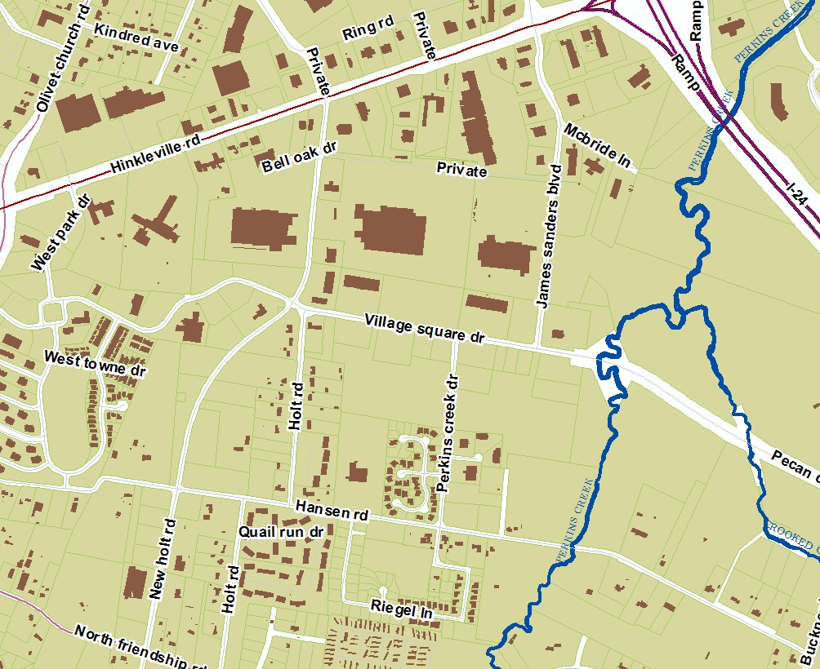

The Paducah Section 8 Housing office has opted to participate in this partnership program with the Veteran's Administration (Marion, Illinois office) to provide housing assistance to area homeless veterans under the HUD- VASH Program.
HUD has legislative and regulatory authority of HUD- VASH vouchers and public housing agencies. Generally, the HUD-VASH program is administered in accordance with regular HCV program requirements (24 CFR, Section 982). However, the 2008 Consolidated Appropriations Act (Public Law 110-161) allows HUD to waive or specify alternative requirements for any provision of any statute or regulation affecting the HCV program to effectively deliver and administer HUD-VASH voucher assistance. The alternative requirements are established in the HUD-VASH Operating Requirements (including the waivers and alternative requirements from HCV program rules), which were published in the Federal Register on May 6, 2008, and updated March 23, 2012. The Operating Requirements can be found here, https://www.gpo.gov/fdsys/pkg/FR-2012-03-23/pdf/2012- 7081.pdf.

The PHA’s local discretionary policies adopted in the PHA’s administrative plan, apply to HUD-VASH Vouchers. If there is a conflict between the program regulations and the agency’s administrative plan, the program regulations have precedence. The City of Paducah Section 8 Housing adheres to HUD Notice FR-5596-N-01, VHA Directive 1162.05(1) and all subsequent HUD notices regarding administration of the HUD-VASH program.
By agreeing to administer HUD-VASH, PHAs are responsible for:
- Accepting Veterans referred by the VA Medical Center only. PHAs do not maintain a separate waiting list for the HUD-VASH program.
  - VA HUD–VASH case managers will refer HUD–VASH-eligible families to the PHA for the issuance of vouchers. The PHA must accept referrals from their VA partner.

  - VA HUD–VASH case managers will screen all families in accordance with VA screening criteria. By agreeing to administer the HUD–VASH program, the PHA is relinquishing its authority to determine the eligibility of families in accordance with regular HCV program rules and PHA policies.

  - The VA-issued photo identification card will also be accepted to verify identification, SSN, and date of birth. The Certificate of Release or Discharge from Active Duty (DD—214) or the VA-verified Application for Health Benefits (10-10EZ) is also acceptable as verification of SSN. Additionally, Paducah Section 8 Housing office accepts as a valid form of income verification for VASH participants the Housing Inquiry statement (HINQ) as provided by our partner VA office.
  - When adding a family member after the HUD–VASH family has been admitted to the program, the rules of § 982.551(h)(2) apply. Other than the birth, adoption, or court- awarded custody of a child, the PHA must approve additional family members and may apply its regular screening criteria in doing so.

- Determining/Verifying income eligibility. If the Veteran is over income, he/she is ineligible for HUD-VASH.
- Completing a background check to insure that the Veteran (or household member) is not a lifetime registered sex offender under a state sex offender registry
  - Specifically, under the HUD–VASH program, PHAs will not have the authority to screen any potentially eligible family members or deny assistance for any grounds permitted under 24 CFR 982.552 (broad denial for violations of HCV program requirements) and 982.553 (specific denial for criminals and alcohol abusers), with one exception: PHAs will still be required to prohibit admission if any member of the household is subject to a lifetime registration requirement under a state sex offender registration program. However, unless the family member that is subject to lifetime registration under a state sex offender registration program is the homeless veteran (which would result in denial of admission for the family), the remaining family members may be served if the family agrees to remove the sex offender from its family composition.

- Conducting briefing sessions and issuing vouchers for all eligible VASH applicants. The initial search term for a HUD-VASH voucher is at least 120 days to search for a unit.
- Providing housing-search resources to HUD-VASH Veterans.
- Assisting with landlord recruitment and housing stock availability.
- Inspecting housing units to insure that HUD-assisted units follow Housing Quality Standards. To expedite the leasing process, PHAs may choose to “pre-inspect” units. If a family selects a unit that passed an NSPIRE/HQS inspection (without intervening occupancy) within 45 days of the date of the Request for Tenancy Approval, the unit may be approved.
- Executing HAP Contracts.
- Making timely housing assistance payments.
- Assisting with the mobility/portability process, whereby a Veteran is using a voucher to lease a unit in another jurisdiction where a PHA operates a Housing Choice Voucher (HCV) program.

- Notifying the HUD-VASH Case Management Team of all upcoming appointments to help guarantee attendance.
- Providing housing-search resources to HUD-VASH Veterans.
- Aiding case managers regarding program rules, local PHA policies written in the agency’s Administrative Plan, including but not limited to procedural guidelines and performance standards for conducting NSPIRE/HQS inspections, revising payment standards, determining rent reasonableness, interim redeterminations informal reviews/hearing procedures (appeals).
- Communicating housing status of Veteran participants to resolve concerns and maintain accurate participant accounting.
- Helping maintain positive relationship with landlords and resolving PHA/HAP related issues.
- Addressing issues with the Veteran following their PHA procedures.
- Communicating the Denial of Assistance notice. If the PHA denies assistance to an HUD- VASH applicant, the PHA must provide:
  - Notification of Termination or Denial of Assistance. If the PHA is denying or terminating assistance the PHA must provide (1) Family obligations of the program; (2) the grounds on which the PHA may deny or terminate assistance because of a family action or failure to act and (3) the informal hearing procedures. A copy of the notification letter should be sent to the VA HUD-VASH case manager. For applicants, the written notification must provide: a brief statement of the reason for denial; and an opportunity for the Veteran to request an informal review.
  - A brief statement of the reason for denial; and
  - An opportunity for the Veteran to request an informal review in accordance with 24 CFR 982.554(a) and (b). A copy of this denial of assistance notice must be sent to a VA HUD-VASH team member.

NOTE: The PHA cannot deny HUD-VASH assistance to a Veteran for any grounds under 24 CFR982.522 and 982.553. Additionally, a PHA cannot refuse to reissue vouchers to Veterans that have been previously terminated from HUD-VASH. The only reasons for denial of assistance by PHA are failure to meet the income eligibility requirements or if any member of the Veteran’s household is subject to a lifetime registration requirement under a state sex-offender registration program, according to HUD’s regulations.

- Ensuring a violation of PHA Rules does not occur. Once a Veteran participant has been issued a voucher, they must follow the usual PHA rules or face possible suspension or termination of their voucher assistance. The PHA must follow their usual procedure in terminating assistance, to include an informal hearing. Case managers are expected to work with the Veteran and PHA to insure that all measures are taken to address options that allow the Veteran to maintain housing. This may include assisting the Veteran with making necessary changes in behavior while advocating for flexibility with the PHA.

- Terminating Assistance. HUD has not established any alternative requirements for termination of assistance for HUD-VASH participants. However, prior to terminating HUD-VASH participants, HUD strongly encourages PHAs to exercise their discretion under 24 CFR 983.552 (c)(2) and consider all relevant circumstances of the specific case, including granting reasonable accommodations for persons with disabilities in accordance with 24 CFR Part 8, as well as including the role of the case manager and the impact that ongoing case management services can have on mitigating the conditions that led to the potential termination, prior to determining whether to terminate assistance.
- Documenting changes in the family.
  - Death of the Veteran. When a Veteran, who is under lease with a HUD-VASH voucher dies, then the family members who are also registered on the voucher and lease are able to continue to utilize the HUD-VASH voucher for as long as they remain otherwise eligible. The PHA is encouraged, though not required, to move the Veteran’s family to a non-HUD- VASH, or “regular,” HCV when one is available. Once the family moves to a regular HCV then the HUD-VASH voucher becomes available for a new Veteran. Case management is not available through this program without the Veteran, but it can be arranged for the family if needed through referral to community or other programs.
  - Separation/Divorce of the Veteran. Since the set-aside of HUD-VASH vouchers is for Veterans, the voucher must remain with the Veteran in case of separation or divorce. This in effect overrides the PHA’s policies on how to determine who remains in the program when a family breaks up (24 CFR Section 982.59(d) (11)).
  - Imprisonment of the Veteran. Veterans who are leasing a unit with their HUD-VASH voucher and are imprisoned may be able to continue to sustain their housing. When the Veteran has been terminated from VA case management, the PHA must terminate HUD- VASH assistance. PHAs may use its discretion under 24 CFR 982.552 (c)(2)(ii) to allow other members of the participant family to continue receiving assistance subject to the condition that the offender will not reside in the unit. The family may retain the HUD-VASH voucher, or the PHA may offer the family a non-VASH voucher to free up the HUD-VASH vouchers for another homeless Veteran. Once the VASH voucher turns over, it must be issued to another homeless Veteran.

- Single Veterans may retain their housing as long as they are not absent from the unit longer than 180 calendar days for continued assistance, and the Veteran’s rent portion continues to be paid to the landlord.
- Veteran families where the Veteran is not expected to return to the family unit may request the PHA to provide them with a regular voucher, if available. The family, already a program participant, would not be subject to a waiting list. However, the PHA determines availability of their regular HCV for the family. If the PHA is not able to move the family to a regular HCV, the family would continue to utilize the HUD-VASH voucher.

- Veterans who have exited HUD-VASH case management and whose voucher was terminated due to excessive lengths of incarceration may be evaluated upon release for readmission to HUD-VASH.
- Veterans who are incarcerated may not receive services from the HUD-VASH team. Consultation with VA’s Veteran Justice Program staff and Fugitive Felon point of contact is recommended.
- Protection for the Victim. When a Veteran’s family member is under lease with a HUD-VASH voucher and is receiving protection as a victim of domestic violence, dating violence, or stalking, and the Veteran is the perpetrator of such violence, the victim must continue to be assisted by PHA.
  - Dating violence, domestic violence, and stalking are violations of family obligations under 24 CFR 982.551(l). Therefore, the perpetrator may be terminated from PHA voucher assistance for committing such acts.
  - Upon termination of a perpetrator’s HUD-VASH voucher due to acts of domestic violence, the victim receiving protection is to be given a regular HCV by PHA, if one is available. If a regular HCV is not available for the victim, the victim continues to utilize the HUD-VASH voucher until another subsidy can be utilized. Case management associated with any remaining household members utilizing this voucher is terminated. The Veteran's victim and family would not be subject to the PHA's voucher waiting list as they are already participants in the voucher program.
  - In the case of the victim utilizing the HUD-VASH voucher, upon release of the voucher by the victim, the HCV must be returned to HUD-VASH for re-issue by PHA to another eligible Veteran family. NOTE: HUD is currently developing guidance that will provide PHAs with further procedures for the implementation of Violence Against Women Act (VAWA) protections under 24 CFR part 5, subpart L.
  - The Veteran perpetrator may continue to be served by the HUD-VASH team, have a new voucher issued, and work towards becoming rehoused as appropriate.
  - Where appropriate referrals need to be made to the health and medical care facility’s local Intimate Partner Violence/Domestic Violence coordinator or point of contact.

Initial term of the Housing Choice Voucher for HUD-VASH participants shall be 120 days, rather than the standard 60 days. The initial lease term may also be less than the standard one-year requirement.
A HUD-VASH participant family’s HCV assistance must be terminated for failure to participate, without good cause, in case management services as verified by the VAMC or CBOC. In such cases, the PHA will offer the family continued HCV assistance through one of its regular vouchers if one is available.

Supported Programs (SP)
The Paducah Section 8 Housing office seeks to support and promote area programs designed to provide coordinated services to residents who are recent victims of domestic violence and/or those who are in pursuit an education by enrolling in a post-secondary educational facility as a full-time student. Any HCV participant in the supported program shall retain their HCV eligibility beyond ending participation in the supported program unless termination of assistance is based upon violation of Family Obligations of the HCV program. Participants that voluntarily withdraw or are terminated with cause under SPs shall not be eligible for application to HCV until two years from last HCV assistance.
Supported Programs currently promoted by the City of Paducah Section 8 Housing:
  - Scholar House of Paducah
  - Merryman House Initiative (domestic violence program)

Family Self-Sufficiency Program
The Paducah Section 8 administers the Family Self-Sufficiency (FSS) Program. The FSS program operates as a voluntary program for eligible Housing Choice Voucher (HCV) participants.

- Participation in the FSS Program is voluntary.
- Eligible HCV families may choose whether to participate without affecting their HCV assistance.
- FSS participants work toward individually established goals designed to promote economic independence and self-sufficiency.
- Participants may receive case management, referrals, supportive services, employment and educational resources, and other assistance consistent with the FSS Program.
- An FSS Contract of Participation and Individual Training and Services Plan will be completed as required for participating families.
- Eligible increases in earned income may result in deposits to their FSS escrow account in accordance with HUD requirements.
- Successful completion of the FSS Program will be determined in accordance with HUD requirements and HCVs approved FSS policies.
- The FSS Program will be administered in accordance with applicable HUD regulations, FSS Action Plan, and established HCV policies and procedures.

Program Objectives
The Program's objectives are listed as follows:
  - Improve coordination of both planning and delivery of services to participants of FSS based on the commitment to make families self-sufficient.
  - Implement a case management system to identify needs, planning, and delivery of services to a FSS family based on the family's commitment to become self-sufficient.
  - Document the implementation of services to be used for future planning of a broader- based FSS Program.
  - Establish interagency partnerships to achieve high quality comprehensive service delivery to all members of a family with long-term results. Assess the accountability of the family, the case management, and the agencies and entities providing service and resources.

Family Objectives
The family's objectives will be to achieve the following:
  - Elevate itself from a status of dependency to that of self-reliance and growth towards the goal of self-sufficiency.
  - Achieve a greater level of self-discipline, self-esteem, and self-motivation by accepting responsibility for decisions and actions.
  - Demonstrate commitment and accountability to a Personal Action Plan, in which both goals and barriers are assessed.

Family Demographics
The City of Paducah Section 8 Program will serve a diverse population in implementing the FSS Program. The Agency does not and will not, under the FSS Program Action Plan, discriminate in its practice or treatment toward any program participant.

Selection Process
The selection of FSS participants will be limited to current Section 8 Housing participants with a selection preference given to JOBS (Job Opportunities and Basic Skills) participants not to exceed 50% of the total FSS slots. Outreach to JOBS participants will be performed through notification and coordination of the local JOBS coordinator and staff.
The Paducah Section 8 Housing office will provide FSS information available by means of notification to all current Section 8 program participants, briefing packets enclosure, media coverage, community, and/or special interest group presentations.
The non-targeted selections will be made by the time and date of the family's expressed interest in participation in FSS.
The selection procedure for FSS participants will be performed without regard to race, color, religion, sex, disability, familiar status, or national origin.

Activities and Support Services
The FSS program will offer the following support services in addition to identified service needs of specific family circumstance:
  - Childcare
  - Transportation
  - Education
  - Employment
  - Personal Welfare
  - Household Skills and Management
  - Counseling (credit, personal, etc.)
  - Other service and resources such as case management
The identification of support needs will be established through case management, self- evaluation, and need assessment. The process of identifying service providers will be done in coordination with the Program Coordinating Committee (PCC) to define and access a broad range of support services.

Incentives
The FSS Program will offer participating families the opportunity to effectively become economically and socially independent of the welfare system through the coordination and provision of services designed to meet the goal of each individual participant.
The Program will also provide for the establishment of an escrow account for any difference of the increase in rent due to earned income in accordance with HUD regulations.

Assurance of Non-Interference
The City of Paducah Section 8 Housing Program hereby assures each family that any admission or right to occupy in accordance to lease provisions will not be affected by a family's participation or nonparticipation in the FSS program.

Termination
The family's Contract of Participation may be terminated for any of the following reasons:
- When the housing agency determines that the head or participating family member(s) has failed to fulfill the terms of the contract and/or any extension, therefore.
  - Withdrawal of the family from the FSS program.
  - Mutual consent of both parties.
  - By such act as it is deemed inconsistent with the purpose of the FSS program.
  - By operation of law.
  - When the family is no longer receiving any federal, state, local or other assistance.

Withholding of Services / Denial
If a Family previously participated in the FSS program and did not meet its obligations and was terminated, the family will be denied participation.
Families that owe the Section 8 program, or another housing agency, money in connection to housing assistance will be denied participation.
Families that are found in noncompliance with the lease that result in lease termination will be denied participation in the FSS program.
Noncompliance with the FSS contract will result in termination of contract.
If a Family fails to meet its obligations or complete goals stated in the contract, services will be denied.

Grievance Procedures
Any decision of the agency to terminate, deny or withhold assistance can be addressed by the participant by utilizing the grievance procedure included in the Administration Plan. Each participant will be informed of their rights and procedures for grievances upon selection to the FSS program.

Timetable for Implementation
The Agency's goal of full implementation of slots will be a period of 90 days from the effective date of the Action Plan.

Certification of Coordination
The Paducah Section 8 Housing office hereby certifies that the development of services and activities have and will be coordinated with the JOBS program and other services related programs to assure that implementation will continue to be coordinated to avoid duplication of services and activities. This will be achieved through the coordinating committee input and services coordinator's program management.

Escrow Withdrawal (early)
FSS participants in good standing shall be eligible to make a one-time withdrawal of escrow funds equal to up to 50% of remaining escrow funds during the contract for the following purposes: to reduce debts in preparation of homeownership certification, to purchase needed transportation if required for employment, to cover moving expenses if needed for employment opportunity or other good cause related to becoming self-sufficient. The Program Administrator will review and approve each written request as submitted by the FSS participant.

Eligibility of graduated FSS participants
Any participant that has graduated and withdrew funds or voluntarily withdrew from the FSS program shall not be eligible to re-apply for FSS until all withdrawn funds are repaid or (2) years from last date of assistance.

HCV Homeownership Program
The City of Paducah Section 8 Housing Choice Voucher Program (also referred to as PHA) hereby establishes a Section 8 tenant-based homeownership option in Paducah/McCracken County, KY pursuant to the U.S. Department of Housing Urban Development (HUD) final rule dated October 12, 2000, and Section 566 of the Quality Housing and Work Responsibility Act of 1998 under Section 8(y), Homeownership Option.
The Paducah Section 8 Housing office hereby establishes a minimum commitment of 50 housing choice vouchers to be utilized as homeownership option vouchers subject to review and adjustment by the City of Paducah Board of Commissioners based upon financial and related considerations.

Participant Qualification
Any Section 8 eligible program participant, Housing Authority of Paducah participant, Habitat for Humanity participant or City of Paducah Planning Department Homebuyer Program applicants, who has been issued a Section 8 housing choice voucher, referred by the Housing Authority, Habitat or the Planning Department may utilize the subsidy for purchase rather than rental of a home, subject to the following:
A family must meet the requirements for admission to or continued participation in the Section 8 Housing Choice Voucher (HCV) Program.
The homeownership option will be included in all briefing and re- certification classes as well as media and community announcements. Current Section 8 participants or public housing participants must follow their lease and program requirements and must terminate their current lease arrangement in compliance with the lease agreement.
A family in which the head or co-head of household has previously received assistance and has defaulted on a mortgage obtained through the Homeownership Option is disqualified from participation.
Participant families must be any of the following: ''first-time homeowners", in which no family member owned any present homeownership interest in a residence of any family member within the last three years; residents of limited equity cooperatives; or a family of which a member is a person with disabilities, and use of the Homeownership Option is needed as a reasonable accommodation. (Title to a mobile home or manufactured home is not considered as homeownership for purposes of this option.)
Participants in the Section 8 Homeownership Option must attend and satisfactorily complete a pre-purchase homeownership counseling program and be deemed to be “mortgage ready" before a homeownership voucher will be issued. Participants are also required to attend and complete post- purchase and ongoing homeownership counseling. At minimum, the counseling will cover the following:
- Home maintenance
- Budgeting and money management
- Credit counseling
- Negotiating the purchase price of a home
- Financing
- Locating the home
- De-concentration issues
- NSPIRE/HQS (housing quality inspection) and independent inspection requirements
The head of household and/or co head must be currently employed on a full-time basis (as defined by HUD to average 30 hours per week) and have been continuously employed during the year before commencement of homeownership assistance. Families in which the head of household or co-head is disabled, or elderly are exempt from this requirement. Families that include a person with disabilities may request an exemption as a reasonable accommodation.
The family's income must be equal to or exceed the HUD minimum. income requirement, currently set at 2000 hours times the Federal minimum wage or $15,080 annually. Welfare assistance will not be considered in meeting the income requirement, except for households in which the head or co-head is elderly or disabled and for households that include a disabled person other than head or co-head.
Applicants may be enrolled in the Family Self-Sufficiency (FSS) Program but are not required to do so to qualify in the program. Funds accumulated in the FSS escrow account may be advanced for purchase of the home, home maintenance, credit clean up or other house purchase related expenses subject to the guidelines of the FSS Program.

Time Frame to Purchase a Home
An applicant will have a maximum of 90 days from the date of issuance of a homeownership voucher to enter into a Purchase Agreement to purchase a home. If an applicant is unable to enter into a Purchase Agreement before the end of the initial 90-day period, the applicant will be provided with an extension of 90 days to enter a Contract for Sale or utilize the voucher for house rental.
Any additional extension will be at the discretion of the Program Administrator.

Portability
Families determined eligible for homeownership assistance may exercise the Homeownership Option outside the PHA's jurisdiction if the receiving PHA is administering an HCV homeownership program and is accepting new families into its program.

Permitted Ownership Arrangements
The Homeownership Option may be utilized for three types of housing:
  - A single-family unit owned by the family, where one or more family members hold title to the home, or a home previously occupied under a lease purchase agreement. Such a unit may be a single-family home, half of a duplex, or single unit within a condominium or multiplex.
  - A cooperative unit, where one or more family members hold membership shares in the cooperative.
  - A manufactured home on a permanent foundation when the family owns the land on which the home sits or if the family does not own the land where the home sits but has the right to occupy the land for at least thirty years.

Contract of Sale and Home Inspections
Participants in the Homeownership Option Program must initially complete a Purchase Agreement with the owner of the property to be purchased.
The Purchase Agreement must include the seller's certification that the seller(s) has not been debarred, suspended, or subject to a limited denial of participation under any federal contract in accordance with 24 CFR part 24.
The Purchase Agreement must include the home's price and other terms of sale, the PHA's pre purchase NSPIRE/HQS inspection requirements (including a provision that the participant will arrange for a pre purchase inspection of the unit as set forth below), a provision that the participant is not obligated to purchase the unit unless the inspection is satisfactory to the purchaser, and an agreement that the purchaser is not obligated to pay for any necessary repairs.
The participant must obtain an independent professional home inspection of the unit's major systems at the participant's expense. A member of the American Society of Home Inspectors (ASHI) or a regular member of the National Association of Home Inspectors (NAHI) must conduct the independent inspection. In all cases the inspection must cover major building systems and components, including foundation and structure, housing interior and exterior, and the roofing, plumbing, electrical and heating systems. The inspector must provide a copy of the inspection report both to the family and to the PHA.
The City of Paducah Section 8 Housing office will conduct a NSPIRE (National Standards for the Physical Inspection of Real Estate) & Housing Quality Standards (HQS) inspection and will review the independent professional inspection of the unit's major systems. The City of Paducah Section 8 Housing office retains the right to disqualify the unit for inclusion in the Homeownership Option based on either the NSPIRE/HQS inspection or the independent professional inspection report.

Financing
Mortgage instruments must meet at least one of the following criteria:
The household is solely responsible for obtaining financing. All loans must meet FHA, or acceptable terms by Fannie Mae, Freddie Mac, reputable secondary markets, or acceptable mortgage insurance credit underwriting requirements. The PHA will review lender qualifications, loan terms, and other family debt and expenses to determine that the debt is affordable and reserves the right to disapprove the loan if it is unaffordable or the terms are considered predatory.
The PHA requires a minimum homeowner down payment of at least 3 percent of the purchase price for participation in its Section 8 Homeownership Option Program and requires that at least two percent (2%) of the purchase price come from the family's personal resources. The PHA will consider waiving or reducing the minimum down payment requirement in cases where the family is using down payment assistance grants or other assistance programs to purchase the unit. Waivers will be granted on a case-by-case basis at the discretion of the Program Administrator.
The PHA prohibits the following:
- Seller financing
- Co-signers not residing in the household.
In the event of an appeal, the Program Administrator will appoint a review panel.

Length and Continuation of Assistance
Section 8 assistance will only be provided for the period that the family is in the occupancy of the home. The maximum term a family may receive homeownership assistance is fifteen years if the initial mortgage incurred to finance purchase of the home is 20 years or longer. In all other cases, the maximum term of assistance is ten years or the length of the actual mortgage if less than 10 years.
Elderly families that qualify as such at the start of homeownership assistance and disabled families that qualify as such at any time during receipt of homeownership assistance are exempt from this time limit. If an elderly or disabled family ceases to qualify as such during homeownership assistance, the maximum term applies from the date the assistance commenced, except that the family will be provided at least 6 months of assistance after the maximum term becomes applicable.

Family Obligations
In addition to completing the pre- and post-purchase homeownership counseling program, the family must execute a statement of family obligations prior to the issuance of the homeownership voucher, agreeing to comply with all family obligations under the Homeownership Option, including:
1) The family must comply with the terms of any mortgage securing debt incurred to purchase the home or any refinancing of such debt.
At any time, the family is receiving homeownership assistance, the family may not sell or transfer any interest in the home to any entity or person other than a member of the assisted family residing in the home.
A home equity loan may not be acquired without the prior written consent of the PHA.
The family must provide required information regarding income and family composition to calculate correctly total tenant payment and homeownership assistance, consistent with Section 8 requirements and any other information requested by the PHA concerning financing, the transfer of any interest in the home, or the family's homeownership expenses.
While receiving homeownership assistance, the family must notify the PHA if the family defaults on a mortgage securing any debt incurred to purchase the home.
While receiving homeownership assistance, the family must notify the PHA before the family moves out of the home.
1) The family must, at annual reexamination, document that the family is current on mortgage, insurance and utility payments.
The family is prohibited from moving more than once in a one (1) year period. The family may be required to participate in pre- and post-purchase homeownership counseling prior to re-housing.
While receiving homeownership assistance, no family member may have any ownership interest in any other residential property.

Assistance Payment
Paducah Section 8 Housing office may provide upon approval by HUD, one of two types of homeownership assistance paid directly to the lender or designee on behalf of the family.
1) Monthly homeownership assistance payment
The family's Section 8 monthly housing assistance payment will be the lower of the Section 8 voucher payment standard minus the Total Tenant Payment or the family's monthly homeowner expenses minus the Total Tenant Payment.
Homeownership expenses include principal and interest on mortgage debt, refinancing charges of mortgage debt, mortgage insurance premiums, real estate taxes and public assessments, home insurance, allowance for maintenance expenses, allowance for major repairs and replacements based on allowance recommended by the PHA 's designees, a utility allowance, and principal and interest on mortgage debt incurred to finance costs for major repairs, replacements or improvements for the home (including expense of reasonable accommodation).
If a family's income increases to a level that they are no longer eligible to receive a housing assistance payment, eligibility for such payments will continue for 180 calendar days. At the end of a continuous period of 180 days without any assistance payments, eligibility for Section 8 assistance will automatically terminate.

Lease-to-Purchase
Lease-to-Purchase agreements are considered rental property and subject to Section 8 tenant-based assistance rules. All regulations of the Homeownership Program will become effective at the time that the family exercises the option to utilize the homeownership voucher.

Default
If the family defaults on the home mortgage loan, the participant will not be able to utilize the Homeownership Voucher for rental assistance but may reapply to the Section 8 waiting list.

Recapture
The PHA will not recapture the Homeownership Voucher payments unless there was an act of fraud or misrepresentation of a material fact to obtain a benefit. The HCV Homeownership recapture provision does not apply to any other program funds that may be used in the transaction.

Denial or Termination of Assistance
The PHA reserves the right to deny or terminate assistance to the family, and will deny homeownership assistance to the family, in accordance with HUD regulations governing any failure to comply with family obligation, mortgage default or failure to demonstrate that the family has conveyed title to the home as required, or the family has moved from the home within the period established or approved.

Informal Hearings
An informal hearing will be offered for participants who are being terminated from the Program because of the family's action or failure to act as provided in 24 CFR 982.552. The rules and procedures are set forth in the Section 8 Administrative Plan, entitled "Grievance Procedures".

Occupancy Standards
The PHA will determine the occupancy standard applicable to each homeownership family to be utilized in the issuance of the payment standard size for lease-to-own calculations and mortgage calculations by consideration of the following:
- size or anticipated size of family
- provision of a valued and salable asset
- analysis of local marketable units
- availability of necessary funding
It is the objective of the PHA to provide the homeowner with the opportunity to purchase local marketable units. In some cases, the homeowner would only qualify (under the regular Voucher Program occupancy standards) for a payment standard that would limit the size of the unit purchased. Under the HCV homeownership program, an analysis will be done on the local market to insure that the homeowner is provided adequate assistance to purchase a valued and salable property which in some cases will equate to adjusting the payment standard size above the occupancy standard of the regular voucher program.

Non-Routine Maintenance/Replacement Reserve
The Paducah Section 8 Housing office will encourage a non-routine maintenance and replacement reserve account for each homebuyer receiving home ownership assistance under the Section 8 Homeownership Program. The account shall be maintained by either the Kentucky Housing Corporation or mortgage company/designee for the benefit of the individual homeowner.
The reserve accounts will insure that the homebuyer has sufficient funds on hand for major repairs and systems replacement.
Each home buyer receiving homeownership assistance with a reserve account option will be required to deposit (minimum) $50.00 monthly to an escrow account to be used to pay for reasonable and non-routine maintenance or repair expenses, or systems replacement, and in the case of a disabled household, the cost of modification of a unit necessary as a reasonable accommodation. Families may access the account with a written request to PSS, which will include the nature of the repair or replacement, bids or estimates, or actual receipts for work that has already been completed. The PHA will make the final determination on approval of account withdrawals and shall submit a request to servicing agent for release of funds.

Participation in the monthly non-routine maintenance/replacement reserve escrow program is required (unless otherwise not offered by a mortgage company or designee) by all participants receiving Section 8 Homeownership assistance from the City of Paducah Section 8 Housing Program after May 1, 2008. Participation by pre-existing homeowners receiving Section 8 Homeownership assistance will be by voluntary written agreement by existing homeowner and will be subject to all provisions under mandatory requirement. The length of individual participation is based on the length of assistance provided by the PHA. After completion of a ten (10) year term of home ownership assistance and obligation, the family may make a written request for the remaining escrow account balance or request it be applied toward the principle balance of their mortgage.
Withdrawal of the funds will be contingent on:
- Good standing with homeownership program and mortgage obligations.
- The expense being approved by the PHA. Such expenses are for the replacement of the heating system, air conditioning, water heater, refrigerator, appliances (funds cannot be used to purchase the initial appliance), and home repairs (not including decorations). It may not be used for additions to the unit or for decorative landscaping.

Disbursements
In order to access maintenance/replacement reserve funds, a written request must be submitted to the PHA stating the estimate of cost and purpose the funds will be used.

Homeownership Option 10 Year Asset Exclusion
Federal Regulations 24 CFR 5.603 (b) Net Family Assets exempts the home purchased with voucher assistance from being counted as an asset for the first 10 years after closing. The PHA will utilize the following method in calculating home value assets after the initial I0 year exemption exclusion:

Market Value minus Loan Value equals Asset Value
Market Value will be obtained by utilizing the assessed value of property as provided by the McCracken County Property Evaluation Office and reduced (adjusted) by 10% (estimated cost of expense to convert to cash)
Loan Value will be determined by the amount obtained from mortgage company to pay-off loan in full effective on re-certification date or other designated date, if pay-off amount is unobtainable, mortgage balance on re-certification date or other designated date will be utilized as loan value.
The PHA shall apply updated rules for assets under/over $50,000 and assets disposed of below market value. The PHA will include anticipated earnings using specified HUD formulas

Project-Based Voucher Program
The City of Paducah Section 8 Housing Program (PHA) hereby creates a project-based housing program (PBV) to achieve the following goals; to expand the affordable housing stock, to increase the affordability of housing currently not affordable to households below 30% of the area median income and to support supported housing programs. The maximum number of PBV units shall not exceed twenty percent of the total number of ACC authorized HCV units of rental assistance at any time (110 units maximum). The PHA shall enter into contracts for PBV assistance based on the rules stated below and HUD regulations published in Federal Register 24 CRF Part 983 including all subsequent corrections and amendments.

Project Selection Criteria
The PHA will consider the following project selection criteria in evaluating proposals to project base housing choice vouchers:
  - Housing that serves homeless households;
  - Housing that serves households with special needs such as people with mental and/or developmental disabilities, people with physical and/or sensory disabilities and other special needs as described by the entity;
  - Housing that reduces concentrations of poverty;
  - Housing that provides opportunities to increase the diversity of neighborhoods;
  - Housing that combines an appropriate level of support services to residents;
  - Housing that provides opportunities for economic self-sufficiency; and
  - Housing that maximizes the use of other funding sources and leverages the use of PHA funds.

Project Selection
- The Paducah Section 8 Housing office may solicit proposals by using a Request for Proposals (RFP) to select proposals on a competitive basis in response to the PHA request. The RFP will be published as required, inviting proposals of projects that seek the commitment of project-based vouchers that meet the goals of the PHA selection criteria. Specific project selection will be performed by a PHA designated evaluation panel utilizing a weighted selection scored according to the applicable factors listed in the selection criteria.
- The Paducah Section 8 Housing office may select proposals that were previously selected based on a competition. This may include selection of a proposal for housing assisted under a federal, state, or local government housing assistance program that was subject to a competition in accordance with the requirements of the applicable program, community development program, or supportive services program that requires competitive selection of proposals (e.g., HOME, and units for which competitively awarded LIHTCs have been provided), where the proposal has been selected in accordance with such program's competitive selection requirements within three years of the PBV proposal selection date, and the earlier competitive selection proposal did not involve any consideration that the project would receive PBV assistance. The PHA need not conduct another competition.
All projects awarded project-based Section 8 subsidy must be developed and operated in a manner consistent with HUD regulations. Project based commi1ments are subject to the availability of adequate federal funding of the PHA Section 8 Housing Choice Voucher Program.

Operation of Project-Based Properties
The PBV program shall operate the same as the regular tenant based vouchers with the following exceptions:

Project-Based Waiting List
The Paducah Section 8 Housing office shall use a separate waiting list for admission to the PBV program. All PBV applications will be maintained according to the same selection criteria as the regular program. If an applicant refuses an offer of assistance for PBV, the applicant will be transferred to the regular waiting list as of their original application date.

Moves with Continued Assistance
Participants that are assisted under the PBV program may move from the assisted project and retain housing choice voucher assistance if the assisted family has occupied the unit under PBV for at least 12months and has given proper notice to vacate.

PBV Program Contract Terms
The contract term shall be negotiated for each project based on the project’s needs, not to exceed 10 years.
Except for units designated for families that are elderly, disabled or receiving supported services, no more than 25% of the project may have PBV assistance.
PBV unit gross rents may not exceed the locally adopted payments standards.
No vacancy loss payments shall be made by the Paducah Section 8 Housing office if the participant vacates the unit.
All units must be inspected by the Paducah Section 8 Housing office for NSPIRE(National Standards for the Physical Inspection of Real Estate) & Housing Quality Standard (HQS) compliance and each unit shall be re-inspected annually.
All contracts are subject to availability of adequate funds.

* * * * *

Part VII. ADMINISTRATION & EVALUATION

Responsibilities of the Paducah Section 8 Housing office
  - Publication and dissemination of information concerning the availability and nature of housing assistance for eligible families.
  - Public invitation of owners to make dwelling units available for leasing by eligible families and development of working relationships and contracts with landlords and appropriate associations and groups.
  - Receipt and review of applications for vouchers, verification of family income, and other factors relating to eligibility and amount of assistance and maintenance of a waiting list.
  - Issuance of vouchers.
  - Notification of families determined to be ineligible.
  - Provision of each voucher holder of basic information on applicable Housing Quality Standards and inspection procedures, search for and selection of housing, owner and tenant responsibilities, and basic rules.
  - Determination of the amount of the total tenant payment and tenant rent.
  - Determination of the amounts of housing assistance payments.
  - Explanation of program procedures to owners, including those who have been approached by voucher holders.
  - Review of and action on requests for lease approval, including monitoring to assure that the limitations on use of Section 8 Housing Assistance in subsidized projects are observed.
  - Making housing assistance payments.
  - Provision of housing information to assisted families and referral of such families to appropriate social service agencies upon request.
  - Re-examination of family income, composition, and extent of exceptional health and medical care or other unusual expenses, and redetermination, appropriate, of the amount of gross family contributions and amount of housing assistance payment in accordance with HUD established schedules and criteria.
  - Adjustment of the amount of tenant rent, utility reimbursement and housing assistance payment because of an adjustment by the PHA of any applicable utility allowance.
  - Inspection prior to leasing and inspection; inspections at least annually determine that the units are maintained in decent, safe, and sanitary condition, and notification to owners and families of PHA determinations.
  - Administration and enforcement of contracts with owners and taking appropriate actions in case of noncompliance or default.
  - Compliance by the Paducah Section 8 Housing office with equal opportunity requirements, including efforts to provide composition, increase or decreases in health and medical care (elderly) or childcare expenses, increases or decreases in family income during each contract year as they occur.

Program Management
Effective July 1, 2025, the Paducah Section 8 Housing Choice Voucher (HCV) Program was merged with the Housing Authority of Paducah (HAP). The HCV Program is administered by the Housing Authority of Paducah in accordance with applicable HUD regulations, including 24 CFR Part 982, the HAP HCV Administrative Plan, HUD notices, and other applicable federal requirements.

The Housing Authority of Paducah provides management, oversight, training, quality control, compliance monitoring, and administrative support for the HCV Program. Required HUD reporting and program submissions shall be completed accurately and timely.

HCV Department Staffing

The HCV Department consists of three employees. Overall agency oversight is provided by the Executive Director. Day-to-day HCV program administration is managed by the Housing Manager.

Executive Director – Program Oversight
- Provides executive oversight of the HCV Program.
- Ensures compliance with HUD regulations and HAP policies.
- Oversee program performance, financial accountability, and regulatory compliance.
- Ensures appropriate internal controls and quality-control procedures are maintained.
- Provides directions to the Housing Manager regarding HCV operations and agency priorities.
- Ensures required HUD reports, certifications, plans, and submissions are completed.
- Oversee portability requests and processing.
- Oversees HUD-VASH and other applicable special-purpose vouchers.
- Reports significant HCV matters and program performance to the HAP Board of Commissioners.
- Oversee the HCV Homeownership Program and Family Self-Sufficiency (FSS) Program, as applicable.
- Oversees informal reviews and informal hearings.
- Oversees SEMAP compliance and quality-control reviews.
- Monitors voucher utilization, leasing, HAP expenditures, and program performance.
- Ensure HUD systems and required program reporting are completed accurately and timely.
- Coordinates audit, monitoring, and HUD review responses.
- Maintains and recommends revisions to the HCV Administrative Plan.
Section 8 Housing Manager
- Provides day-to-day management and supervision of the HCV Department.
- Supervises Housing Specialists and inspection activities.
- Oversee applications, eligibility determinations, admissions, and voucher issuance.
- Oversee annual and interim reexaminations.
- Oversees income, asset, deduction, rent, utility allowance, and HAP calculations.
- Oversees participant briefings and ensures required information is provided to families.
- Oversees waiting-list administration and applicant processing.
- Oversees landlord participation and owner documentation.
- Oversees move-ins, transfers, moves, and terminations.
- Oversee reasonable accommodation requests in coordination with appropriate HAP staff.
- Issues vouchers and processes requests for tenancy approval.
- Oversee fraud, unreported income, and program-integrity matters.
- Ensure the rent to the owner does not exceed rents charged for comparable unassisted units, as required by HUD regulations.
- Oversees and schedules HCV inspections and ensures compliance with current HUD inspection requirements.
- Monitors failed inspections, required corrections, abatements, and enforcement actions.
- Coordinates inspection results including abatement or other action when required.
- Coordinates FMR, payment standard, and utility allowance reviews and updates.
- Processes repayment agreements and program-integrity matter as assigned.
- Monitors move-ins, transfers, move-outs, and portability transactions for accuracy.
- Prepares and issues required notices and determination letters.
- Processes change in family composition and income.
- Conducts applicant and participant briefings.
- Monitors participant compliance with family obligations.
- Performs other HCV program duties assigned by the Executive Director.
Housing Specialist(s)
- Processes applications and determines program eligibility.
- Assist with the completion of annual and interim reexaminations.
- Verifies income, assets, deductions, and family composition.
- Uses EIV and other HUD-approved verification systems as required.
- Calculating Total Tenant Payment, family rent, utility reimbursement, and Housing Assistance Payments.
- Maintains participant and landlord records.
- Assist with reasonable accommodation requests and supporting documentation.
- Assists with HUD-VASH, Homeownership, FSS, and other special programs as assigned.
- Schedules for HCV inspections.
- Assist with processing move-ins, transfers, move-outs, and portability transactions.
- Maintains complete and accurate electronic and/or physical participant files.
- Assists with audits, quality-control reviews, SEMAP, and HUD monitoring.
- Prepares required reports and program documentation.
- Performs other HCV duties assigned by the Housing Manager.
Inspector
Inspection Responsibilities
- Schedules and performs HCV inspections in accordance with applicable HUD inspection standards.
- Documents inspection results and identified deficiencies.
- Inspects units for compliance with HUD requirements.
- Communicates deficiencies and correction requirements to owners and participants.
- Conducts initial, periodic, special, complaint, and quality-control inspections as assigned.
- Performs HCV inspections in accordance with applicable HUD inspection standards.
- Identifies deficiencies requiring expedited or emergency correction.
- Conducts require follow-up inspections or verify acceptable documentation of completed repairs when permitted.
- Maintains inspection records and supporting documentation.
Rent Reasonableness Responsibilities
- Conducts and documents rent reasonableness determinations in accordance with HUD requirements and the HCV Administrative Plan.
- Obtains and evaluates comparable unassisted units when determining whether the proposed rent is reasonable.
- Completes rent reasonableness determinations before initial lease-up and whenever otherwise required by HUD, including applicable owner-requested rent increases.
- Coordinates inspection and rent reasonableness results with HCV staff before HAP approval and execution of required HCV documents.
- Maintains inspection reports, rent reasonableness documentation, photographs, and other required supporting records.

Board of Directors – Beginning 07/01/2025 the Paducah Section 8 Housing Program will be merged with the Housing Authority of Paducah and effectively be under the leadership of the Housing Authorities Executive Director and Board of Commissioners who is appointed by the Mayor of Paducah.

Outreach
It shall be the policy of the Paducah Section 8 Housing office to aggressively promote the Section 8 Housing Choice Voucher, Family Self-Sufficiency (FSS) and Homeownership Option through public service announcements, brochures, local radio, and advertising in the local daily and weekly newspapers. In addition, all public service agencies in the Paducah area will receive information circulars describing these programs and who may receive benefits. Informational materials will be circulated among local Realtors, private rental property owners, and rental property managers for the purpose of soliciting participation. If additional listings are needed, staff members may go into the community to meet one-on-one with citizens or groups for the purpose of outreach.
The Paducah Section 8 office will actively promote the availability of housing assistance to eligible applicants by contact with local media, brochures, and community organizations. To target the "least likely to apply'' applicants, the Paducah Section 8 office will provide flyers and brochures to be distributed through places of employment, union offices, neighborhood groups, churches, and commercial establishments if there is a need for outreach demonstrated by our application pool.

Briefing Families, Issuing Housing Choice Vouchers
- This PHA will provide brochures to each family, however, we believe it will be necessary to give individual instructions (small groups when possible), in order that the program may be properly explained. The staff will be available to discuss housing search problems during the introductory search period.
- Briefing documents to be included in each participant packet are as follows:
HOUSING CHOICE VOUCHER PACKET
- Housing Utility Allowance
- Request for Lease Approval
- Required and Prohibited Lease Provisions
- Lead Based Paint Information
- Fair Housing Information and Complaint Form
- Housing Assistance Payment Information
- Informal Hearing Information
- NSPIRE/HQS Information
- Federal Privacy Act Statement
- Statement of Family Responsibilities
- Security Deposit Information
- A Guide to Housing Vouchers
- Housing Voucher
- EIV Applicant/Participant Information
- VAWA/Emergency Transfer
- Portability

Administrative Fee Reserve Expenditures
All expenditures from the administrative reserve of the Section 8 programs shall be housing related and shall be approved by the Housing Authority of Paducah Board of Commissioners.

Monitoring Program Performance & De Minimis Errors
The Program Administrator will monitor and perform quality control audits on waiting list selection, rent reasonableness, adjusted income determination, NSPIRE/HQS enforcement, and NSPIRE/HQS quality control as required.

De minimis errors occur when the Agency’s determination of a family’s income deviates from the correct income determination by no more than $30 per month in monthly adjusted income (or $360 in annual adjusted income). HUD may revise the amount of de minimis error through rulemaking.

Once the Agency becomes aware of the existence of an income calculation error, the error(s) will be corrected retroactive to the effective date of the action resulting in an error regardless of the dollar amount associated with the error. Families will not be required to repay the Agency in instances where the Agency miscalculated income resulting in a family being undercharged for rent. Once the Agency becomes aware of the error the family will be provided with a 30-day notice of the increase to their rent portion. The Agency will take corrective action to credit or repay a family if the family was overcharged tenant rent, including di minimis errors, in the income determination. In the case of public housing residents, the Agency will provide an immediate rent credit. If the amount of the credit would be more than the charges due in the next 30 days, the Agency will provide payment to the family within 30 days of becoming aware of the error.

Purged Files
All participant files purged by this Agency will retain the original application made by the family and will include the previous one-year re-examination documentation and leasing contracts.

Fair Housing Policy and Equal Opportunity Housing Plan
Fair Housing Policy: The Fair Housing Policy of the Paducah Section 8 Housing office is to comply fully with all Federal, State, and local nondiscrimination laws and in accordance with the rules and regulations governing Fair Housing and Equal Opportunity in housing and employment and with the Americans with Disabilities Act. Specifically, the PHA shall not based on race, color, religion, sex, handicap, familial status, and national origin, deny any family or individual the opportunity to apply for or receive assistance under HUD's Section 8 Programs, within the requirements and regulations of HUD and other regulatory authorities. To further its commitment to full compliance with applicable Civil Rights laws, the PHA will provide access to information to Section 8 participants regarding "discrimination". Also, this subject will be discussed during the briefing session and any complaints will be documented and made part of the applicants/participant’s file.
For families and/or individuals who report apparent discrimination in obtaining assisted housing, the Paducah Section 8 Housing office shall assist them by providing the family/individual with a HUD Housing Discrimination Complaint Form, HUD - 903. The individual can complete this form and report apparent discrimination to the Louisville HUB Office of Fair Housing and Equal Opportunity. For example, a resident may be trying to obtain other rental housing and/or is attempting to purchase a home and experiences apparent discrimination.
Equal Opportunity Housing Plan: The PHA is a participant in the tenant-based program and is required to comply with equal opportunity requirements imposed by contract or federal law (Ref: 24 CFR 982.S4). This includes applicable requirements under:
- The Fair Housing Act, 42 U. S. C. 3610-3619 (implementing regulations at 24 CFR parts 100, et seq.);
- Title VI of the Civil Rights Act of 1964, 42 U.S. C. 2000d (implementing regulations at 24 CFR part l);
- The Age Discrimination Act of 1975, 42 U. S. C. 6101-6107 (implementing regulations at 24 CFR, part 146);
- Executive Order 11063, Equal Opportunity in Housing (1962), as amended, Executive Order 12259, 46 FR1253 (1980), as amended, Executive Order 12892, 59FR 2939 (1994) (implementing regulations at 24 CFR, part 107);
- Section 504 of the Rehabilitation Act of 1973, 29 U.S. C. 794 (implementing regulations at 24 CFR, part 8; and
- Title II of the Americans with Disabilities Act, 42 U.S. C.12101, et seq.

Equal Opportunity Posting Requirements:
There shall be maintained in the PHA's office waiting room a bulletin board, which will accommodate the following posted materials:
- Statement of Policies and Procedures Governing the Section 8 Administrative Plan.
- Open Occupancy Notice (Applications being Accepted and/or Not Accepted)
- Income Limits for Admission.
- Utility Allowances.
- Informal Review and Hearing Procedure.
- Fair Housing Poster.
- "Equal Opportunity in Employment" Poster.

Limited English Proficient (LEP) Policy
It is a policy of the City of Paducah Section 8 Housing Program (PHA) to take reasonable steps to insure meaningful access to PHA programs and activities by limited English proficient (LEP) persons, taking into account the proportion of LEP persons in the eligible service population, the frequency with which LEP individuals come in contact with the program, the nature and importance of the service provided by the program, and the available resources.
In all housing programs it provides, PHA complies with applicable federal and state law, including, without limitation:
Title VI of Civil Rights Act of 1964 and the implementing regulations at 24 CFR part 1, ''Nondiscrimination in Federally Assisted Programs of the Department of Housing and Urban Development-Effectuation of Title VI of the Civil Rights Act of 1964''; Executive Order 13166.
In addition, PHA complies with the related rules, regulations and procedures prescribed under the above-mentioned federal and state law.
Definition of LEP Person
Persons who do not speak English as their primary language and who have a limited ability to read, write, speak, or understand English can be LEP.
Identifying LEP Individuals who Need Language Assistance
PHA shall take reasonable steps to identify LEP persons served or encountered using the following methods:
- Using the Census Bureau "I speak" cards to invite LEP persons to identify their language needs to staff;
- Posting notices in PHA office listing commonly encountered languages and notifying LEP persons of available language assistance;
- Requesting applicants and participants to list their primary language and need for interpreter on applications and eligibility statements;
- Tracking the LEP information electronically;
Language Assistance Measure
Types of Language Services Available
PHA shall take reasonable steps to provide oral and written language services as described in this section. In determining what language services should be provided, PHA shall consider the following factors:
- The number or Proportion of LEP Persons Served or Encountered in the Eligible Service Population
PHA shall examine its prior experiences with LEP encounters to determine the breadth and scope of language services needed. PHA shall also consult other data to refine or validate its prior experience, including the latest census data for the area served.
- The Frequency with which LEP individuals encounter the Program
PHA shall take reasonable steps to assess, as accurately as possible, the frequency of contact with LEP persons from different language groups. The more frequent the contact with a particular language group, the more likely that enhanced language services in that language are needed. Less frequent contact with different language groups may suggest a different and less intensified solution.
The Nature and Importance of the Program, Activity, or Service provided by the Program.
The more important the activity, information, service, or program, or the greater the possible consequences of the contact to the LEP persons, the more likely language services may be needed.
The Resources Available to PHA and Costs
While it is PHA's policy to take reasonable steps to provide meaningful access to PHA programs and activities by LEP persons, the availability of resources may limit the provision of language services in some instances "Reasonable steps" may cease to be reasonable where the costs imposed substantially exceed the benefits. PHA shall explore the most cost-effective means of delivering competent and accurate language services before limiting services due to resource concerns.
Oral Language Services (Interpretation)
PHA shall use contract interpreters and bilingual PHA or City of Paducah staff to provide the services. Where LEP persons so desire, they can use, at their own expense, an adult interpreter of their own choosing (whether a professional interpreter, family member, or friend) in place of or as a supplement to the free language services offered by PHA. PHA may, at its discretion, choose to provide their own Interpreter in addition to the one used by the family.
PHA shall take reasonable steps to insure competency of the language service provider. When providing oral language assistance, PHA shall use the following general criteria to insure effective communication with LEP persons:
- Demonstrated proficiency in and ability to communicate information accurately in both English and in the other language and identify and employ the appropriate mode of interpreting;
- Knowledge in both languages of any specialized terms or concepts peculiar to PHA's program or activity and of any vocabulary and phraseology used by the LEP person;
- Understanding of and following confidentiality and impartiality rules;
- Awareness of “regionalisms" used by the LEP person;
- Understanding of and adherence to their role as interpreters without deviating into a role as counselor, legal advisor, or other roles.
When interpretation is needed and is reasonable, it shall be provided in a timely manner to avoid the effective denial of a benefit or service. Where access to or exercise of a benefit or service is not effectively precluded by a reasonable delay, the language assistance may be reasonably delayed.
Written Language Services (Translation)
PHA shall take reasonable steps to provide written translations of vital documents that list program rules and instructions for each eligible LEP language group that constitutes 5% or 28 persons, whichever is less, of program applicants/participants. Whether or not a document (or information it solicits) is vital may depend upon the importance of the program, information, encounter, or service involved, and the consequence to the LEP person if the information in question is not provided accurately or in a timely manner. For example, applications for certain recreational activities would not generally be considered vital documents, whereas applications for housing could be considered vital.
All documents that require action from an applicant or participant should include a statement in the languages of eligible groups reading "Important information about your housing. If you need assistance, please contact us immediately." PHA shall take reasonable steps to provide oral interpretation of other documents, if needed.
For all documents available in the languages of eligible groups, the English version of the documents shall include a statement on the bottom in the languages of eligible groups reading "This form is available in (language) upon request."
For LEP language groups that constitute less than of program applicants, participants, or residents, PHA will not translate written materials, but shall take reasonable steps to provide oral interpretation of the written materials upon request.
As with oral interpreters, PHA will take reasonable steps to insure competency of translators of written documents. Where legal or other vital documents are involved, PHA shall make a reasonable effort to use certified translators.
Telephone Services
When calls are received by an LEP applicant, participant, or resident, PHA staff will make every effort to determine the language being spoken by the caller. Calls will be forwarded to PHA or City staff who speak the same language as the caller for assistance. If PHA or City staff is not available at the time of the call, the caller will be requested to call back when an interpreter can be available. An interpreter will be secured within a reasonable time frame.
On-Site Visitation
When an LEP applicant, participant or resident comes to the PHA office, PHA staff will make every effort to determine the language being spoken by the caller by using the "I Speak" cards. If PHA or City staff who speak the language are available to assist the applicant, participant, or resident, they will do so, either in person or via telephone. If PHA or City staff are not available at the time of the visit, the person will be requested to come back when an interpreter can be available. An interpreter will be secured within a reasonable time frame.
Written Communications
Correspondence received in languages other than English will be translated by PHA or City staff who speak the language, where available, or by PHA's contracted translation agency. Responses will be translated into the same language as the letter that was received.
Training Staff
PHA will insure that staff knows the obligation to provide meaningful access to information and services to LEP persons. PHA will provide training to insure that:
- Staff is competent on LEP policies and procedures; and
- Staff having contact with the public are trained to work effectively with interpreters. The training will be included as a part of departmental orientation for new employees.
Staff will be provided with listing of forms available in languages other than English and with a list of bilingual City staff.
Providing Notice to LEP Persons
PHA shall provide a notice to LEP persons of the availability of free language assistance that insures meaningful access to PHA's programs and services. Examples of notification may include:
- Posting signs in common areas, offices, and anywhere applications are taken. The signs shall be translated into the most common languages encountered;
- Stating in outreach documents that language services are available. These statements shall be translated into the most common languages encountered;
- Working with grassroots and faith-based community organizations and other stakeholders to inform LEP persons of PHA's services, including the availability of language assistance services;
Monitoring and Updating LEP Plan
PHA will monitor the implementation of the LEP plan on an ongoing basis to determine whether new documents, programs, services, and activities need to be made accessible for LEP persons. In addition, PHA will review its LEP plan annually to evaluate the following information:
- Proportion of LEP persons in the eligible service population;
- Frequency of encounters with LEP language groups;
- Nature and importance of activities to LEP persons;
- Availability of resources;
- Whether existing language assistance meets the needs of LEP persons;
- Whether staff knows and understands LEP plan and its implementation.
SEE Appendix C page

Reduction of Families Due to Reduced Funding
In the event of a reduction of federal funding, the PHA will utilize a family reduction plan as follows:
- Terminate HAP contracts for families that are receiving the least rental assistance not to exceed 5% of total families assisted, if reduction is not adequate;
- Terminate HAP contracts for families based upon the most recent executed rental agreements to the extent that remedies reduction forecast.
- All terminated families due to reduced funding will be offered preference placement on a waiting list to be re-assisted when adequate funding exists.

* * * * *

Part VIII. MANAGEMENT ASSESSMENT OBJECTIVES
The Paducah Section 8 Housing office policies and practices are consistent with the areas of measurement for the following HUD SEMAP indicators.
  - Selection from the Waiting List
  - Reasonable Rent
  - Determination of Adjusted Income
  - Utility Allowance Schedule
  - NSPIRE/HQS Quality Control Inspections
  - NSPIRE/HQS Enforcement
  - Expanding Housing Opportunities
  - FMR/exception rent & Payment Standards
  - Annual Re-examinations
  - Correct Tenant Rent Calculations
  - Pre-Contract NSPIRE/HQS Inspections
  - Annual NSPIRE/HQS Inspections
  - Lease-up
  - Family Self-Sufficiency Enrollment and Escrow Account Balances
A qualified person will perform supervisory quality control reviews on the following SEMAP indicators:
  - Selection from the waiting list
  - Rent reasonableness
  - Determination of adjusted income
  - NSPIRE/HQS Enforcement
  - NSPIRE/HQS Quality Control
  - Annual Re-examinations
  - Correct Tenant Rent Calculations
  - Pre-Contract NSPIRE/HQS Inspections
The annual sample of files and records will be drawn in an unbiased manner that is documented.
The minimum sample size to be reviewed for each SEMAP indicator is provided in 24 CFR Part 985 and will relate directly to each factor.

******

APPENDIX: 2027 Fair Market Rents and 2026 Income Limits

2027 Fair Market Rents
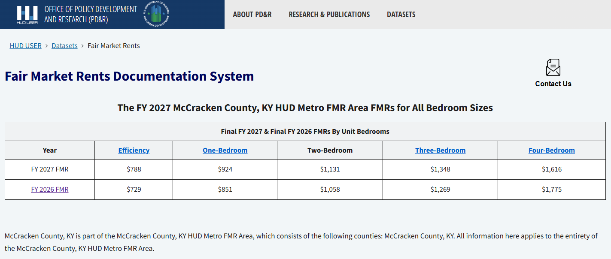

2026 Income Limits
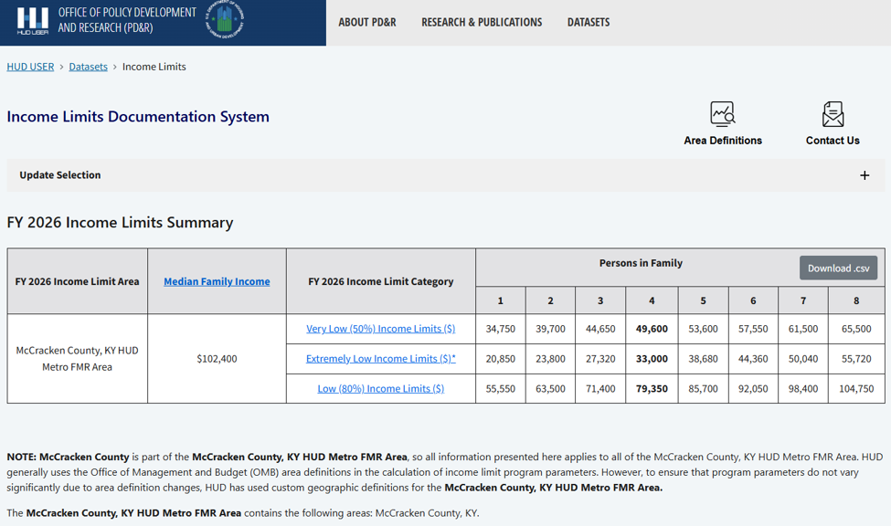

APPENDIX: 2026 Utility Allowances

Single-family / Manufactured Home

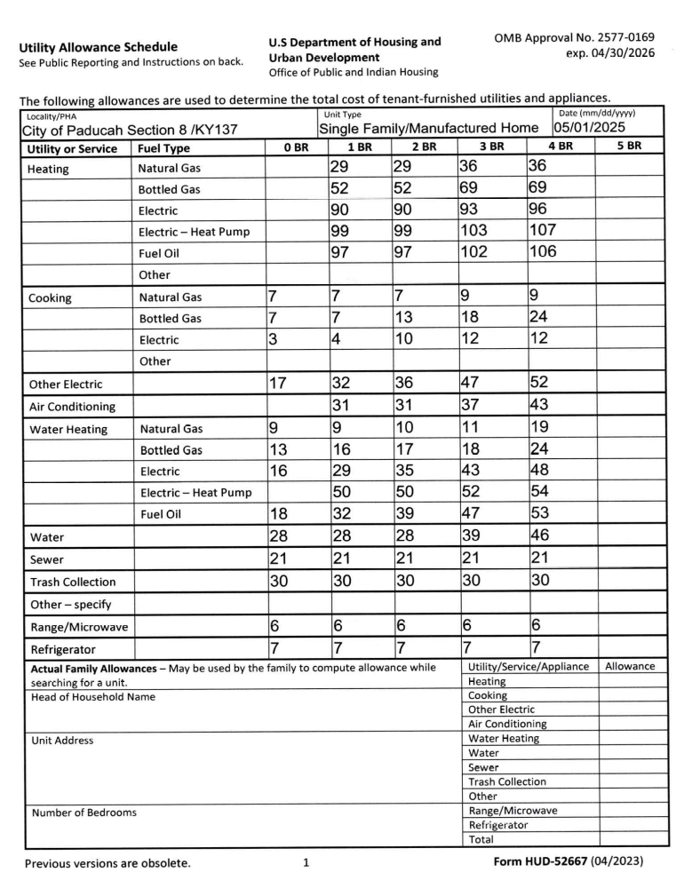

Walk-up / multi-family

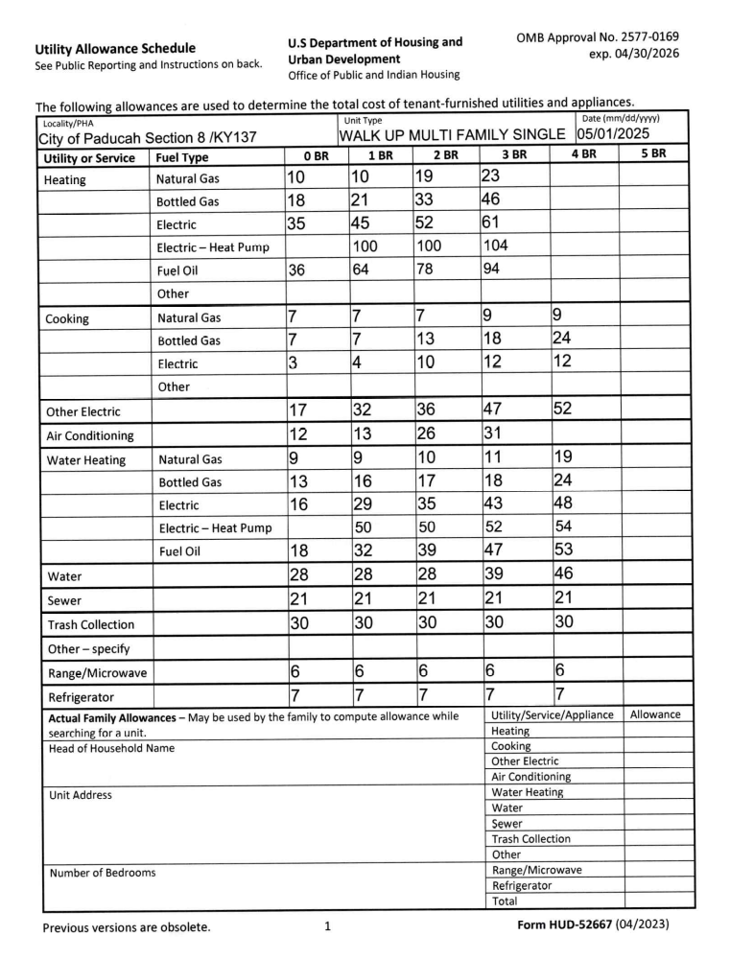

Duplex / Townhouse
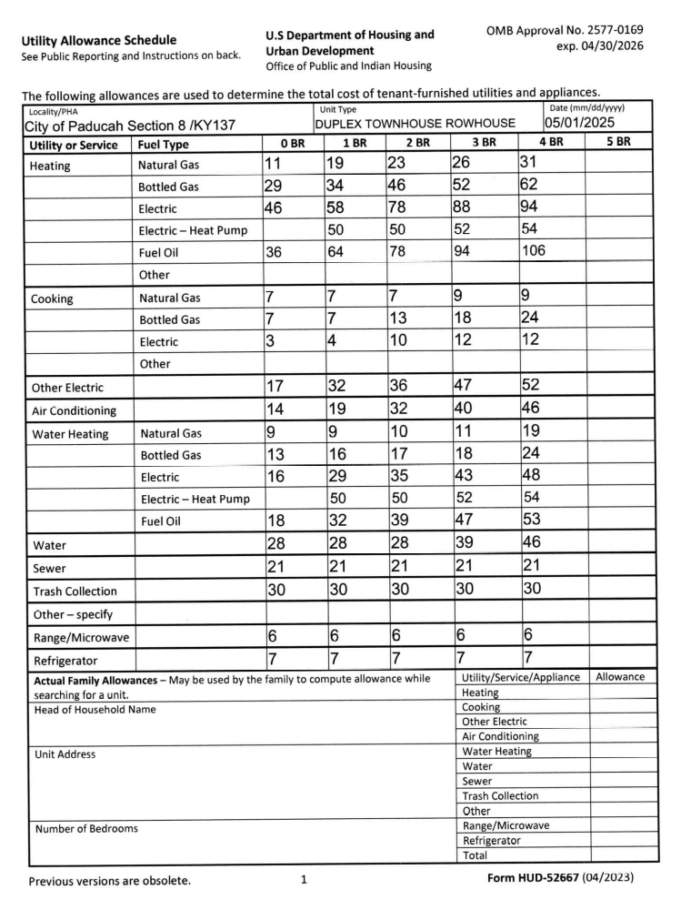

APPENDIX: VAWA Emergency Transfer Plan
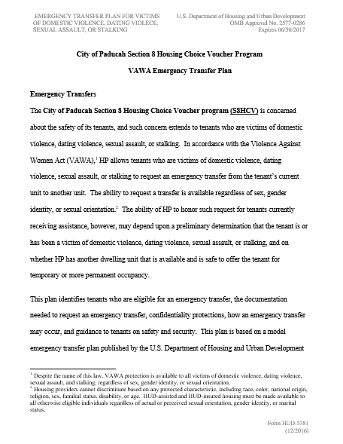

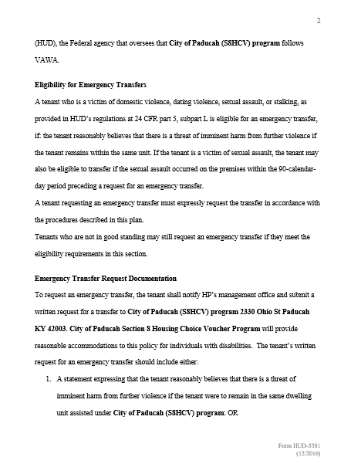
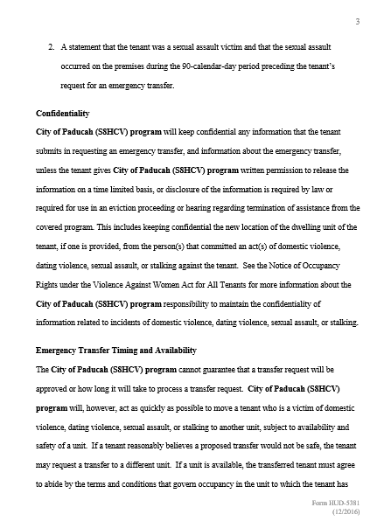

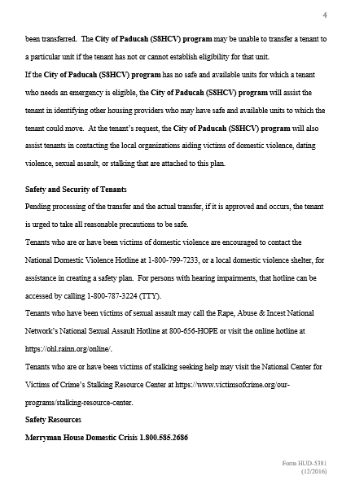

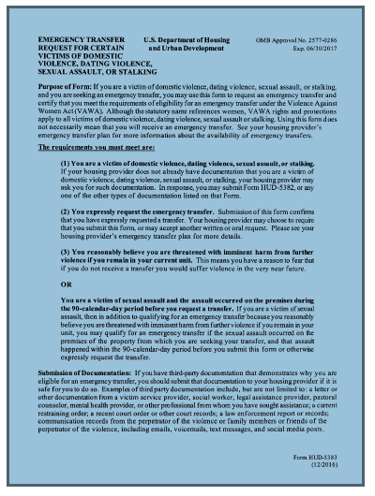

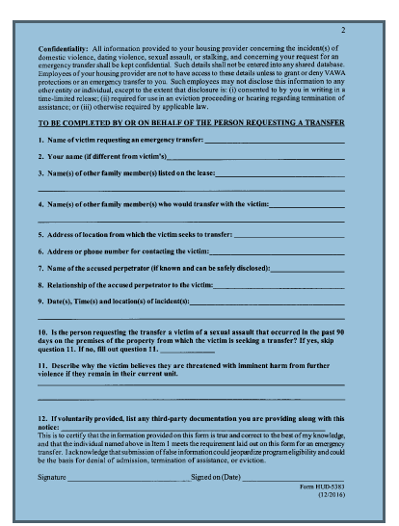

This page is intentionally left blank

Appendix: HOTMA
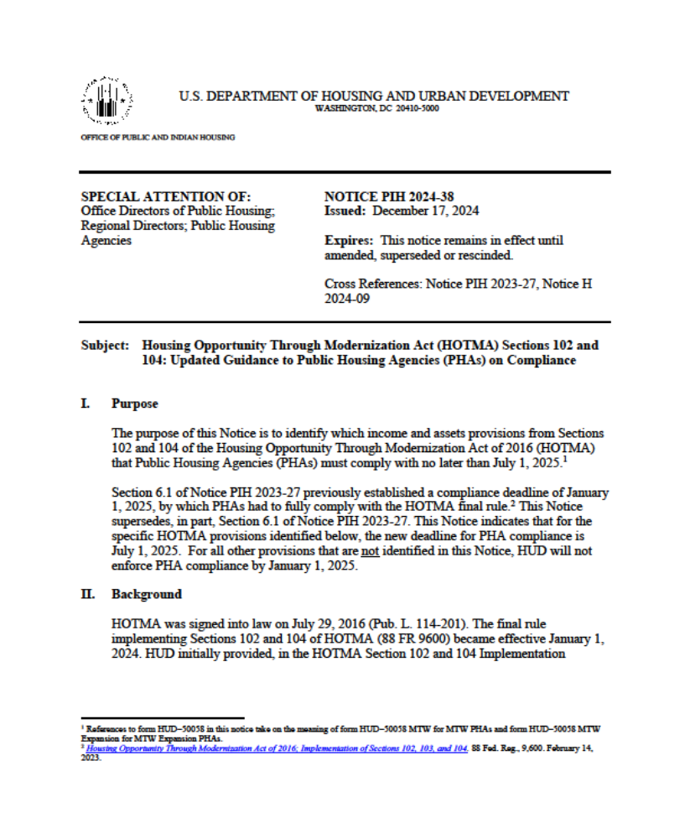
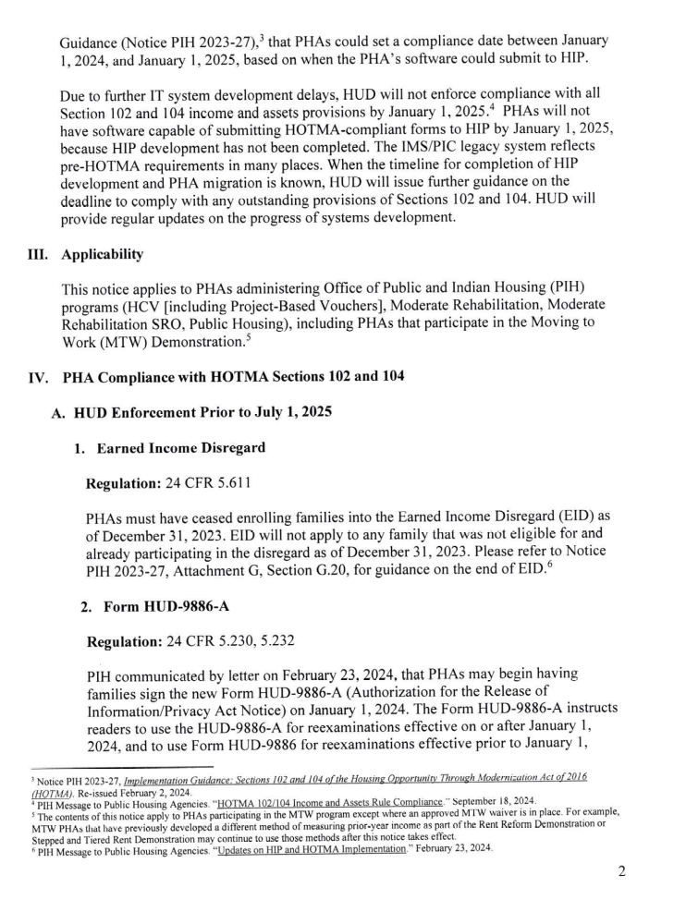
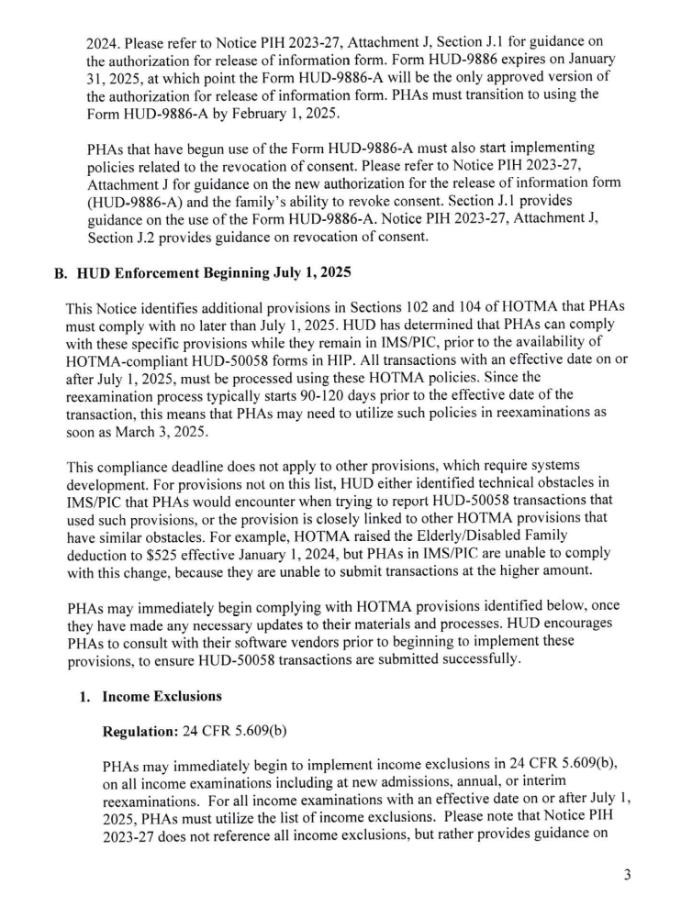
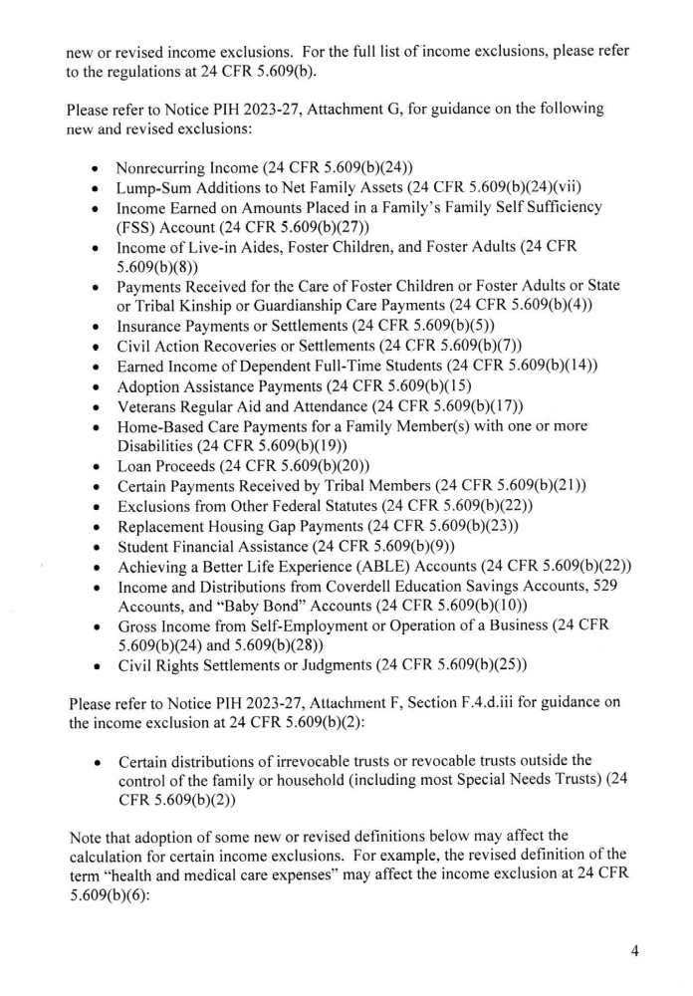
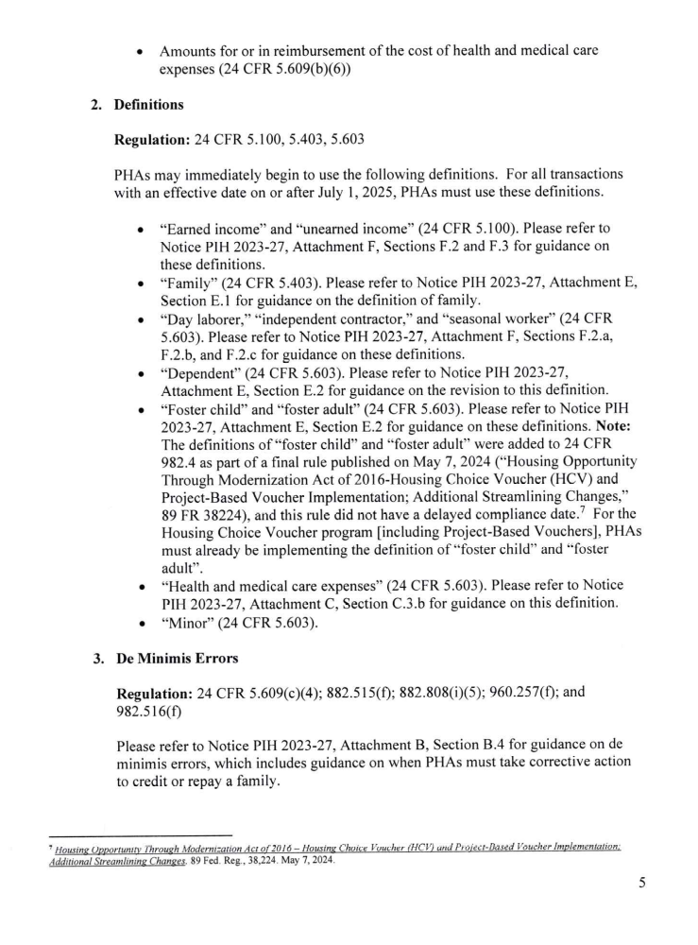
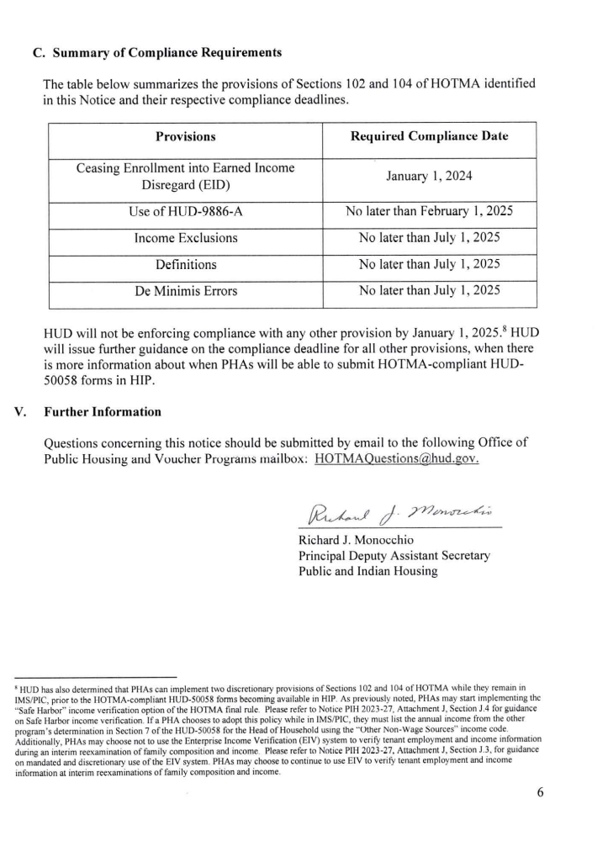

- EFFECTIVE DATE, COMPLIANCE, AND UPDATES TO PHA OWNER POLICIES

To comply with HOTMA, the PHA will submit transactions to the Housing Information Portal (HIP). “Compliance” means, in this instance, utilizing the HOTMA rules as it applies to the affected programs and corresponding reporting in HIP.

Per requirements in Section 104 of HOTMA, 24 CFR 5.618 the PHA will restrict the eligibility of a family to receive assistance if the family owns real property that is suitable for occupancy by the family as a residence or has assets more than $100,000, as adjusted annually in accordance with the Consumer Price Index for Urban Wage Earners and Clerical Workers.

When calculating a household’s income, including asset income, at the time of admission to the program or during interim re-examinations, PHA will use anticipated income (current income) (i.e., the family’s estimated income for the upcoming 12-month period). This requirement is consistent with the pre-HOTMA process for conducting income examinations at admission and for interim reexaminations.

PHA will not use “safe harbor” income verification from another federal means-tested program to verify gross annual income.

During annual re-examinations, except where the PHA uses a streamlined income determination under 24 CFR §§ 5.657(d), 960.257(c), or 982.516(b) (see Attachment I (paragraph I.8) (Streamlined Income Determination)), PHAs will first determine the family’s income for the previous 12-month period and use this amount as the family income for annual reexaminations; however, adjustments to reflect current income must be made. Any change of income since the family’s last annual reexamination, including those that did not meet the threshold to process an interim reexamination of family income in accordance with the PHA’s policies and 24 CFR §§ 5.657(c), 960.257(b), or 982.516(c), must be considered. Income from assets is always anticipated, irrespective of the income examination type.

Determine the annual income for the previous 12-month period as defined at 24 CFR § 5.609(a) and (b). If there have been no changes to income beyond this calculation, then this is the amount that will be used to determine the family’s rental assistance. If there are no reported changes to an income source, the PHA will use documentation of prior-year income to calculate the annual income used for the current annual reexamination HUD–50058.

De Minimis Errors
Regulations: 24 CFR §§ 5.609(c)(4); 5.657(f); 960.257(f); 982.516(f); 882.515(f); 882.808(i)(5); 891.105; and 891.655
PHA will not be considered out of compliance solely due to de minimis errors in calculating family income. De minimis errors occur when a PHA/MFH Owner’s determination of a family’s income deviates from the correct income determination by no more than $30 per month in monthly adjusted income (or $360 in annual adjusted income).

As PHA become aware of the existence of an income calculation error, we will correct the error(s) retroactive to the effective date of the action the error was made regardless of the dollar amount associated with the error. PHA will take corrective action to credit or repay a family if the family is overcharged tenant rent, including when PHA makes de minimis errors in the income determination. Families will not be required to repay the PHA in instances where the PHA miscalculated income resulting in a family being undercharged for rent. A check will be made out to the tenant no later than the following month that the de minimis error was discovered.

PHA will consider mandatory deductions when determining a family’s annual adjusted income. PHAs will also consider additional (permissive) deductions to a family’s annual income established by a written policy in the PHA’s Administrative Plan.

Effective January 1, 2027, the dependent deduction amount is $480. This amount will be adjusted annually and applies to a family’s next annual or interim reexamination after the annual adjustment, whichever is sooner. Not later than September 1 annually, HUD will publish the CPI–W adjusted dependent deduction to the HUD User Web site. PHA will implement the adjusted dependent deduction for all income examinations that are effective on January 1or later.

Effective January 1, 2027, the elderly/disabled family deduction increases from $400 to $525 and applies to a family’s next interim or annual reexamination, whichever is sooner. The amount of the deduction will be adjusted annually. Not later than September 1 annually, HUD will publish the CPI–W adjusted elderly/disabled family deduction to the HUD User Web site. PHAs/MFH Owners must implement the adjusted elderly/disabled family deduction for all income examinations that are effective on January 1 or later.

Unreimbursed Health and Medical Care Expenses and Reasonable Attendant Care and Auxiliary Apparatus
Expenses Deduction

The final rule establishes that the sum of unreimbursed health and medical care and reasonable attendant care and auxiliary expenses that exceed 10 percent of the family’s annual income can be deducted from annual income. Prior to January 1, 2027, the threshold was 3 percent of the family’s annual income.

Regulation: 24 CFR § 5.603

Health and medical care expenses, as defined in 24 CFR § 5.603, include costs incurred for the diagnosis, cure, mitigation, treatment, or prevention of disease or payments for treatments affecting any structure or function of the body. Health and medical care expenses include medical insurance premiums and long-term care premiums that are paid or anticipated during the period for which annual income is computed. Medical insurance premiums continue to be eligible health and medical care expenses. However, health and medical care expenses may be deducted from annual income only if they are eligible and not otherwise reimbursed and may only be deducted for elderly or disabled families. In order to claim the deduction for the cost of unreimbursed reasonable attendant care and auxiliary apparatus expenses, the family must include a person with a disability, and the expenses must enable any member of the family (including the member who is a person with a disability) to be employed. If the unreimbursed reasonable attendant care and auxiliary apparatus expense exceeds the amount earned by the person who was enabled to work, the deduction will be capped at the amount earned by that individual.

Hardship Exemptions for Health and Medical Care Expenses and Reasonable Attendant Care and Auxiliary Apparatus Expenses

Regulations: 24 CFR §§ 5.611(c)(1); 5.611(c)(1)(D); and 5.611(c)(2)

Summary: The threshold to deduct health and medical care expenses and reasonable attendant care and auxiliary apparatus expenses has been increased from an excess of 3 to an excess of 10 percent of annual income. Concurrently with this increase, the regulations provide financial hardship exemptions for unreimbursed health and medical care expenses, and for reasonable attendant care and auxiliary apparatus expenses for eligible families. A family will benefit from this hardship exemption only if the family has eligible expenses that can be deducted in excess of 5 percent of annual income. In order to claim unreimbursed health and medical care expenses, the family must have a head, co-head, or spouse that is elderly or a person with a disability. In order to claim unreimbursed reasonable attendant care and auxiliary apparatus expenses, the family must include a person with a disability, and the expenses must enable any member of the family (including the member who is a person with a disability) to be employed.

Families may be eligible for relief under one of two categories; phased-in relief or general relief, as defined below. Note: A family receiving phased-in relief may request to receive general hardship relief instead; once a family chooses to obtain general relief, a family may no longer receive the phased-in relief. PHAs/MFH Owners must track the 24-month phase-period for each eligible family, even if a family’s expenses go below the appropriate phase-in percentage, during the first or second 12-month phase-in period. The phase-in must continue for families who move with continued assistance in the HCV program or port to another PHA. The phase-in must also continue for families who move to another Public Housing unit at the same PHA, or who transfer internally to another unit within the same property. The family must receive phased-in relief if they are determined to be eligible as of January 1, 2027.

Phased-In Relief

This section describes the phased-in relief for families affected by the statutory increase in the threshold to receive unreimbursed health and medical care and reasonable attendant care and auxiliary apparatus expense deductions from annual income. All families who received a deduction for unreimbursed health and medical care and/or reasonable attendant care or auxiliary apparatus expenses based on their most recent income review prior to January 1, 2024, will begin receiving the 24- month phased-in relief at their next annual reexamination or interim reexamination, whichever occurs first after January 1, 2024. Families who receive phased-in relief will have eligible expenses deducted that exceed 5 percent of annual income for 12 months. Twelve months after the 5 percent phase-in began, families will have eligible expenses deducted that exceed 7.5 percent of annual income for the immediately following 12 months. After the family has completed the 24 months phase-in at the lower thresholds, as described above, the family will remain at the 10 percent threshold, unless the family qualifies for relief under the general hardship relief provision. When an eligible family’s phased-in relief begins at an interim reexamination, the PHA will need to process another transaction one year later to move the family along to the next phase. The transaction can be either an interim reexamination if triggered, or a non-interim reexamination transaction.

General Relief

This section describes when a family is eligible for general relief related to the health and medical care expense and reasonable attendant care and auxiliary apparatus expense deduction. To receive general relief, a family must demonstrate that the family’s unreimbursed health and medical care expenses or unreimbursed reasonable attendant care and auxiliary apparatus expenses increased, or the family’s financial hardship is a result of a change in circumstances that would not otherwise trigger an interim reexamination. Relief is available regardless of whether the family previously received an unreimbursed health and medical care expense deduction, unreimbursed reasonable attendant care and auxiliary apparatus expense deduction, are currently receiving phased-in hardship relief, or were previously eligible for either this general relief or the phased-in relief. If a PHA/MFH Owner determines that a family is eligible for general relief, the family will receive a deduction for the sum of the eligible expenses that exceed 5 percent of annual income. The family’s hardship relief ends when the circumstances that made the family eligible for the relief are no longer applicable or after 90 days, whichever comes earlier. However, PHAs/MFH Owners may, pursuant to their own discretionary policy, extend the relief for one or more additional 90-day periods while the family’s hardship condition continues.

Child-Care Expenses Deduction and Hardship Exemption to Continue Child-Care Expenses Deduction

Regulation: 24 CFR §§ 5.603 Child-Care Expenses and 5.611(d) See also Attachment I (paragraph I.4) (Non-Interim Reexamination Transactions). Summary: Under 24 CFR § 5.611(d), any reasonable child-care expenses necessary to enable a member of the family to be employed or to further their education are deducted from income. Reasonable child-care expenses are defined in 24 CFR § 5.603(a) and are expenses for the care of children (including foster children if the unreimbursed child-care expenses are paid from the family’s annual income and not from another source, such as 32 a stipend from the child welfare agency), age 12 and younger, when all the following statements
are true:
• The care is necessary to enable a family member to be employed or to further his or her education (e.g., work, look for work, or further their education (academic or vocational));
• The expense is not reimbursed by an agency or individual outside the household; and
• The expenses incurred to enable a family to work do not exceed the amount of employment income that is included in annual income.

A family whose eligibility for the child-care expense deduction is ending may receive a hardship exemption to continue receiving a child-care expense deduction in certain circumstances when the family no longer has a member that is working, looking for work, or seeking to further their education, and the deduction is necessary because the family is unable to pay their rent. When a family requests a hardship exemption to continue receiving a child-care expense deduction that is ending, the PHA must recalculate the family’s adjusted income and continue the child-care deduction if the family demonstrates to the PHA’s satisfaction that the family is unable to pay their rent

(Policy for Determination of the Family’s Inability to Pay Rent)) because of loss of the child-care expense deduction and the child-care expense is still necessary even though the family member is no longer working, looking for work, or furthering their education. The hardship exemption and the resulting alternative adjusted income calculation must remain in place for a period of up to 90 days. The PHA, at our discretion, may extend such hardship exemptions for additional 90-day periods based on family circumstances. To initiate, extend or conclude a hardship exemption,
PHA will submit a non-interim transaction code on form HUD–50058, unless there is an accompanying event that triggers an interim reexamination.

Additional (Permissive) Deductions

Regulation: 24 CFR § 5.611(b)(1)

Summary: PHA may, but is not required, to establish an additional deduction or deductions from a family’s annual income. These deductions are also known as “permissive deductions.” Note that the PHA is aware that the public housing Operating Fund formula is not revised to account for any decrease in PHA revenue attributable to implementing permissive deductions. Likewise, the subsidy costs attributable to implementing permissive deductions will not be taken into consideration in determining the PHA’s HCV renewal funding or moderate rehabilitation funding. PHA understands that adopting permissive deductions are required to incorporate these policies as part of our Administrative Plan.

Summary
See subtopics.
Subtopics

Definition of Family

Regulation: 24 CFR § 5.403 Summary: The final rule revises the definition of family to also include a single person who:
• Is an otherwise eligible youth who has attained at least 18 years of age and not more than 24 years of age;
• Has left foster care, or will leave foster care within 90 days, in accordance with a transition plan described in section 475(5)(H) of the Social Security Act (42 U.S.C. 675(5)(H)); and
• Is homeless or is at risk of becoming homeless at age 16 or older.

The definition of “family” in the final rule incorporates revisions made to the 1937 Act by the Fostering Stable Housing Opportunities provisions of the Consolidated Appropriations Act, 2021, which expands the definition of “single persons.”

New Definitions of Foster Adult and Foster Child Regulation:
24 CFR § 5.603

Summary: The final rule establishes definitions for “foster adult” and “foster child.” A foster adult is defined as a member of the household who is 18 years or older and meets E1 SPRACs have a program-specific definition of Family found in paragraph 2.3 (Families to be Housed) of the SPRAC II (form HUD–93742a). 40 the definition of a foster adult under state law. State-level agencies define who is considered a foster adult/child, so the classification may vary from state to state.

In general, a foster adult is unable to live independently due to a debilitating physical or mental condition and is placed with the family by an authorized placement agency or by judgment, decree, or other order of any court of competent authority.

A foster child is defined as a member of the household who meets the definition of a foster child under state law. In general, a foster child is placed with the family by an authorized placement agency (e.g., public child welfare agency) or by judgment, decree, or other order of any court of competent authority.

Foster adults/children are not considered family members and must not be included in calculations of income for eligibility and rent determination purposes. However, foster adults/children are considered household members and must be included when determining unit size or subsidy standards based on established policies. The definition of “dependent” under § 5.603 was revised to explicitly exclude foster children and foster adults.

Families may be eligible to continue to receive the child-care expense deduction, pursuant to a hardship exemption, when the unreimbursed child-care expense is for the care of a foster child under the age of 13, but only if the unreimbursed child-care expense for the care of the foster child is paid from the family’s annual income (and not another source, such as a stipend from a child welfare agency).
When a member of an assisted family is temporarily placed in foster care (as confirmed by the state child welfare agency), the member is still counted as a family member in the unit from which they were removed. This means that a foster child or foster adult could be considered an assisted family member in one household while also being a foster child or adult in another household and receiving consideration in both families’ voucher size and/or unit size.

Annual Income
Regulations: 24 CFR §§ 5.609(a)(1)–(a)(2); and 891.105

Annual income includes all amounts received from all sources by each member of the family who is 18 years of age or older, the head of household, or spouse of the head of household, in addition to unearned income received by or on behalf of each dependent who is under 18 years of age.

All amounts received by the head of the household, co-head, or spouse, including the income of a day laborer, independent contractor, and seasonal worker are included in annual income.

Note: Annual income includes “all amounts received,” not the amount that a family may be legally entitled to receive but which they do not receive. A family’s child support or alimony income must be based on payments received, not the amounts to which the family is entitled by court or agency orders. A copy of a court order or other written payment agreement alone may not be sufficient verification of amounts received by a family.

Annual income also includes all actual anticipated income from assets even if the asset is excluded from net family assets but the income from the asset is not otherwise excluded. Imputed returns on net family assets are included in annual income only when net family assets exceed $50,000 (a figure that is annually adjusted for inflation) and actual asset income cannot be calculated for all assets. PHA will not impute income from assets if the total value of net family assets is equal to or less than $50,000 (as adjusted by inflation).

Earned Income
Regulation:
24 CFR § 5.100
Summary: Earned Income is defined as income or earnings from wages, tips, salaries, other employee compensation, and net income from self-employment. Earned income does not include any pension or annuity, transfer payments

(meaning payments made or income received in which no goods or services are being paid for, such as welfare assistance, Social Security, and other governmental subsidies/benefits), or any cash or inkind benefits.

Definition of Unearned Income
Regulation: 24 CFR § 5.100
Summary: Unearned income means any annual income that is not earned income. Net family assets are defined as the net cash value of all assets owned by the family, after deducting reasonable costs that would be incurred in disposing of real property, savings, stocks, bonds, and other forms of investment, except as excluded.

Assets
Assets with negative equity.
The cash value of real property or other assets with negative equity would be considered $0 for the purposes of calculating net family assets. Negative equity in real property or other investments does not prohibit the family from selling the property or other investments, so negative equity alone would not justify excluding the property or other investments from family assets.

Assets disposed of for less than fair market value.
In determining the value of net family assets, PHAs/MFH Owners must include the value of any business or family assets disposed of by an applicant or tenant for less than fair market value (including a disposition in trust,F2 but not in a foreclosure or bankruptcy sale) during the two years preceding the date of application for the program or reexamination, as applicable, in excess of the consideration received.

Exclusions from Net Family Assets
Regulations: 24 CFR § 5.603(b)(3)–(b)(4)
Required exclusions from net family assets include the following:
• The value of necessary items of personal property.
• The value of all non-necessary items of personal property with a total combined value of $50,000 or less, annually adjusted for inflation.
• The value of any account under a retirement plan recognized as such by the Internal Revenue Service, including Individual Retirement Accounts (IRAs), employer retirement plans (e.g., 401(k), 403(b)), and retirement plans for
self-employed individuals.
• The value of real property that the family does not have the effective legal authority to sell in the jurisdiction in which the property is located. Examples of this include but are not limited to: co-ownership situations (including situations where one owner is a victim of domestic violence), where one party cannot unilaterally sell the real property; property that is tied up in litigation; inherited property in dispute.
• Any amounts recovered in any civil action or settlement based on a claim of malpractice, negligence, or other breach of duty owed to a family member arising out of law that resulted in a member of the family being a person with disabilities.
• The value of any Coverdell education savings account under section 530 of the Internal Revenue Code of 1986;
the value of any qualified tuition program under section 529 of such Code; and the amounts in, contributions to, and distributions from any Achieving a Better Life Experience (ABLE) account authorized under section 529A of such code.
• The value of any “baby bond” account created, authorized, or funded by the federal, state, or local government (money held in trust by the government for children until they are adults).
• Interests in Indian trust land.
• Equity in a manufactured home where the family receives assistance under 24 CFR Part 982. 47
• Equity in property under the Homeownership Option for which a family receives assistance under 24 CFR Part 982.
• Family Self-Sufficiency accounts.
• Federal tax refunds or refundable tax credits for a period of 12 months after receipt by the family.
• The full amount of assets held in an irrevocable trust.

• The full amount of assets held in a revocable trust where a member of the family is the beneficiary, but the grantor/owner and trustee of the trust is not a member of the participant family or household.

Necessary and Non-Necessary Personal Property
Regulation: 24 CFR § 5.603
Summary: Necessary personal property is excluded from net family assets. Non-necessary personal property with a combined value greater than $50,000, as adjusted by inflation, is considered part of net family assets. When the combined value of all non-necessary personal property does not exceed $50,000, as adjusted by inflation, all non-necessary personal property is excluded from net family assets. All assets are categorized as either real property (e.g., land, a home) or personal property. Personal property includes tangible items, like boats, as well as intangible items, like bank accounts. Necessary personal property are items essential to the family for the maintenance, use, and occupancy of the premises as a home; or they are necessary for employment, education, or health and wellness.

Necessary Personal Property

Car(s)/vehicle(s) that a family relies on for transportation for personal or business use (e.g., bike, motorcycle, skateboard, scooter)
• Furniture, carpets, linens, kitchenware • Common appliances
• Common electronics (e.g., radio, television, DVD player, gaming system)
• Clothing
• Personal effects that are not luxury items (e.g., toys, books)
• Wedding and engagement rings
• Jewelry used in religious/cultural celebrations and ceremonies
• Religious and cultural items
• Medical equipment and supplies
• Health care–related supplies
• Musical instruments used by the family
• Personal computers, phones, tablets, and related equipment
• Professional tools of trade of the family, for example professional books
• Educational materials and equipment used by the family, including equipment to accommodate persons with disabilities
• Equipment used for exercising (e.g., treadmill, stationary bike, kayak, paddleboard, ski equipment)

Non-Necessary Personal Property

Recreational car/vehicle not needed for day-to-day transportation (campers, motorhomes, travel trailers, all-terrain vehicles (ATVs))
• Bank accounts or other financial investments (e.g., checking account, savings account, stocks/bonds)
• Recreational boat/watercraft
• Expensive jewelry without religious or cultural value, or which does not hold family significance
• Collectibles (e.g., coins/stamps)
• Equipment/machinery that is not used to generate income for a business
• Items such as gems/precious metals, antique cars, artwork, etc.

Trusts Regulations:
24 CFR §§ 5.603 and 5.609
Summary: Whether the value of a trust counts as a net family asset and whether distributions from the trust count as annual income to the family depend on the following three factors:
• Whether the trust is under the control of the family;
• Whether distributions are made from the trust’s principal; and

• The purpose of the distribution, if the distribution is made from income earned on the trust’s principal.

Trusts as Net Family Assets
The value of irrevocable trusts and revocable trusts that are not under the control of the family are both excluded from net family assets. The distinguishing feature of a revocable trust is that the grantor can terminate and/or amend the trust at any time for any reason before his or her death.

A revocable trust that is under the control of the family or household (e.g., the grantor is a member of the assisted family or household) is included in net family assets, and, therefore, income earned on the trust is included in the family’s income from assets. This also means that PHA will calculate imputed income on the revocable trust if net family assets are more than $50,000, as adjusted by inflation, and actual income from the trust cannot be calculated (e.g., if the trust is comprised of farmland that is not in use).

Federal Tax Refunds or Refundable Tax Credits
Regulations: 24 CFR § 5.603
Summary: All amounts received by a family in the form of federal tax refunds or refundable tax credits are excluded from a family’s net family assets for a period of 12 months after receipt by the family.

Passbook Rate
Regulations: 24 CFR § 5.609(a)(2)
Summary: HUD will annually publish a passbook rate based on the Federal Deposit Insurance Corporation (FDIC) National Deposit Rate for savings accounts, which is an average of national savings rates published on a monthly basis. PHA must use the HUD-published passbook rate when calculating imputed asset income for net family assets that exceed $50,000 (a figure that is annually adjusted for inflation). The HUD-published passbook rate will be posted to a dataset on the HUD User Web site, alongside annual inflationary adjustments. PHA will be required to use the HUD-published passbook rate.

Actual and Imputed Income from Assets
Regulation: 24 CFR § 5.609(a)(2)
Summary: Actual income and imputed income are treated as described below. F.6.a Actual Income Actual income
from assets is always included in a family’s annual income, regardless of the total value of net family assets or whether the asset itself is included or excluded from net family assets, unless that income is specifically excluded. Income or returns from assets are generally considered to be interest, dividend payments, and other actual income earned on the asset, and not the increase in market value of the asset. The increase in market value is relevant to the cash value of
the asset for the purpose of determining total net family assets and imputing income.

Self-Certification of Net Family Assets Equal to or Less Than $50,000 (as adjusted for inflation)
Regulations: 24 CFR §§ 5.603; 5.609; 5.618; 5.659(e); 882.515(a); 882.808(i)(1); 891.105; 960.259(c)(2); and 982.516(a)(3)
Summary: PHA may determine net family assets based on a self-certification by the family that the family’s total
assets are equal to or less than $50,000, adjusted annually for inflation, without taking additional steps to verify the accuracy of the declaration at admission and/or reexamination. PHA are not required to obtain third-party verification of assets if they accept the family’s self-certification of net family assets. When PHA accept self-certification of net family assets at reexamination, the PHA must fully verify the family’s assets every three years.

PHA are not required to adopt a policy to allow for self-certification of net family assets for families with net family assets that are equal to or below $50,000, adjusted annually for inflation. PHA will choose to accept self-certifications of assets. Third-party verification of assets is required when net family assets exceed $50,000, adjusted annually by HUD.

Nonrecurring Income
Regulation: 24 CFR §§ 5.609(b)(24) and CFR 891.105
Summary: Income that will not be repeated beyond the coming year (i.e., the 12 months following the effective date
of the certification), based on information provided by the family, is considered nonrecurring income and is excluded from annual income. However, income received as an independent contractor, day laborer, or seasonal worker is not excluded from income under § 5.609(b)(24), even if the source, date, or amount of the income varies. Income that
has a discrete end date and will not be repeated beyond the coming year during the family’s upcoming annual reexamination period will be excluded from a family’s annual income as nonrecurring income. This does not include unemployment income and other types of periodic payments that are received at regular intervals (such as weekly, monthly, or yearly) for a period of greater than one year that can be extended.

The following list of exclusions is codified at 24 CFR § 5.609(b)(24) as nonrecurring income.
Please note that the list is not exhaustive:
• Payments from the U.S. Census Bureau for employment lasting no longer than 180 days and not culminating in permanent employment;
• Direct federal or state economic stimulus payments;
• Amounts directly received by the family as a result of state refundable tax credits or state tax refunds at the time they are received;
• Amounts directly received by the family as a result of federal refundable tax credits or federal tax refunds at the time they are received;
• Gifts for holidays, birthdays, or other significant life events or milestones (e.g., wedding, baby shower, or anniversary gifts);
• In-kind donations (e.g., food, clothing, or toiletries received from a food bank or similar organization); and
• Lump-sum additions to net family assets (e.g., lottery winnings, contest winnings, etc.).

Lump-Sum Additions to Net Family Assets
Regulation: 24 CFR § 5.609(b)(24)(vii)
Summary: Lump-sum additions to net family assets, including but not limited to lottery or other contest winnings, are excluded from annual income. These amounts may count toward net family assets in accordance with 24 CFR § 5.603.

Civil Action Recoveries or Settlements Regulation: 24 CFR § 5.609(b)(7) Summary: Any amounts recovered in any civil action or settlement based on a claim of malpractice, negligence, or other breach of duty owed to a family member arising out of law that resulted in a member of the family becoming a person with disabilities are excluded from annual income. Any amounts recovered are excluded irrespective of whether they are received periodically or in a lump sum payment.

Earned Income of Dependent Full-Time Students
Regulation: 24 CFR § 5.609(b)(14)
Summary: Earned income of dependent full-time students in excess of the amount of the deduction for a dependent
in § 5.611 is excluded from annual income. Full-time students must be dependent family members for this exclusion
to apply. This exclusion does not apply to the head of household, spouse, or co-head. This means that the first $480 of the income earned by dependent full-time students will be included in the family’s calculation of annual income. The dependent deduction will be adjusted annually in accordance with the (CPI–W). Full-time dependent students are eligible to receive both the $480 (as adjusted for inflation) dependent deduction and the exclusion.

Adoption Assistance Payments
Regulation: 24 CFR § 5.609(b)(15)
Summary: Adoption assistance payments in excess of $480 per adopted child are excluded from the family’s calculation of annual income. This amount will be adjusted annually in accordance with the CPI–W All dependents, including adopted family members, are eligible to receive the $480 (as adjusted for inflation) dependent deduction and the exclusion.

Veterans Regular Aid and Attendance
Regulation: 24 CFR § 5.609(b)(17)
Summary: Payments to veterans in need of regular aid and attendance are excluded from annual income under 38 U.S.C. 1521. This income exclusion applies only to veterans in need of regular aid and attendance and not to other beneficiaries of the payments, such as a surviving spouse. Certain veterans are eligible for “aid and attendance” payments from the Veterans Affairs (VA) Administration. These payments are distinct from payments made to
veterans under other VA programs, including the Veterans Pension program. PHAs/MFH Owners should carefully review any income documentation provided by the family, because many types of VA income, including the Veterans Pension and the VA Survivors Pension, are included in annual income.

Home-Based Care Payments for a Family Member(s) with a Disability(ies)
Regulation: 24 CFR § 5.609(b)(19)
Summary: Payments made by or authorized by a state Medicaid agency (including through a managed-care entity) or other state or federal agency to a family to enable a family member who has a disability to reside in the family’s assisted unit are excluded from the calculation of the family’s annual income. Authorized payments may include payments to a member of the assisted family through the state Medicaid agency (including through a managed-care entity) or other state or federal agency for caregiving services the family member provides to enable a family
member who has a disability to reside in the family’s assisted unit. A family member with a disability qualifies for this income exclusion. Amounts received may be intended for items such as services, equipment, and compensation provided to a family member. The payments are excluded from income as long as the amounts are provided to enable a family member with a disability to remain in the family’s assisted unit. Both the person providing the care and the person who has the disability must be family members (not household members) and must live in the same assisted household. The exclusion does not apply to income earned by the family for other caregiving services provided to individuals outside of the assisted household.

Loan Proceeds
Regulation: 24 CFR § 5.609(b)(20)
Summary: Loan proceeds (the net amount disbursed by a lender to a borrower under the terms of a loan agreement) received by the family or a third party (e.g., proceeds received by the family to finance the purchase of a car) are excluded from annual income. The 68 loan borrower or co-borrower must be a member of the family for this income exclusion to be applicable. Loan proceeds may include, but are not limited to, personal loans (with a loan agreement) and student loans, regardless of whether the proceeds are received in the form of a refund to the student.

Replacement Housing Gap Payments
Regulation: 24 CFR § 5.609(b)(23)
Summary: Replacement housing “gap” payments made in accordance with the Uniform Relocation Assistance and Real Property Acquisition Policies Act of 1970 (“URA”), as implemented by 49 CFR Part 24, are excluded from annual income. “Gap” payments offset the increased out-pocket costs of displaced persons who move from one federally subsidized housing unit to another federally subsidized housing unit. However, replacement housing “gap” payments are not excluded from annual income if the increased cost of rent and utilities is reduced or eliminated, and the displaced person retains or continues to receive the replacement housing “gap” payments. Replacement housing “gap” payments should cover a minimum of 42 months of tenancy at the new unit.

Student Financial Assistance
Regulation: 24 CFR § 5.609(b)(9)
Summary: The treatment of student financial assistance depends on the HUD program, student/household characteristics, and the type of financial assistance received by the student. The student financial assistance rules

apply to both full-time and part-time students. The two types of student financial assistance applicable to MFH and PIH programs are described below.
Amounts Received Under Section 479B of the Higher Education Act (HEA) of 1965, as amended (20 U.S.C. 1087uu) Section 479B provides that certain types of student financial assistance are to be excluded in determining eligibility for benefits made available through federal, state, or local programs financed with federal funds. The types of financial assistance listed below are considered 479B student financial assistance programs; however, this list is not exhaustive, and 479B will be updated as of July 1, 2024.
• Federal Pell Grants;
• Teach Grants;
• Federal Work Study Programs;
• Federal Perkins Loans;
• Student financial assistance received under the Bureau of Indian Education;
• Higher Education Tribal Grant;
• Tribally Controlled Colleges or Universities Grant Program;
• Employment training program under section 134 of the Workforce Innovation and Opportunity Act (WIOA).

Other Student Financial Assistance

Other student financial assistance includes grants or scholarships received from the following sources:
• The Federal government;
• A state (including U.S. territories), Tribe, or local government;
• A private foundation registered as a nonprofit under 26 U.S.C. 501(c)(3);
• A business entity (such as a corporation, general partnership, limited liability company, limited partnership, joint venture, business trust, public benefit corporation, or nonprofit entity); or
• An institution of higher education. Other student financial assistance does not include:
• Financial support provided to the student in the form of a fee for services performed (e.g., a work study or teaching fellowship that is not excluded under section 479B of the Higher Education Act HEA); or
• Gifts, including gifts from family or friends.

Note: Other student financial assistance may be paid directly to the student or to the educational institution on the student’s behalf. The PHA/MFH Owner must verify that the other student financial assistance is for the student’s
actual covered costs. The following sections describe the treatment of the two above-described types of student financial assistance by program type.

There are distinct differences in the treatment of student financial assistance between the Section 8 program and the Public Housing and non–Section 8 programs administered by MFH due to language in the annual appropriations acts. Section 210(b) of the Consolidated Appropriations Act, 2023,G5 requires that, “for purposes of determining the eligibility of a person to receive assistance under section 8 of the United States Housing Act of 1937
(42 U.S.C. 1437f), any financial assistance (in excess of amounts received for tuition and any other required fees and charges) that an individual receives under the Higher Education Act of 1965 (20 U.S.C. 1001 et seq.), from private sources, or from an institution of higher education (as defined under section 102 of the Higher Education Act of 1965 (20 U.S.C. 1002)), shall be considered income to that individual, except for a person over the age of 23 with
dependent children.” HUD interprets that “a person over the age of 23” is 24 years old.

Achieving a Better Life Experience (ABLE) Accounts
Regulation: 24 CFR § 5.609(b)(22)
Summary: ABLE accounts are excluded from the definition of net family assets, and therefore income generated from such accounts is not considered when calculating income from assets. Distributions from these accounts are also excluded from income. HUD developed specific guidance on ABLE accounts based on language included in the
ABLE Act of 2014. Certain contributions deposited into ABLE accounts are excluded in addition to the above-

mentioned exclusions. See Treatment of ABLE Accounts in HUD Assisted Programs (Notice H 2019–06/PIH
2019–09).

Gross Income from Self-Employment or Operation of a Business
Regulation: 24 CFR §§ 5.609(b)(24) and 5.609(b)(28)
Summary: The gross income received by a family through self-employment or the operation of a business is excluded from income. Gross income is all income amounts received into the business, prior to the deduction of business expenses. To determine the amount of business or self-employment income included in a family’s annual income, the net income of the business must first be determined. Net income is the “gross income amount minus business expenses” that allows the business to operate. The net income from self-employment or the operation of a business is considered income. Expenditures for business expansion or amortization of capital indebtedness are not deductible when determining the income from a business. An allowance for the depreciation of assets used in a business or profession may be deducted, based on a straight-line depreciation, as provided in IRS’s regulations.G7 Any
withdrawal of cash or assets from the operation of a business is income except to the extent that such withdrawal is to reimburse the family member for cash or assets that the family has invested in the operation of the business.

Elimination of the Earned Income Disregard (EID)
Regulation: 24 CFR § 5.611
Summary: The Earned Income Disregard (EID) will not apply to any family who is not eligible for and already participating in the disallowance as of December 31, 2023. The EID allowed eligible families to have a portion of
their earned income excluded from annual income for a maximum period of 24 consecutive months. Although HOTMA eliminates the EID from HUD regulations, families who were receiving the EID benefit as of December 31, 2023, may continue to receive the full benefit until the remaining timeframe for an individual family’s EID expires. Because the EID lasts up to 24 consecutive months, no family will still be receiving the EID benefit after December
31, 2025.

Civil Rights Settlements or Judgments
Regulation: 24 CFR § 5.609(b)(25)
Summary: Civil rights settlements or judgments, including settlements or judgments for back pay, are excluded from the calculation of annual income. Historically HUD has followed a practice of excluding from income civil rights settlements and judgments as lump-sum additions to assets, which would include amounts received as a result of litigation or other actions, such as conciliation agreements, voluntary compliance agreements, consent orders, other forms of settlement agreements, or administrative or judicial orders under nondiscrimination laws. However, this new exclusion clarifies that even where such payments are not lump-sum payments but instead may have a payment schedule, such payments are excluded. Additionally, this 80 exclusion applies to back pay received by the family pursuant to a civil rights settlement or judgment.

ATTACHMENT H: TOPIC: INFLATIONARY ADJUSTMENTS
Regulations
Summary HUD will annually publish the eight inflation-adjusted items no later than September 1, and the updated values will be shared online at the HUD User Web site. The publication will apply to both MFH and PIH programs. The revised amounts will be effective on January 1 of the following year. HUD will annually publish the recalculated inflationary-adjusted items to HUD’s Policy Development and Research Web site, HUD User. The new amounts will become effective January 1 of the following year.

ATTACHMENT I: TOPIC: INTERIM REEXAMINATIONS
Regulations 24 CFR §§ 5.567(c)(1); 882.515(b)(1); 960.257(b)(1); 982.516(c)(1);
891.105; 891.410(g); and 891.610(g)
Summary A family may request an interim determination of family income or composition because of any changes since the last determination. The PHA/MFH Owner must conduct any interim reexamination within a reasonable
period of time after the family request or when the PHA/MFH Owner becomes aware of a change in the family’s adjusted income that must be processed in accordance with the final rule. What qualifies as a “reasonable time” may

vary based on the amount of time it takes to verify information, but the PHA/MFH Owner generally should conduct
the interim reexamination not longer than 30 days after the PHA/MFH Owner becomes aware of changes in income.

Decreases in Adjusted Income Regulations:
24 CFR §§ 5.657(c)(2); 882.515(b)(2); 891.105; 891.410(g)(2); 891.610(g)(2); 960.257(b)(2); and 982.516(c)(2) Summary: A family may request an interim determination of family income for any change since the last determination. However, the PHA will decline to conduct an interim reexamination of family income if the PHA estimates that the family’s adjusted income will decrease by an amount that is less than 10 percent of the family’s annual adjusted income. In addition to decreases in family income, increases in deductions may produce a sufficient decrease in adjusted income to support an interim reexamination effective January 1, 2024, or later.

PHA will follow HUD discretion, as authorized by HOTMA, to establish a lower threshold through notice to process interim reexaminations under certain circumstances. Specifically, HUD is requiring PHAs/MFH Owners to apply a
0-percent threshold and to process an interim reexamination when there is a decrease in family size attributed to the death or permanent move-out from the assisted unit of a family member during the period since the family’s last reexamination that results in a decrease in adjusted income of any amount. If there is no change/decrease in adjusted income as a result of the decrease in family size, then a non-interim transaction is processed instead of an interim reexamination. This 0-percent threshold for interim reexamination applies only to decreases in family size that result
in a decrease in adjusted income. If the net effect of the changes in annual adjusted income due to a decrease in
family size results in an increase in annual adjusted income, then PHA/MFH Owner will process the removal of the household member(s) as a non-interim reexamination transaction without making changes to the family’s annual adjusted income. PHA will not permitted to establish a dollar-figure threshold amount instead of a percentage threshold.

Increases in Adjusted Income
Regulations: 24 CFR §§ 5.657(c)(3); 882.515(b)(3); 960.257(b)(3); and 982.516(c)(3); 891.105; 891.410(g)(2); and 891.610(g)(2)
Summary: PHA will conduct an interim reexamination of family income when the PHA/MFH Owner becomes aware that the family’s adjusted income has changed by an amount that the PHA estimates will result in an increase of 10 percent or more in annual adjusted income or another amount established through a HUD notice, with the following exceptions:
• PHA may not consider any increases in earned income when estimating or calculating whether the family’s adjusted income has increased, unless the family has previously received an interim reduction during the same reexamination cycle; and
• PHA will choose not to conduct an interim reexamination during the last three months of a certification period if a family reports an increase in income within three months of the next annual reexamination effective date.

Note: Families who delay reporting income increases until the last three months of their certification period may be subject to retroactive rent increases in accordance with the PHA policies. PHAs will not process interim
reexaminations for income increases that result in less than a 10-percent increase in annual adjusted income. When
the family previously received an interim reexamination for a decrease to annual adjusted income during the same annual cycle, a PHA will ignore a subsequent increase in earned income for the purposes of conducting an interim reexamination.

Non-Interim Reexamination Transactions
Regulations: 24 CFR §§ 5.657(c)(2) 891.105; 891.410(g)(2); and 891.610(g)(2)
Summary: Families may experience changes within the household that do not trigger an interim reexamination under HOTMA but still need to be reported in a non-interim reexamination submission to HUD. In these cases, PHA will submit a separate, new action code on form HUD–50058. Further instructions on the use of this action code will be

provided along with supplemental guidance on other revisions to forms HUD–50058. The code will be used for the
following transaction types when an interim reexamination is not triggered under the final rule:
• Adding or removing a hardship exemption for the child-care expense deduction;
• Updating or removing the phased-in hardship relief for the health and medical care expense deduction and/or reasonable attendant care and auxiliary apparatus expense deduction (the phased-in relief will begin at an eligible family’s first annual or interim reexamination, whichever is sooner, after January 1, 2024);
• Adding or removing general hardship relief for the health and medical care expense deduction and/or reasonable attendant care and auxiliary apparatus expense deduction;
• Adding or removing a minimum rent hardship;
• Adding or removing a non-family member (i.e., live-in aide, foster child, foster adult);
• Ending a family’s EID or excluding 50 percent (decreased from 100%) of a family member’s increase in
employment income at the start of the second 12-month EID period.
• Adding a family member and the increase in adjusted income does not trigger an interim reexamination under the final rule;
• Removing a family member and the increase in adjusted income does not trigger an interim reexamination under the final rule;
• Adding/updating a family or household member’s Social Security number; and
• Updating a family member’s citizenship status from eligible to ineligible or vice versa, resulting in a change to the family’s rent and/or utility reimbursement, if applicable (i.e., family begins receiving prorated assistance or previously prorated assistance becomes full assistance), or updating the prorated rent calculation due to the addition or removal
of family members in household with an ineligible noncitizen(s).

HCV Program Only:
• Processing contract rent changes that do not correspond with an interim or annual reexamination (including PBV
rent increases);
• Implementing an update to the payment standard that does not correspond with an interim or annual reexamination. Note: PHAs/MFH Owners will make all other changes to assets, income, and deductions at the next annual or interim reexamination of income, whichever is sooner.

Policies for Families to Report Changes to Annual Adjusted Income or Household Composition Regulations:
24 CFR §§ 5.657(c)(4); 882.515(b)(1)–(4); 882.808(i)(4); 891.105; 891.410(g)(2); 891.610(g)(2); 960.257(b)(4);
and 982.516(d)
Summary: PHA will require families to report household composition changes as they occur; . PHA has developed policies that describe when and under what conditions families must report changes in annual adjusted income consistent with the new requirements for processing interim reexaminations. PHA request the family to report changes as they occur and PHA will educate families on the requirements for reporting changes. Families are responsible for reporting these changes to the PHA. PHA will track all reported changes to a family’s annual adjusted income to
ensure that the PHA is correctly processing interim reexaminations in accordance with HUD’s requirements. A PHA will require families to report all changes and the PHA will determine if an interim reexamination is necessary. Alternatively, PHA has established policies requiring that families report all changes in income and household composition, and the PHA will subsequently determine if the change requires an interim reexamination.

Processing Time Period for Interim Reexaminations Regulations:
24 CFR §§ 5.657(c)(1); 882.515(b)(1); 891.105; 891.410(g)(2); 891.610(g)(2); 960.257(b)(1); and 982.516(c)(1) Summary: The updated regulations codified long-standing guidance on how long PHA should take to process an interim reexamination. PHA will conduct the interim reexamination not longer than 30 days after the PHA becomes aware of changes in income.

Changes Reported Timely:
If the family has reported a change in family income or composition in a timely manner according to the PHA

policies, then the PHA will provide the family with 30-day advance notice of any rent increases, and such rent increases will be effective the first day of the month beginning after the end of that 30-day period. If the tenant has complied with the interim reporting requirement and the tenant’s rent is anticipated to decrease, rent decreases will be effective on the first day of the month after the date of the actual change leading to the interim reexamination of
family income. This means the decrease will be applied retroactively.

Changes Not Reported Timely:
If the family has failed to report a change in family income or composition in a timely manner by the 20th of the month PHA will must implement any resulting rent increases retroactively to the first day of the month following the date of the change leading to the interim reexamination of family income. PHA will clearly communicate the effect of the retroactive adjustment to the owner as well. An exception to the requirement that a PHA implement resulting rent increases retroactively to the first of the month following the date of the change leading to the interim reexamination exist if a PHA failed to process a family’s interim reexamination because the family did not timely report an income decrease.

Streamlined Income Determination Regulation:
24 CFR §§ 5.609(c)(2)(i); 5.657(d); 891.105; 891.410(g)(4); 891.610(g)(4); 960.257(c); and 982.516(b)
PHA will elect not to apply a streamlined income determination for families receiving fixed income.

Impact of Interim Reexamination Requirements on Family Self-Sufficiency (FSS) Programs
PHA may not consider any increases in earned income when estimating or calculating whether the family’s adjusted income has increased unless the family has previously received an interim reduction during the same reexamination cycle. Families participating in the FSS program are subject to these interim requirements, therefore their escrow accounts may not grow as their earnings increase throughout the year. The PHA may not perform an interim reexamination of annual income when enrolling a family in the FSS program unless the family experienced a
change in annual adjusted income that meets the threshold for conducting an interim reexamination under the
HOTMA final rule. Families for whom their first reexamination of income does not occur until their regularly scheduled annual reexamination will not have the opportunity to begin escrowing their increased earnings until that time and may have fewer escrow increases over the life of the 5-year contract.

Authorization for the Release of Information (Forms HUD–9886/HUD–9887)
Regulations: 24 CFR §§ 5.230; 5.232; 891.105; 891.410(b)-(c); and 891.610(b)-(c)
Summary: In accordance with the final rule, all applicants must sign the consent form at admission, and participants must sign the consent form no later than their next interim or regularly scheduled income reexamination. After an applicant or participant has signed and submitted a consent form either on or after January 1, 2024 (regardless of the PHA/MFH Owner’s compliance date), they do not need to sign and submit subsequent consent forms at the next interim or regularly scheduled income examination except under the following circumstances:
• When any person 18 years or older becomes a member of the family;
• When a member of the family turns 18 years of age; and
• As required by HUD or the PHA in administrative instructions. These consent forms contain provisions authorizing HUD and the PHA to obtain necessary information for verification of an application or to maintain a family’s assistance, including income information and tax return information. The executed consent forms will remain effective until the family is denied assistance, the assistance is terminated, or if the family provides written notification to the PHA to revoke consent. If a family voluntarily leaves a HUD program, the family's assistance is considered to be terminated and the signed consent forms will no longer be in effect.

HUD will publish a new form HUD–9886–A and is updating forms HUD–9887 and HUD–9887–A (Fact Sheet) to conform with the final rule. HUD will include language in the forms allowing PHA to obtain financial records from financial institutions whenever the PHA determines that such a record is needed to determine an applicant’s or participant’s eligibility for assistance or level of benefits. PHA

PHA Discretion:
PHA has the discretion to establish policies around when family members must sign the consent forms when they
turn 18 between the reexaminations. PHA will require family members to sign consent forms at annual reexamination.

Revocation of Consent
Regulations: 24 CFR §§ 5.230(c)(5)(iii); 24 CFR 5.232(c); 891.105; 891.410(g)(3)(ii); and 891.610(g)(3)(ii)
Summary: The executed consent forms will remain effective until the family is denied assistance, the assistance is terminated, or if the family provides written notification to the PHA to revoke consent. Revocation of consent or
refusal to sign the consent forms prohibits the PHA/MFH Owner from requesting and accessing income information and financial records, including pulling EIV reports and using the EIV data to verify income (although the data
matches between HUD and other agencies will continue to occur automatically if the family is not terminated from the program). PHA will not be able to process interim or annual reexaminations of income, including when a family’s income decreases and the family requests an interim reexamination to decrease tenant rent, without the family’s executed consent form(s).

Families have the right to revoke consent by providing written notice to the PHA; however, revoking consent may result in termination of assistance or denial of admission. PHAs/ will not establish such a policy, the family is
required to sign a new consent form by the next reexamination, whichever occurs first, to avoid termination of assistance or be reviewed for eligibility for admission. PHA will explain to families the consequences, if any, of revoking their consent.

Mandated and Discretionary use of HUD’s Enterprise Income Verification (EIV) System
Regulation: 24 CFR § 5.233
Summary: The regulation clarifies that PHA must use EIV to verify tenant employment and income information at annual and streamlined reexaminations of family composition and income. However, PHAs/MFH Owners are no longer required to use EIV to verify tenant employment and income information during an interim reexamination of family composition and income. PHA is still required to use EIV in its entirety, including using all of the required reports, such as the Existing Tenant Search and Income Reports, to verify tenant employment and income information at all other times.

PHA may choose to use EIV to verify tenant employment and income information at interim reexaminations of family composition and income. PHA will not use EIV to verify income information at interim reexaminations.

Determination of Income Using Other Means Tested Public Assistance (i.e., “Safe Harbor”)
Regulation: 24 CFR §§ 5.609(c)(3) and 891.105; 891.410(b)-(c) and (g); and 891.610(b)-(c) and (g)
Summary: PHA will not determine a family’s annual income, including income from assets, prior to the application of any deductions based on income determinations made within the previous 12-month period, using income determinations from the following types of means-tested federal public assistance programs:
• The Temporary Assistance for Needy Families block grant (42 U.S.C. 601, et seq.).
• Medicaid (42 U.S.C. 1396 et seq.).
• The Supplemental Nutrition Assistance Program (42 U.S.C. 2011 et seq.).
• The Earned Income Tax Credit (26 U.S.C. 32).
• The Low Income Housing Tax Credit (26 U.S.C. 42).
• The Special Supplemental Nutrition Program for Woman, Infants, and Children (42 U.S.C. 1786).
• Supplemental Security Income (42 U.S.C. 1381 et seq.).
• Other programs administered by the Secretary.
• Other means-tested forms of federal public assistance for which HUD has established a memorandum of understanding.
• Other federal benefit determinations made by other means-tested federal programs that the Secretary determines to have comparable reliability and announces through a Federal Register notice.

Verification Hierarchy Regulation:
24 CFR §§ 5.240(c); 5.659(d); 891.105; 891.410(b)-(c) and (g); 891.610(b)- (c) and (g); 960.259(c); 982.201(e); and 982.516(a)(2)
Summary: PHA is responsible for obtaining third-party verification of reported family annual income, the value of assets, expenses related to deductions from annual income, and other factors that affect the determination of adjusted income. Third-party verification will be obtained directly from the third-party or through the family. PHA must document in the tenant file the reason why third-party verification was not available unless HUD’s regulations specifically permit families to self-certify a particular component of adjusted income.

Third-Party Verification Descriptions and Guidance
• Upfront Income Verification (UIV) (Level 6/5): The verification of income before or during a family reexamination, through an independent source that systematically and uniformly maintains income information in computerized form for a number of individuals. It should be noted that the EIV system is available to all PHAs/MFH Owners as a UIV technique and that all PHAs/MFH Owners are required to use EIV in its entirety (see paragraph J.3 on Mandated and Discretionary Use of EIV). PHAs/MFH Owners are encouraged to continue using other non-HUD UIV tools, such as The Work Number (an automated verification system) and state government databases, to verify tenant-reported income.
• Written, Third-Party Verification (Level 4): An original or authentic document generated by a third-party source dated within 120 days of the date received by the PHA. For fixed-income sources, a statement dated within the appropriate benefit year is acceptable documentation. Such documentation may be in the possession of the tenant (or applicant) and is commonly referred to as tenant-provided documents.
• Written, Third-Party Verification Form (Level 3): This practice is also known as “traditional third-party verification.” This type of verification is a form developed by the PHA and used uniformly for all families when needed to collect information from a third-party source. The form is completed by the third party by hand (in writing
or typeset). PHA will send the form directly to the third-party source by mail, fax, or email. The PHA/MFH Owner may skip this level of verification before attempting Level 2, which means they will have only completed Level 3 or Level 2 verification before moving to Self-Certification.
• Oral Third-Party Verification (Level 2): Independent verification of information by contacting the individual income/expense source(s), as identified through the UIV technique, or identified by the family, via telephone or in-person visit. PHA will document in the tenant file the date and time of the telephone call (or visit to the third party)
and the name of the person contacted and their telephone number, along with the confirmed information. The PHA may skip this level of verification if they attempted Level 3, which means they will have only completed Level 3 or Level 2 verification before moving to Self-Certification.
• Non-Third-Party Verification Technique: Self-Certification (Level 1): The tenant submits a signed statement of reported income and/or expenses to the PHA. This verification method should be used as a last resort when the PHA has not been successful in obtaining information via all other required verification techniques. When the PHA/MFH Owner relies on self-certification to verify income or expenses, the PHA/MFH Owner will document in the tenant file why third-party verification was not available. HUD does not require that a self-certification be notarized; however, HUD recommends including language on any self-certification to ensure the certifier understands the consequences of knowingly providing false information.

Sample language: “I/We, the undersigned, certify under penalty of perjury that the information provided here is true and correct, to the best of my knowledge and recollection. WARNING: Anyone who knowingly submits a false claim or knowingly makes a false statement is subject to criminal and/or civil penalties, including confinement for up to 5 years, fines, and civil and administrative penalties. (18 U.S.C. 287, 1001, 1010, 1012; 31 U.S.C. 3279, 3802)”

Verification of Social Security Number (SSN)
Regulation: 24 CFR § 5.216(g)(1) 891.105; 891.410(b)-(c) and (g); 891.610(b)-(c) and (g)
Summary: It has become increasingly difficult for applicants to meet HUD’s SSN disclosure requirements, particularly

for those individuals experiencing homelessness. To help protect individuals’ privacy, many federal, state, and local
agencies no longer print an individual’s SSN on official documentation. Individuals may be required to visit their
local Social Security office and provide original identity documentation in order to obtain a replacement Social Security card.

HUD is adjusting what the Department considers acceptable documentation of SSN under 24 CFR § 5.216(g)(1) to make it easier for applicants to access programs even if they do not have access to their Social Security card or other documentation acceptable to HUD. PHA will still attempt to gather third-party verification of SSN prior to admission; however, they will also have the option of accepting a self-certification and a third-party document with the
applicant’s name printed on it to satisfy the SSN disclosure requirement if the PHA has exhausted all other
attempts to obtain the required documentation. HUD has provided similar flexibility to PHAs through CARES
Act waivers and for Emergency Housing Vouchers.

Self-certification of SSN and at least one third-party document, such as a bank statement, utility or cell phone bill, benefit letter, etc., that contains the name of the individual. If verifying an individual’s SSN using this method, the PHA will document why the other SSN documentation was not available. If the tenant’s SSN becomes verified in
EIV, then no further verification is required. If the tenant’s SSN fails the SSA identity match, then the PHA must obtain a valid SSN card issued by the SSA or an original document issued by a federal or state government agency
that contains the name of the individual and the SSN of the individual, along with other identifying information of
the individual. The tenant’s assistance must be terminated if they fail to provide the required documentation.

Verification of Excluded Income
To reduce administrative burdens on PHA, HUD is providing guidance and clarification on the requirements for verifying excluded income. For income sources where the entire amount qualifies to be excluded from the annual income determination in accordance with 24 CFR § 5.609(b) and any Federal Register notice on mandatory
exclusions issued by HUD, the PHA/MFH Owner is not required to:
• Verify the income using third-party verification;
• Document in the tenant file as to why the third-party verification was not available as required by 24 CFR §§ 5.659(d), 960.259(c)(i), and 24 CFR 982.516(a)(2); 891.105; 891.410(b), (c) and (g); 891.610(b)-(c) and (g); or
• Report the income on forms HUD–50058/HUD–50059. PHAs/MFH Owners may accept an applicant or
participant’s self-certification as verification of excluded income. The PHA/MFH Owner’s application and reexamination questionnaire documentation may serve as the self-certification of excluded income. PHAs/MFH Owners have the option of verifying the income using third-party verification, if necessary, to determine if a source
of income qualifies for exclusion. Examples of excluded income categories that are verifiable through applicant or participant self-certification include:
• Supplemental Nutrition Assistance Program (SNAP) benefits, formerly known as food stamps.
• Income of a live-in aide. For a complete list of income exclusions, see 24 CFR § 5.609(b). An income source that is partially excluded, for example, earnings in excess of $480 for full-time students 18 years of age or older (24 CFR § 5.609(b)(14)), must be third-party verified and reported on forms HUD–50058.

Zero Income Reviews
A “zero income review” is an assessment, sometimes periodic, performed by the PHA of the income of a family who claims that they do not receive income from any source, including from assets.
During such reviews, it is common for PHA to request that families complete and sign a worksheet explaining how
they pay for the household’s expenses. HUD does not require PHA to conduct periodic zero income reviews. In calculating annual income, PHA must not assign monetary value to non-monetary in-kind donations from a food bank or similar organization received by the family (24 CFR § 5.609(b)(24)(vi)).

PHA will perform an interim reexamination only due to an increase in the family’s adjusted income (24 CFR §§ 5.657(c)(3); 882.515(b)(3); 891.410(g)(2); 891.610(g)(2); 960.257(b)(3); and 982.516(c)(3)). PHA will continue to

perform zero income reviews and will update local discretionary policies, procedures, and forms to comply with the
final rule requirements. For example, families who begin receiving income which does not trigger an interim reexamination should no longer be considered zero income even though the family’s income is not reflected on the form HUD–50058.

Appendix: NSPIRE-V

HUD NSPIRE-V (National Standards for the Physical Inspection of Real Estate for Vouchers) regulations are codified in the Code of Federal Regulations at 24 CFR Part 5, Subpart G. This framework consolidates and modernizes housing quality standards across the U.S. Department of Housing and Urban Development (HUD) programs. It specifically replaces the legacy Housing Quality Standards (HQS) previously located at 24 CFR 982.401.

The Section 8 program has adopted HUD’s NSPIRE-V model in compliance with current federal regulations. NSPIRE will be used for all public housing inspections and Housing Choice Voucher (HCV) Housing Quality Standards (HQS) beginning [insert implementation date, typically October 1, 2024, for PHAs].

NSPIRE applies to initial, bi-annual, and special inspections:

NSPIRE will guide the physical inspection standards for HCV units, replacing HQS. The agency will ensure that units meet the new streamlined health and safety standards through NSPIRE-compliant inspections during initial lease-ups, biennial reviews, and special inspections.

The PHA has conducted or is planning staff training, vendor orientation, and policy updates:
Staff and third-party inspectors have received NSPIRE-V training and guidance. The PHA is updating administrative plan policies and landlord education materials to reflect NSPIRE-V standards, emphasizing health, safety, and functional livability.

Relevant portions of the Admin Plan and internal procedures have been or will be updated to comply:
The PHA’s Administrative Plan has been revised to incorporate NSPIRE standards and inspection protocols. Policies reflect HUD’s requirements for deficiency levels, correction timelines, and life-threatening hazards.

